INTRODUCTION

This thesis explores the rationale and procedures for the relocation of historic buildings, and is intended to provide preliminary guidance for those who are considering the possibility of such a move. Besides preservationists and property owners, interested parties might include architects and engineers, planners with land use responsibilities, museum professionals, and building contractors. In addition, the work provides a glimpse into the history of the building moving industry.
The author’s initial selection of this thesis topic arose from her participation in a local historical society. Middletown Historical Society of Steuben County (MHS), owners of the nineteenth-century Williams School in Tuscarora, New York, planned to relocate and rehabilitate the building in order to reuse it as a local museum. From the outset, there was conviction that the proposed relocation of a historic building was a good means of meeting the building owners’ needs. The author’s interest in the subject was reinforced by a tour of the Cradit-Moore House which had been moved recently from the Cornell University campus to a nearby residential site. The Cradit-Moore represented the successful preservation of an endangered building by its relocation and reuse, and thus provided encouragement that the Historical Society’s plan was feasible.
Research methods included gathering historical and practical information by review of published materials, interviews of practitioners in multiple related disciplines, and personal observation. As an outcome of that research, the author broadened the scope of her work. What began as a pursuit of logistical information that was needed by the Middletown Historical Society quickly expanded. Her revised goal became to deepen her understanding of the ramifications of moving a historic building, and thus to enhance her ability to convince others that building relocation could be an effective device in the arsenal of preservation options. Surely this tactic could be offered as a creative solution, a method to rescue valuable resources that were destined to become rubble, or to reuse buildings that stood neglected in surroundings that no longer suited the building’s purpose. She would investigate the methods and substantiate the benefits that could be attained through relocation. In her quest to convince others of the validity of this alternative approach, she would investigate the application of the criteria which govern inclusion of properties in the National Register of Historic Places. But in the course of this research, she also would modify her premise. Unexpectedly, what began as a matter-of-fact planning for the Williams School’s relocation and adaptive reuse quickly evolved into a debate over the wisdom of the decision to move the building.
The Williams School served as the author’s initial case study. In partial fulfillment of the requirements for her Building Materials Conservation course, the author examined the one-room schoolhouse and confirmed that it was structurally sound. Indeed, the vertical plank building was proclaimed a “gem.” With minor exceptions, the original design and materials had been relatively undisturbed, and the little building was sturdy. Naturally, the building could serve as an example of early educational facilities, but MHS had already restored a similar country schoolhouse for that purpose and continued to use it for student tours and summertime outings. The Historical Society, instead, saw the adaptive reuse of the Williams School as an
opportunity to create a facility in which to publicly share the organization’s growing collection of artifacts. The organization’s goals for the rehabilitation were manifold: preservation of the 140-year-old former schoolhouse, education of the public, and promotion of the small community in which it would be located. The Society, by displaying interesting exhibits about subjects such as early industries or the area’s natural beauty, strove to heighten awareness of local history and increase civic pride. By integrating a welcome center into the proposed museum, they hoped to stimulate the local economy through the promotion of the community’s businesses and attractions to resident and traveler alike. But in order to accomplish those goals, the Society would have to contend with several obstacles.

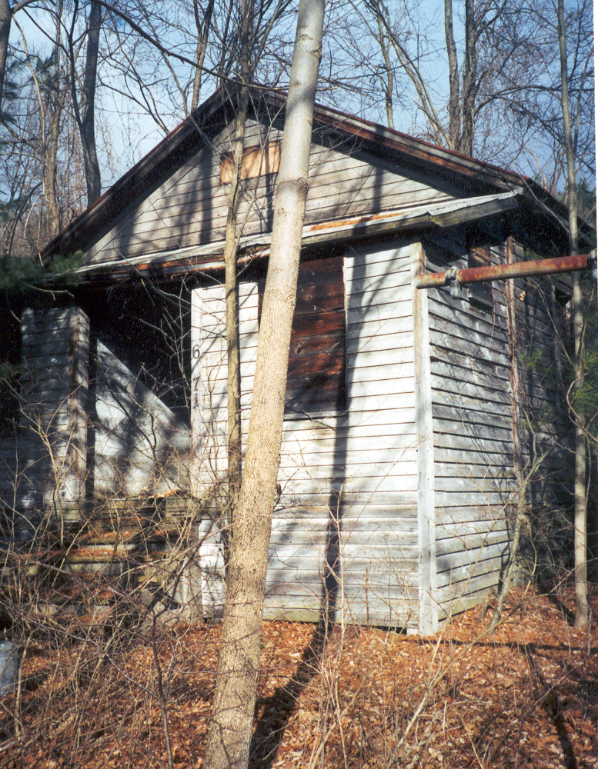
Williams School, Tuscarora District No. 1, Tuscarora, New York
(Photograph by author, Spring 2001)

First, while the building itself could be modified to accommodate the operations of a small museum, its location posed a major drawback. The isolation and difficult access at the historic site likely would discourage potential visitation to the proposed museum. Williams School is situated several miles out of town, on a little-used dead-end, its road frontage nearly obscured by overgrown vegetation, its entry reached by clambering up a relatively small but never-the-less steep embankment. Alas, the way to overcome that obstacle seemed obvious: identify a more desirable location for the proposed museum, and move the school to town! The organization purchased a village lot on a quiet residential street, readily visible from the main thoroughfare. The plot of land was narrow, but deep enough to accommodate adequate parking. It wasn’t exactly the ideal spot, but it would do – visitors could arrive on foot or by car, and the newly acquired lot was next door to the oldest house in town. The two early buildings could “rub elbows,” so to speak, conveying an atmosphere of history for the public’s edification. The Society secured a zoning variance, and continued the planning process.
At the outset, the promises of the opportunity to showcase and more effectively utilize the resource seemed adequate justification for relocation of the school from its remote setting to a more visible and accessible site. The author conducted a literature search, and thus provided more support for the plan. Ample journal articles and a few books about building moving had been published and were available from the libraries at Cornell University. The very existence of that documentary history provided reassurance that the MHS relocation project was indeed feasible. Those accounts chronicled numerous successful moves, many of which had been far more difficult, more spectacular than the proposed transport of a one-room schoolhouse over relatively flat terrain to a new site just a few miles away. The literature search yielded affirmation that it was possible to move all manner of buildings, covering the gamut from small wooden buildings to grand masonry structures, and even entire neighborhoods. Certainly the concept was not novel, for the articles had been written as early as 1870 and some described even earlier practices, such as farmers rearranging their outbuildings for greater efficiency of operations. The published materials provided a record of the diverse circumstances that prompted moves. The motivations varied, but often an investigation of the outcomes revealed economic gain, appealing aesthetics, environmental advantages, and social benefits. The feats were intriguing for their impressive scale. The published materials illustrated changes in the technology of building moving, and the ingenuity proved to be interesting in and of itself.
But, specifically, what would the relocation of the Williams School entail? Information about current methods for moving historic structures would be obtained from those experienced in the business, notably members of the International Association of Structural Movers. Assistance was sought from an experienced building mover, and John Dexheimer (who had executed the move of the Cradit-Moore House) offered his expert advice to the Williams School’s owners. Mr. Dexheimer visited the existing and proposed sites, explained the straightforward process to the property owners, provided cost estimates for his portions of such a project, and recommended that MHS contact other agencies that would need to be involved in the undertaking. And so the investigation continued: what equipment would be utilized, what preparations were necessary for the building and its two locations, what regulations must be satisfied, what other costs would be incurred?
The second major obstacle became evident when the Middletown Historical Society was cautioned by the State Historic Preservation Office that the school, if moved as planned, would not be eligible for listing on the National Register of Historic Places (NR). Nomination of the Williams School to the National Register was perceived by MHS as pivotal to the project, providing honorific recognition and increasing the likelihood of eligibility for much needed financial assistance from private and public funding sources. Denial of eligibility for the National Register of Historic Places prompted yet another series of questions. Although the assertion had been made that relocation of a building would preclude a National Register nomination, the literature search revealed several examples of properties that were listed despite having been moved either prior to or following the resource’s nomination to the NR. To a novice, this apparent contradiction was confusing. In order to qualify for listing in the National Register of Historic Places, a property must possess historic significance and retain integrity. Benchmarks for historic significance must include one or more of the following: association with historic events or activities; association with important persons; distinctive design or physical characteristics; potential to provide important information about prehistory or history. Evidence of a property’s integrity includes location, design, setting, materials, workmanship, feeling, and association. Obviously, at least some moved buildings satisfied those requirements even though no longer situated at their original location. What were the extenuating circumstances under which a moved building could be listed? Were there valid reasons for these exceptions, or did they reflect inconsistency in the application of preservation guidelines? And if it were moved as planned, could the Williams School, in fact, possibly be recognized with placement on the National Register? To address this uncertainty, the author would investigate more thoroughly the criteria established by the National Park Service for the National Register of Historic Places, conduct interviews with practicing professionals, and personally visit selected properties.
Why should moving historic resources render them ineligible for inclusion in the National Register? In the case of the Williams School, the property owners were committed to retention of the original design and materials, to protection of the resource by good stewardship and careful maintenance, and to the creation of an attractive landscape. Weren’t they trying to make the most of an interesting, old building that had played a role in the community’s development? To do something worthwhile, to contribute to the struggling economy? Why should the Williams School project and others like it be disqualified from many grant opportunities and other financial advantages, and not afforded the benefits associated with historic designation? At this juncture, however, the author will forego the details of the Middletown Historical Society and its quest to move the former Williams School. It suffices to say that the project has not yet come to fruition. The organization still owns the village lot which it purchased as a destination for the school, and also has considered alternative locations, but the building remains at its original site. Fund-raising continues slowly. Community response has vacillated, sometimes optimistic and excited but at other times faltering. The outcome is yet to be determined.
While this synopsis of the local schoolhouse proposal and its associated lessons represents only a minor case study, similar situations are oft-repeated elsewhere, and thus this thesis will address the topic of moving historic buildings from a general perspective. There are many organizations, in communities large or small, who are stymied similarly in their efforts to preserve a treasured resource. Their motives are well-intended, their dedication to preservation is genuine. But what exactly is preservation? Preservation is a form of advocacy, an approach that favors extending the viability of finite resources, encourages an appreciation of works produced by previous craftsmen, and demonstrates respect for earlier cultures. Preservation is also a process. The definition of preservation, generally, is “saving from destruction or deterioration old and historic buildings, sites, structures, and objects, and providing for their continued use by means of maintenance, restoration, rehabilitation, or adaptive reuse.” Designation of a property in the National Register of Historic Places is widely recognized as a hallmark of preservation. In order to assist the reader, the author provides the following definitions of interventions as proffered by the United States’ Secretary of the Interior and the National Park Service, the federal agency charged with oversight of historic preservation.
- Preservation: “The act or process of applying measures necessary to sustain the existing form, integrity, and materials of an historic property. Work, including preliminary measures to protect and stabilize the property, generally focuses upon the ongoing maintenance and repair of historic materials and features rather than extensive replacement and new construction. New exterior additions are not within the scope of this treatment; however, the limited and sensitive upgrading of mechanical, electrical, and plumbing systems and other code-required work to make properties functional is appropriate within a preservation project.”
- Rehabilitation: “The act or process of making possible a compatible use for a property through repair, alterations, and additions while preserving those portions or features which convey its historical, cultural, or architectural values.”
- Restoration: “The act or process of accurately depicting the form, features, and character of a property as it appeared at a particular period of time by means of the removal of features from other periods in its history and reconstruction of missing features from the restoration period. The limited and sensitive upgrading of mechanical, electrical, and plumbing systems and other code-required work to make properties functional is appropriate within a restoration project.”
- Reconstruction: “The act or process of depicting, by means of new construction, the form, features, and detailing of a non-surviving site, landscape, building, structure, or object for the purpose of replicating its appearance at a specific period of time and in its historic location.”
For the sake of consistency, those terms are utilized throughout this thesis. Note that the issue of relocating a historic building is not specifically addressed in any of the definitions.
In summary, the author set out determined to convince others that the relocation of historic buildings was one effective means of preservation, and to facilitate efforts to save buildings in that way. Initially, she concentrated her research on the following functions:
- Identify examples of moved buildings, and describe in what ways they demonstrate successful preservation.
- Determine what candidates are appropriate for moving. Before choosing to move a building, it would be prudent to consider the risks. A review of past experiences would disclose which construction types are conducive to relocation and which are most susceptible to damage.
- Acquire at least a rudimentary understanding of the moving process. Investigate the history and technology of the building moving industry. Compile a list of terminology pertinent to the equipment and methods that are commonly utilized to relocate a building. Outline key considerations in the selection of a mover.
- Itemize other factors which are associated with a move. Determine what steps, other than the physical transfer of the building, are necessary for a successful relocation. How should a building or structure be integrated into a new setting, and what should be left in the wake behind? What regulatory parameters (e.g. zoning, building codes) must be observed? The answers to each question would influence feasibility and manageability of the move.
Recognizing both the merit of saving a historic building and the high costs associated with an undertaking of such magnitude, the author was determined to justify the inclusion of a significant building, though no longer on its original site, in the National Register of Historic Places. Research showed readily that some moved buildings were recognized by placement on the National Register of Historic Places, while others were not. What were the differences? Thus, another dimension was added to the thesis: it was essential to gain greater understanding of the NR guidelines. This would require analysis of case studies, and would lead the author to become more familiar with remediation procedures. To supplement the review of official policies, a survey would be conducted of State Historic Preservation Officers and other practitioners to gather information on attitudes about moving historic buildings.
A subset of moved buildings proved to be particularly interesting. Many outdoor history museums include or even consist of moved buildings. Simultaneously, such museums save buildings and offer visitors an experience that is educational and/or entertaining (although admittedly, the degree to which each site does this varies). Such institutions are popular destinations, both for visitors and displaced buildings. Preliminary reviews of three prominent museums (Greenfield Village in Michigan, Hopewell Furnace in Pennsylvania, and The Farmers Museum in New York) appeared to reflect inconsistent application of the National Register criteria, so prompted further inquiry. Subsequently, personal visits to the three enabled the author to draw conclusions based on direct observation.
It is important underscore this caveat to the reader: the fact that a vacant site was occupied at one time, or that a building at a given location formerly stood elsewhere, may not be readily apparent to the casual observer. Museum professionals are aware of this, and should judiciously plan their facilities in order to facilitate proper interpretation to visitors. Beyond the museum realm, the observer also must be careful not to overlook evidence of building moves. Graduate students of Cornell University’s Historic Preservation Planning Program, when surveying the South Main Street neighborhood of Athens, Pennsylvania in 2001, identified and substantiated several relocations that had occurred shortly before and after the turn of the twentieth century, some prompted by the widening of Main Street and others by the transfer of no-longer-needed structures from one owner to another. The changes became evident when, in the course of evaluating properties for possible nomination to the National Register of Historic Places, the surveyors examined early maps, traced deeds, and interviewed local residents. Preservationists, historians, archaeologists all should be alert to such possibilities when conducting similar research. Failure to recognize a building as having been moved can lead to inaccurate interpretation of historic context.
Research has carried the author on a trail through changes in the construction and housemoving industries, and alongside the evolution of preservation. With the investigation of those underpinnings, came clearer understanding. Both the reasoning behind such projects, and an appreciation for their differences, have been revealed along the way. Within this thesis, the findings have been organized into four chapters, with images inserted into the text for purposes of illustration. Chapter One contains several examples gleaned from the literature search and illustrates the technological methods of moving buildings, thus answering the question, “Can a historic building be moved?” Chapter Two summarizes guidelines governing current preservation professional practices and thus tackles the question, “Should a historic building be moved?” For readers who decide to proceed with building relocation, Chapter Three offers practical advice for how to execute a building relocation, with descriptions of building preparation according to method of construction, and an outline of other considerations for planning such a project. Chapter Four addresses outdoor museums that feature relocated buildings, concentrating on three noted examples. Finally, the conclusion summarizes the author’s findings, identifies limitations of the study, and suggests additional questions which could be investigated by a future researcher.

CHAPTER ONE

HISTORY OF BUILDING RELOCATION

Before giving serious consideration to the relocation of a historic building or structure, it is prudent to develop a general understanding of such an undertaking. This chapter presents numerous examples of relocations, thus demonstrating the wide variety of building types that have been moved. Further, these examples disclose numerous motives for moving, and illustrate the evolution of methods and equipment associated with the process. For those who are intrigued by the evolution of the industry, the House Moving Museum, established in 1985 by H.D. Snow and Son House Moving, Inc. of Fort Worth, TX, features house moving equipment and related materials. Some businesses and individuals possess photographic archives. Michael J. Crowe, Inc., a construction management company in Minneapolis, MN that serves as consultant for jobs involving structural moving, maintains an extensive photo collection of the Crowe Moving Business. (That organization was founded in 1859 during the midst of Chicago’s development. The generation which took over the business in 1888 focused particularly on large buildings, and participated in the raising of many structures by four to five feet, actions necessary to permit installation of city sewer and water lines at grade due to poor drainage conditions.) A private collection, held by Bob and Dottie Gheen includes photographs taken when the community of Osborn was moved in the 1920s to a permit flood control project (construction of the Huffman Dam near Dayton). In 1950, New Osborne united with the Fairfield community to form what is now Fairborn, Ohio.

Examples of building relocation
A literature search revealed numerous publications that addressed moved buildings, and thus provided illustration of successful moving ventures. The examples included in this chapter were chosen for their diversity in time, technique, and building type. While the references consulted during this investigation date to 1870, it should be noted that some recall earlier events. Some are spectacular cases, but the reader is cautioned not to dismiss the concept of moving buildings as either novel or frivolous. Rather, it has evidently been a relatively widespread practice, satisfying functional, economic, aesthetic and social needs. Also by examining past experiences, the author was introduced to technology associated with the building moving industry, and thus compiled a basic guide to the pertinent methods and equipment.
After recounting a 1598 incident wherein a London house was moved in a dispute among neighbors, English architect Arthur Ling wrote in 1944, “. . . this remarkable engineering feat might have been chronicled as a great invention, providing the solution to the chaos and congestion caused by the narrowness of the City streets. As it is, the process has been neglected in this country, and since this incident, little progress has been made. It has been left first to the Americans to develop the technique [for moving buildings]. . .” The literature search revealed that the practice of moving buildings is not restricted to the United States. Study of published articles that detail relocations in Australia, Canada, Colombia, Czechoslovakia, Egypt, England, New Zealand, Poland, Spain, Sweden, Switzerland and the former U.S.S.R. could provide insight into international preservation practices, but that is beyond the scope of this thesis. The following chronology represents interesting American cases, each the subject of publication:
- 1843: “The removing of wooden houses with brick chimneystacks, en masse, is so commonly effected here, that to question its practicability would be the height of absurdity . . .”
- 1855: Six successive years of dysentery and cholera epidemics in Chicago led to the formation of the city’s Board of Sewerage Commissioners. That group adopted engineer Ellis Chesbrough’s plan whereby new sewer lines were installed at existing street level, then the grade raised six to ten feet in order to accommodate the sewer and other utility networks. While some property owners simply converted their first story spaces to basements and second story spaces to the principal areas, many opted to elevate their buildings to the new street level. George M. Pullman (famed later as the designer of sleeper railroad cars) and his brother were prominent among the house-movers who, over the course of three years, raised single buildings and sometimes whole city blocks. Notably, they used 5000 jackscrews and 1200 men to lift the six-story Tremont Hotel while guests remained in their rooms.
- 1869: In Boston, the Hotel Pelham was moved fourteen feet to accommodate the widening of Tremont Street. The seven-story, brick and freestone building featured granite columns and had a footprint of 5800 square feet. The move was accomplished over a period of four days, during which the use of flexible tubes enabled uninterrupted utility service for the building’s occupants.
- 1875: A three-story brick dwelling, measuring thirty by eighteen feet, was drawn a distance of four hundred feet by two horses, thus making way for the construction of a Frankford and Southwark Railroad depot in Pennsylvania. Stones from the original cellar were used to build the cellar walls at the new site.
- 1899: When the county seat was changed from Hemingford to Alliance, Nebraska, the frame courthouse was transported a distance of nineteen miles, balanced between two sixty-ton coal cars and towed by a freight engine.
- 1900: Similarly, homes were moved to a new, more desirable location when a new railroad connection was announced at Platte, South Dakota. Following an auction of lots at the new junction, to which members of the surrounding communities had been invited, “buildings of all shapes and sizes could be seen moving across the prairie,” drawn by the promised growth of a thriving little city. For some owners, the moves were complicated by the necessity to cross Platte Creek – achievements which required the construction of temporary bridges.
- 1903: In Pittsburgh, the Baltimore and Ohio Railway prompted another move, this time to clear the way for realignment of the tracks. The Brown Mansion, measuring 85 x 40 feet and weighing 800 tons, was removed from its foundation, and lifted a remarkable distance of 160 feet, then repositioned on the cliff directly overlooking the building’s original site. In order to accomplish this, a series of four benches on which to rest the building were cut into the cliff’s face at thirty-foot intervals.
- In 1913, and again in 1923, articles were published that described the moving of houses at such elevation that traffic (San Francisco cable cars in the first instance, automobiles along a Brooklyn thoroughfare in the second) continued to flow underneath throughout the operations.
- 1916: The installation of a new breakwater effectively rendered the lighthouse at Sheboygan, Wisconsin inadequate. Rather than scrap the tower, the U.S. Bureau of Lighthouses decided it would be more economical to shift it to a new location so that it could cast its beacon farther out onto the waters. Using wooden rollers, blocks and tackles, and a windlass, the lighthouse was transported on a scow. The same year, while installing a double-track line for the 649-mile Southern Railway, it was determined that it would be more economical to move the brick station at Danville, Virginia than to reconstruct.
- 1919: The Oliver Mining Company, a subsidiary of United States Steel Corporation, began to buy surface rights in Hibbing, Minnesota; the company had acquired mineral rights in 1899 to the iron ore underground, and subsequently open pit mines had surrounded the village. In order to expose more of the vein of valuable ore, approximately one-fourth (sixteen blocks) of the village was moved. By 1921, approximately two hundred buildings were removed from their original sites, and transported approximately two miles to South Hibbing, where they were placed on new foundations, repaired, and reconnected to utilities. Depending on the size of the building, some were disassembled for moving on trucks, others were pulled on rollers by steam locomotive tractors. Plans included the dismantling of an additional seventy-five buildings, with the materials to be reused in the construction of other buildings at the new site.
- As Los Angeles sprawled rapidly during the early twentieth century, one newspaper columnist described what he called, “wandering house syndrome.” Rather than leave behind their lavish houses, some wealthy homeowners “hauled them to the suburbs,” even going so far as to flaunt the occasion by holding a party in the house while it moved through the streets.
- In another interesting case, an eight-story office building stood in the way of widening Second Avenue in Pittsburgh. But the obstacle was overcome, rather
than sacrificed: the building (of brick construction over steel frame), along with its reinforced concrete sidewalks, was raised twelve inches and moved back forty feet, and all the while even the elevator remained in operation.
- 1922: At a Los Angeles movie studio, a glass stage structure, 50 x 150 feet, and containing no interior partitions for support, was moved to its prepared foundation at a nearby location and joined with a second structure to form one large studio, 100 x 150 feet. None of the 3,384 leaded panes of glass was broken. Had the original structure been demolished and reconstructed, approximately six months’ time would have been required; instead, the move was accomplished and the new studio transformed in two months.
- 1923: When it became necessary to move the Roman Catholic Church of St. Nicholas twenty feet back from East Ohio Street in Pittsburgh, John Eichleay, Jr. accomplished the relocation of the 3200-ton brick building using hand-operated jacks, rollers and steel rails. There was no damage to intricate mosaics or art glass, and no interruption in the use of the building.
- 1927: New York State began acquiring lands to create Fair Haven Beach State Park – a project that would be further developed by Civilian Conservation Corps workers in the 1930s and early 1940s. Many buildings were moved as a result, including the 1855 Sabin cottage, which was transported across the frozen Sodus Bay. In 1956, subsequent homeowner George Sheldon, employed as a foreman for the Fair Haven Moving Company, relocated the house for the second time, to a site more suitable for his family’s needs.
- 1954: A trade magazine, in an issue devoted to modernization, posed this question, “If a new highway is headed your way, should you get into house moving?” The article, which included an estimate of 50,000 houses moved or wrecked annually to accommodate highway construction, went on to cite numerous examples of profitable ventures. Furthermore, it was noted, “. . . the man who ends up living in a moved house usually has a better house than he could buy for the same money elsewhere.” Generally, the examples given were relatively small houses, relocated to lots in nearby subdivisions. In one rather extraordinary case, an 1876 Long Island mansion was reconfigured into three separate residences.
- 1961: Westminster College, in Fulton, Missouri, planned to commemorate the twenty-fifth anniversary of Sir Winston Churchill’s acceptance of an honorary degree from that institution. After international negotiations, a memorial suited to the historic occasion was selected – London’s St. Mary Aldermanbury. The small stone church, which had been designed by Sir Christopher Wren and Robert Hooke in the 1670s and still bore the heavy damage incurred during World War II bombings, would be dismantled, then re-erected on the grounds of Westminster College. In the process, the stonework was cleaned, a thorough documentary record was prepared, and Victorian additions were removed. The restored memorial chapel and museum beneath were dedicated in 1969.
- 1963: The small, timber-framed Hapgood Wool Carding Mill was partially disassembled in South Waterford, Maine for transport to Old Sturbridge Village in Massachusetts. After acquiring the mill from its owner/operator a few earlier, the outdoor museum intended to create its first exhibit of industrial technology. Archaeological excavations at the original site were performed in order to gain the knowledge of the mill’s mechanical works, for the museum intended to reconstruct the mill and reactivate its turbines. Preparations for the relocation of the mill were extensive. In order to integrate smoothly into the museum’s period of interpretation, building modifications that had resulted from post -1840 operations at the mill (i.e. blacksmithing, a wagon wheel hub turning shop and a creamery, the significance of which was not stated in the article) were stripped away. To facilitate the anticipated reconstruction, detailed records were prepared, the roof and floorboards de-nailed, chimney bricks removed and cleaned, and the building divided into six sections for transport on low-bed trailers. At its new site, the mill would be carefully reconstructed, reusing original building materials to the extent possible. This venture, Sturbridge’s first attempt to educate its visitors about industrial technology, was also an educational experience or “trial run” for museum personnel who were already planning to develop a larger cotton mill.
- 1963: The National Lead Company financed the relocation of seventy buildings from the company-owned town of Tahawus, New York in order to expose another vein of titanium. The young village, which had been constructed during World War II, was moved approximately ten miles through the Adirondacks to establish a new community, Winebrook Hills. In the process, National Lead contracted for the sale of the houses to former tenants. The community’s original site, its deposits exhausted, now lies beneath a deep, man-made pond.
- 1993: After being flooded four times that spring and summer, residents of the Village of Rhineland, Missouri voted to move the entire community off the floodplain. With one exception, the housing inventory of the village consisted of frame houses, ranging from approximately fifteen to one hundred years old. Of the fifty-two homes, thirty-two were relocated, with funding made possible in part by grants (up to $12,000) and low-interest loans. (In the new town, replacements were constructed for the balance; those twenty had been demolished due to building conditions or homeowner’s preference.) Rather than relocate the village’s business buildings (many of which were either in poor condition, or had been built on a slab and thus were difficult to move), owners participated in a buy-out program and new buildings were constructed. At the new location, there was not an attempt to duplicate the community’s original configuration. Rather, the new site was developed to allow clustering of housing types, which has proved both to be attractive and to encourage more new home construction. While this project is perhaps more appropriately described as disaster relief than preservation, it is included in this chronology as an example of government-sponsored building relocation. Reportedly, the town has done extremely well since its relocation.
- 1999: The International Chimney Corporation, under contract by the National Park Service, had already restored the Cape Hatteras Lighthouse prior to moving it (and its associated buildings) 2,900 feet in order to protect it from shoreline erosion. A National Landmark, the granite and brick structure was built in 1872 and stands 208 feet tall. Many other lighthouses have been moved for either utilitarian or aesthetic purposes, e.g. to serve as a beacon in a different location, to protect the lighthouse from beach erosion, or to preserve the structure and yet accommodate reuse as home / restaurant / museum.

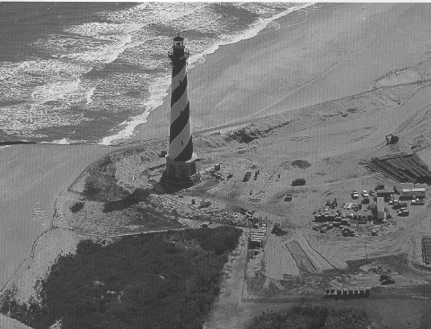
Cape Hatteras Lighthouse after the keepers’ dwellings and other outbuildings had been moved (source: Out of Harm’s Way – Moving America’s Lighthouse, page 80)

Overview of findings
Review of the literature confirmed that it is possible to move buildings of various materials and sizes. Wooden, masonry, and even glass structures were moved without damage. Small agricultural outbuildings, monumental religious and public buildings, private residences and multi-story hotels all were relocated with minimal disruption. While some buildings were moved horizontally a distance of just a few feet or many miles, others were elevated at their original site.
Analysis of the reports described above reveals numerous motives for building relocations. In many cases, the move was prompted by economic and functional pragmatism. Many agricultural structures were repositioned in order to enhance the efficiency of farm operations. In cities such as Chicago and Boston, changes to street configuration permitted improvements in public utilities and transportation routes. Financial gain was the impetus in the cases of Hibbing and Tahawus, where the communities had grown atop valuable ore reserves; relocation would expose those underground resources. Homeowners in sprawling Los Angeles capitalized on appreciated property values, moving houses to the less-congested suburbs while reaping profits from the land which they vacated. As communities expanded, the resituation of homes might be the only way to spare them from encroaching development. On the other hand, as in Platte, it was the attraction to promised development that spurred homeowners to move their homes across the prairie. The Village of Rhineland relocated to higher ground in order to escape the cycle of repeated flooding. Historically, it was often more prudent to relocate the extant structure (be it agricultural, residential, or commercial) rather than rebuild and incur the hefty expenses associated with materials and labor. In some cases, “the relocation of buildings may have been carried out as much for the image and feeling of progress and mastery over technology and environment, as for the actual benefits of the improvements themselves.” But that was not the “norm.” Most of the cases cited above were motivated by practicality, by the need to use a building most effectively for its intended purpose. Financial incentives, whether offered by private developers or public officials, were utilized in many of the case studies to further encourage relocation projects.
Several of the examples cited above (particularly those published beginning in the 1960s) also reflect the growing influence of the historic preservation movement. In addition to substantiating the practical reasons for moving buildings, the articles characterize cases where preservation via relocation spared significant historic structures in recognition of the buildings’ aesthetic or cultural qualities. Transfer of London’s St. Mary Aldermanbury to the campus of Westminster College celebrated a historic occasion, and the restoration gave new purpose to a remaining example (albeit heavily damaged) of the notable Christopher Wren’s work from the seventeenth century. Disassembly of the Hapgood Wool Carding Mill and its reconstruction at Old Sturbridge Museum provided educational benefits, including interpretation of industrial heritage. Moving the Cape Hatteras Lighthouse, threatened by changes in soil conditions, stabilized the structure and thus extended the longevity of a National Historic Landmark.

Basic mechanics
The examples above depict the assorted apparatus employed in moving a structure, ranging from wooden rollers, pulleys and simple jackscrews to precision hydraulic jacks, with the driving force behind the move provided by men, horses, tractors, boats, trains and trucks. The basic steps in the process are straightforward – removal of the building from its original location, transportation, and placement at the new site. To move a building intact, appropriate equipment is needed for each stage of activity. Specialized equipment that may utilized is described in the following paragraphs. Other basic tools for handling large timbers may include nail removers, metal detectors, sledge hammers, logging tools (e.g. a peavey for turning/ rolling, large tongs, a come-along or hand winch, chain saw and handtools for cutting), and hoisting apparatus (pulley blocks, ropes or wire cables, heavy chain, hooks).
First, the building must be separated from its foundation. In order to do this, the mover creates beam pockets in the old foundation for placement of supports, i.e. essentially break holes in the foundation to allow the insertion of large wood or steel beams under the building. If the building has been constructed only on a concrete slab, ground conditions determine the course of action – either the building can be removed from the slab, or steel banding placed under the walls (essentially creating straps) can be used to lift the slab along with the building.
The next phase requires lifting and supporting the building, employing methods similar to those used today for shoring and even seismic retrofitting of buildings. Cribbing (oak blocks, typically measuring 6”x6”x42”) is carefully stacked in criss-cross fashion, positioned around the perimeter as well as in a grid pattern within the foundation’s cavity. Bed blocks, two wooden blocks each with a semi-circular hollow to contain the nut of the jack, together cap the cribbing. (In some instances, pump logs – posts with a hollowed end to receive the jack – can be used to reduced the amount of cribbing needed.) Spacing of the jacks fluctuates according to the weight and construction of the building. To elevate the building, jacks of one form or another are placed atop the platforms of cribbing, then extended to allow insertion of additional supports. Traditionally, screw-type (threaded) jacks were used, synchronously turned by a crew of muscular men one-quarter revolution at a time to create slow, steady pressure to raise the building without damage. Later development included jacks operated by air compression, variations in bore size, and the design of heavy rubberized mat jacks. While traditional methods are still used as “back-up” in the event of system failures, today the jacking equipment has greatly expanded force, is generally powered by hydraulics, and may be integrated into the dollies that are used for moving the building. Peter Friesen, now semi-retired and living in Lynden, Washington, is frequently referred to as pioneer of the unified hydraulic systems which can be operated synchronously from central controls.

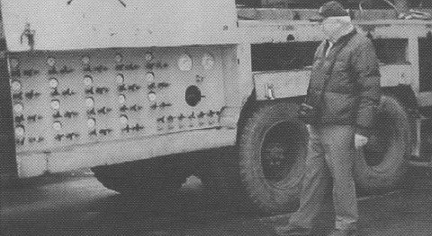
Hydraulics pioneer Peter Friesen (source: The Structural Mover, Volume 20, No. 2 [September 2002], page 31.

Throughout the move, lateral support of the building (if needed) is provided by cross-bracing. Beneath the building, a layer of cross-beams (traditionally wood, but now generally steel I-beams) extend side-to-side and the main-beams (generally two) run front-to-back to carry the structural weight. Smaller needle beams, on top of and perpendicular to the cross-beams, support the walls which run parallel to the cross-steel. International Chimney Corporation advocates pre-stressing or pre-loading the steel support beams, thereby compensating for deflection before the weight of the building is shifted to the beams. (The importance of confirming the building’s actual load-bearing in advance was emphasized, for the structure may have previously settled unevenly and thus the original pilings may not be providing adequate support.) The placement of a large steel beam, known as a stiff-back, atop and perpendicular to the ends of the cross-steel on either side of the building can provide additional stability for a masonry building. The following image illustrates the layering of the support beams beneath a building that was being moved on dollies.

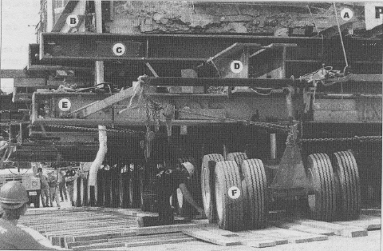
Support system for a building moved on dollies (source: International Chimney Corp.) Legend: (A) needle beams; (B) stiff-back; (C) cross beams; (D) main beam; (E) rocker beam; (F) dollie

The mechanism of moving will be determined largely based on the path to be traveled. To move in a straight line, the building can be pushed / pulled, rolling along beams. If one needs to maneuver turns, roll beams can be used in conjunction with a turn-table platform, constructed to rotate the building, or the beams can be repeatedly realigned as the building approaches its destination. In the case of a curvilinear route or if moving a great distance, the building more likely will be transported by using dollies.
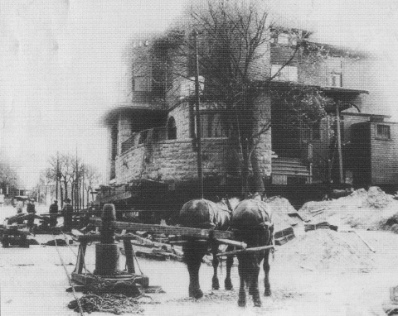 Capstan and horses [Photo from The Structural Mover, Volume 14, Number 2 (September 1996), page 36.]

Historically, buildings were moved by rolling on logs, then six-inch black rubber rollers which were slightly elliptical to allow greater control of movement. The building would be rigged with pulleys and cables, and pulling power might be provided by horses as shown above. Draft horses could work without supervision, hitched and simply responding to commands to walk in a circular fashion around a capstan, or winch, to slowly and steadily move a building on or off its foundation. Heavy chain connected to a tree or anchor (known as a dead-man), would securely counterbalance the force. Leverage to turn the capstan might also be provided by a man, pivoting the spool with a large bar in order to coil the cable. Less force is required to move a building as the numbers of cables and pulley blocks increase.
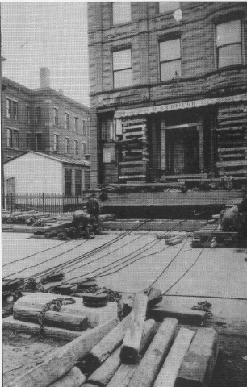
Rigging with cables and pulleys [Photo from The Structural Mover, Volume 14, Number 2 (September 1996), page 42.]

Today, power winches have replaced manpower. Beveled wooden shoes, inserted between the wooden beams and rollers, facilitated the building transfer. Now those timber tracks are steel, and the shoes have been replaced by modern devices such as Hilman rollers and Hevi-Haul skates that can glide much like ball-bearings along the I-beam.

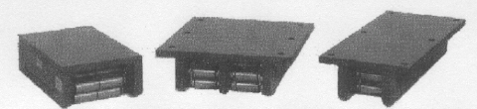
Examples of Hilman rollers (source: www.hilmanrollers.com)
As noted previously, the building might be drawn along the tracks or skid
across the ice by horses, locomotives, tractors or trucks. In 1904, Benjamin Holt invented crawler track to replace tractor wheels, which proved extremely useful for moving projects. (His company later merged with C.L. Best Tractor Company to become Caterpillar, Inc.) In addition or alternately, various means might be used to propel the building along the tracks. The forerunner of modern piston systems, push-screws (ten-foot timbers with five- to six-foot screws inserted) could provide the impetus, again with the screws turned slowly by men using angled bars. Today, such motion is accomplished through the use of hydraulic push-jacks. The jack is connected by means of two end plates – one attached to the move steel under the building, the other fastened to the roll beam. As the piston extends, the building is thus slowly pushed along the rail. Once fully extended, the end plate attached to the rail is freed and the jack is allowed to retract. It is then reattached to the rail, and the push cycle repeated.
Dollies, rather than rails, are more efficient if the building is to be transported more than a short distance, or along a route which requires several turns. For optimal leveling, the building is maintained in three-point balance while in motion. Envision a three-legged versus four-legged table or stool – the triangular basis is less prone to rock if one leg is slightly shorter than the others. When moving a building, the

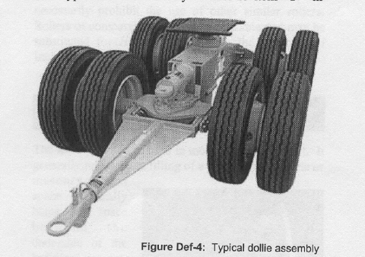
Typical dollie assembly (source: International Chimney Corporation)
primary contact points for a dollie will generally be tires at the rear corners and a front, central junction (much like the tongue of a trailer). Such equipment might be fabricated by the mover, perhaps offsetting the axles to lower clearance. A saddle allows suspension of the jack plate on which the building rests, and numerous dollies can be connected to allow coordinated steering. Among the dollies commonly used were those manufactured by LaPlant-Choate Manufacturing of Cedar Rapids, Iowa. The steerable, steel-wheeled dollies had spoke wheels, then more durable disc wheels to carry heavier loads. (LaPlant-Choate also produced heavy road-building equipment, snow plows, and hydraulic landing gear struts for World War II bomber aircraft. Allis-Chalmers acquired the plant in 1952.] Modern dollies are each equipped with eight pneumatic rubber tires and one jack, and again work in unison per hydraulic controls.
If the ground over which the dollies will travel is soft, logging mats may be placed in the path in order to distribute the load across the surface. Such mats are made of fiberglass or wooden timbers bolted together, and typically measure approximately five by sixteen feet. After the dollies have rolled over mat, the mat is picked up and placed in the path ahead of the moving structure, leading to the expression “leap-frogging.”
Once at the new site, the processes detailed above are reversed, with the building put into position over its waiting plot. As noted previously, the preparation at the site should have included the pouring of footings. Placement of cribbing permits the mason to reconstuct the walls of the foundation while gradually withdrawing the support steel. Shimming may be necessary to a snug fit between the relocated building and its new foundation. A “finishing touch” suggested by some preservationists is the placement of two historic markers – one at the new location, and one at the original site once cleared – denoting basic information about the project.

Conclusion
What was once the ideal setting for a particular building may no longer be appropriate. Perhaps the building now stands in the path of a proposed highway extension, airport expansion, or urban redevelopment project. Or perhaps there have been changes in the environment – erosion of shoreline, repeated flooding, ground subsidence. Whether the adverse circumstances originate by design or by natural forces, in each case there may be buildings at risk. All too often, the apparent solution is demolition. But at what cost? And might it not be better, instead, to make use of those buildings? It was estimated, in 1983, that eighty thousand buildings were relocated annually. Carl Tuxill, a founding member of the IASM and editor of The Structural Mover, estimated that between eight and ten thousand buildings are moved annually. While these statistics are not well-defined and thus not comparable, both confirm that moving is not an isolated instance. The potential for protecting historic buildings by relocation is clearly a viable alternative to neglect and destruction. While not the line of first defense, it is an option that has been successfully employed in a wide variety of situations. It is an option that warrants serious consideration when tackling historic preservation projects under particular circumstances.

CHAPTER TWO
PERSPECTIVES ON BUILDING RELOCATION

Commonly, preservationists identify moving a historic building as an option of last resort. They quickly cite two major drawbacks. First, there is a risk of fabric loss and thus compromise of the building’s integrity. Technology and great care in handling may minimize that loss, but there is danger of damage to plaster, masonry, and other building materials throughout the process and often the entire foundation is replaced. Second, the removal of a building from one site to another implies the loss of the building’s context, i.e. the natural features which surround it, the immediate landscape, and its place within a cultural setting. And, “from the other side of the lens,” the removal of the building represents a loss to its original district, the elimination of one element in the composition of the neighborhood. Finally, at its new location, the building may be perceived as an intrusion that detracts from or is incompatible with its new surroundings. All of these alterations can have functional, economic, aesthetic and cultural implications. But should the practice of moving historic buildings be so quickly condemned? The overriding goal of preservation is to protect and provide for continued use of historic buildings, structures, sites and objects. In some circumstances, that goal can be accomplished by moving a building to a site where it may be better utilized, generate income, and be carefully maintained all while retaining its significant historic associations. In this chapter, several arguments are presented in support of building relocation. First, as England was preparing to rebuild after World War II, architect Arthur Ling declared that American and Russian examples of building relocation demonstrated the economic benefits derived by conservation of building materials and reduction manpower requirements, then went on to advocate the use of building relocation during his country’s large-scale reconstruction efforts. Economic as well as cultural benefits have also been cited as justification for rearranging buildings on numerous college campuses. Second, concerned citizens and the National Trust for Historic Preservation (before the introduction of federal legislation that offered protective measures for historic properties) collectively argued for the relocation of the Pope-Leighey House in order to preserve an example of an architecturally significant work when threatened by highway development. Finally, after the passage of federal regulations pertinent to historic preservation, there are instances in which moving historic buildings was officially condoned. Officials in Eugene, Oregon and other cities argued the case for relocation in order to revitalize communities and retain local character. New York’s State Historic Preservation Office oversaw the temporary relocation a structure as mitigation during a federally- funded highway project. The National Park Service supported the move of a National Historic Landmark in order to spare it from the damaging forces of nature. In sum, relocation can be a means of historic preservation, and in fact has been successfully exercised by individuals, organizations, and government officials.

Building relocation for economic reasons: a post-war perspective
English architect Arthur Ling, in 1944, extolled the virtues of moving buildings, based upon his investigation of the technology and applications in both America (where, he asserted, the practice of moving buildings had been effectively utilized to permit the widening and reconstruction of main roads) and Moscow (where the process had been utilized extensively to rebuild after the Russian revolution). He anticipated shortages of housing, building materials, and labor for his country’s reconstruction post World War II, and endorsed the concept of moving buildings as a means of facilitating that large-scale reconstructive progress. Ling advocated the saving of buildings through relocation, and his argument bears repeating to those who are considering whether or not to move a building. Affirmative decisions about moving architecturally or historically valuable buildings were assumed, even before economic consideration, with Ling commenting that, “Their preservation in most cases is worth even more than the cost of demolition and erection of a new building.” The aesthetic qualities and cultural values were sufficient justification in those cases. Economic and practical advantages were employed to justify the relocation of other buildings, i.e. those that were in good repair but of less architectural or historical significance. Rather than demolish a building that stood in the path of a proposed project, rather than revise the city planners’ outlines for reconstruction, or postpone construction of a needed roadway, Ling advocated moving the building. At a time when accommodations were in short supply, the moving alternative offered continued capacity for occupancy. In contrast to his estimate of ten months required for site work, construction and finishing of a new building that measured 250,000 cubic feet, he calculated five months as the time needed to prepare, move, and reestablish an existing building at its new site. His argument compared the quantities of building materials (in short supply due to wartime demands) consumed for the new construction versus the savings available via the relocation alternative.
According to Ling, greater efficiency of a move could be achieved by conformance with the following criteria: the building should be in good repair, over three stories high, and have a relatively small, simple footprint; the ground over which the building was to be transported should have good load-bearing capacity; in order to minimize the distance, the building should be moved horizontally, in a straight line, with the shortest side foremost. Deviations from those criteria would cause variations in moving costs. To facilitate economic analysis, Ling recommended the calculation of costs per cubic foot of building. He indicated that his estimates were conservative, and that improvements in both moving technique and building materials would provide even more substantial savings. Realistically, he recognized the relative ease with which property could be acquired in the former U.S.S.R. Even given those limitations, however, Ling offered a compelling case for the reuse of buildings during England’s reconstruction. His argument warrants continued regard in today’s economy.

Saving the Pope-Leighey House: Cooperation with the Department of Transportation
The move of Virginia’s Pope-Leighey House predates the 1966 enactments of the National Historical Preservation Act with its requirement for Section 106 reviews for state- and federally-funded projects that impact historic properties, and the U.S. Department of Transportation Act with its Section 4(f) provision requiring that all prudent and feasible alternatives be explored before new road construction through historically significant public properties. The controversy surrounding the house’s disposition, when threatened by routing of the proposed U.S. Route 66 through Fairfax County, demonstrates what private citizens can accomplish through collective efforts with the National Trust for Historic Preservation and federal and state government agencies.
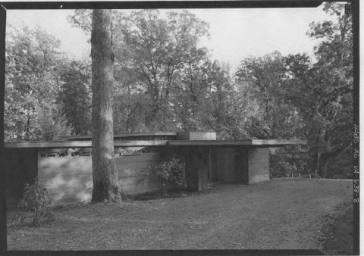
Pope-Leighey House (source: HABS, VA,30-FALCH,2-8)
Originally, Loren Pope, a newspaperman for the Washington Post who was enthralled with the works of Frank Lloyd Wright, had approached the architect, requesting the design and construction of a home. Wright responded enthusiastically, creating an efficient and affordable Usonian style home to meet the young family’s needs. Availability of building materials and financing were limited by the looming World War when the house was completed in 1941. Wright’s major contribution to architecture, his innovative use of interior space, was combined in this house with the aesthetic “rich in abstract shapes, forms and patterns; alive with luxuriant textures and subtle, earth-given colors.” The absence of an attic in the compact home (1,200 square feet), lent a low profile. The installation of radiant flooring in a concrete slab replaced a basement filled with mechanical systems. Of paramount importance was the relationship of building to its wooded site: the position of the structure was determined by the desires to take greatest advantage of exposure for natural lighting, and to integrate interior and exterior spaces within the context of extant trees and topography. Characteristically, the home contained a dominant, central fireplace, and many furnishings were customized. Wright tolerated few modifications to his plan, although the Popes did enclose a patio with screen and a copper framing. They transplanted laurel, rhododendron, hemlock, and dogwood trees, did not build a low brick wall extending along the driveway in Wright’s plan, and added hedges and a magnolia to which Wright objected. Mr. and Mrs. Robert Leighey, who subsequently purchased the home in 1946, commissioned landscape architect Rose Greely to prepare long-range plans for development of the property, and executed many of her recommendations for plantings, but did not construct the brick steps and retaining wall she designed. Simplicity of possessions fostered deeper imaginative, intellectual and creative processes, according to Wright, and his philosophy was manifest in paucity of storage space. Leigheys felt it necessary to add an unobtrusive storage shed for the containment of the overflow of their family’s belongings. Overall, the house and property were largely unchanged when, in December 1963, widowed Mrs. Leighey received formal notification from Virginia’s Department of Highways that her property would be needed for the construction of Highway 66. She quickly requested assistance from the National Trust for Historic Preservation and from the U.S. Department of the Interior. While unsuccessful in changing the course of the proposed highway, Mrs. Leighey obtained a higher purchase price ($31,500) than had originally been offered; she turned this entire amount over to the NTHP, simultaneously transferring the ownership to the NTHP. The National Trust, in exchange, provided a new location with similar topography, raised the additional funds necessary to relocate the building and care for it in perpetuity, and guaranteed Mrs. Leighey the right to continue to occupy the home for the rest of her life. A national organization committed to public participation in historic preservation, the NTHP served as both an advocate for the preservation of this significant property, and as caretaker by adding the Pope-Leighey House to its growing collection of house museums.
After an extensive search for property with qualities similar to the original Falls Church lot, it was agreed that the Pope-Leighey House would be moved to the grounds of Mount Vernon’s Woodlawn Plantation. Howard Rickert, the craftsman who had built the house in 1941, was still available in 1964 when it was time to move, and his knowledge of the construction methods was valuable when he disassembled the house. He used the opportunity to replace the innovative, but by now termite-damaged, Z-Ro-Board in the load-bearing sandwich walls with exterior, waterproof plywood, and to install steel termite shields between the wood and masonry. The house rested on a new concrete slab with radiant heating; electrical wiring was also upgraded at the time. Unlike the original construction, this time the replacement masonry was laid to conform to the reused lumber (rather than the lumber cut to fit the masonry), and the slight variations in slope required adjustments in the masonry. The new site, sixteen miles from the original, was steeper, and approximated the wooded environment but with a different mix of trees and shrubs. There is no mention of an attempt to replicate Rose Greely’s landscape design. It is noteworthy that Secretary of the Interior, Stewart Udall, took great personal interest in the project and attended dedication ceremonies once the house was resituated.
In the interim, the 1966 preservation legislation was passed, and likely bore the influence of the high-profile Pope-Leighey case. The house, designed by Frank Lloyd Wright less than thirty years previously, and in a comparable, but different setting, was successfully nominated to the National Register of Historic Places in 1970.
Yet another move would be required for the Pope-Leighey House. The second move, this time in 1996, was coordinated by Washington’s Quinn Evans/Architects. Improperly prepared soil and an inadequate foundation had resulted in serious structural problems after the 1964 move. The 1996 move, over a distance of only thirty feet to the northwest, provided the opportunity to correct that. In addition, the house was reoriented on the lot, thus more closely conforming to Wright’s original design. Simultaneously, other deterioration typical of Usonian houses (sagging cantilevers, improper drainage from the flat roof, inadequate window framing, outdated mechanical systems, and further termite damage) was remedied. The restoration project’s chairman, Loren Pope, objected to the replacement of operable windows with stationary ones when an air conditioning system was installed. Air conditioning was considered to be “profanity, because if the house is air-conditioned it’s not functioning as Mr. Wright designed it to function, which is to open to the outdoors.” Total construction costs for the second move and associated repairs were $750,000.
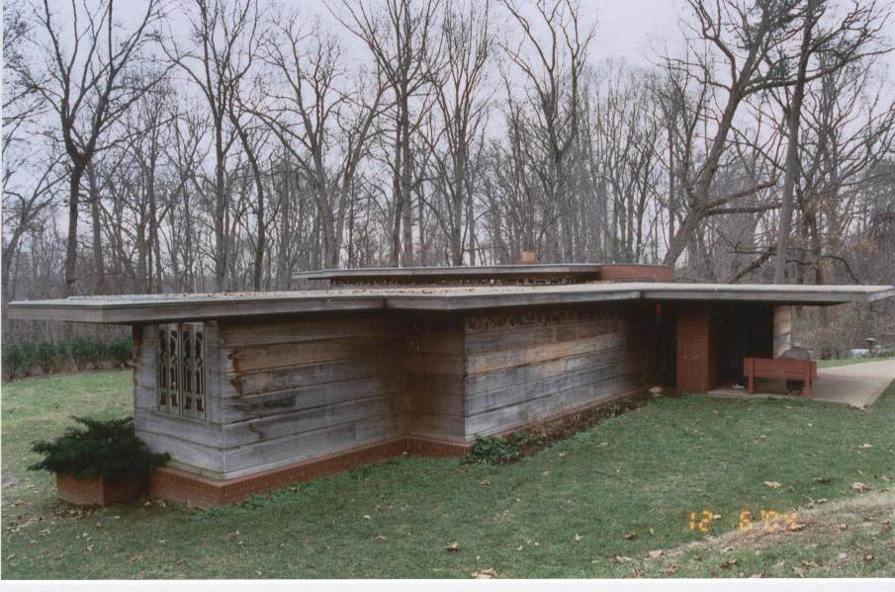
Pope-Leighey House (December 2004)
Perhaps, even more than significant for its architect and style, the Pope-Leighey case teaches us about the power of collaboration, and the fledgling preservation movement. By turning to the National Trust for Historic Preservation when the house was threatened in 1964, Mrs. Leighey was able to save her home from likely demolition, and in the process, make desperately needed structural repairs. The transfer of this significant house to the National Trust ensured its ongoing maintenance, and its conversion to a house museum afforded the opportunity for public access. But the greatest outcome from the preservation of the Pope-Leighey house may be that it reinforced the impetus behind soon-to-come protective legislation. The timing was opportune. For the past decade, the country had experienced the loss of historic resources brought on, in part, by federal programs of highway building and urban renewal. Now, by mustering the resources of the National Trust for Historic Preservation, private individuals called the attention of even the Secretary of the Interior to the all-too-familiar plight of an important building threatened by a highway project. Only one year later, in 1965, the National Trust and a Special Committee of the U.S. Conference of Mayors would publish their report, With Heritage So Rich. That report would be highly influential in the establishment of the 1966 National Historic Preservation Act, and therefore would stimulate the expansion of the historic preservation movement in the United States.

Federal Regulations: The National Register of Historic Places
Since its inception with the National Historic Preservation Act in 1966, approximately 76,000 properties (1,200,000 individual resources) have been listed in the National Register of Historic Places. Of these, approximately 2,300 have been recognized as National Historic Landmarks, signifying their importance to all Americans. Less than three per cent of the National Register properties have been moved, with the majority (2,127) having been moved prior to listing and very few (104) moved subsequently.
Briefly stated, properties can be eligible for the National Register by satisfying one or more of four criteria. Consideration of the criteria addresses historic context at the local, state, and national levels. Criterion A reflects association with events that have made a significant contribution to broad patterns of history, whether single events, a series of activities, or trends. Criterion B is applicable if the property is associated with the lives or persons significant in our past. Generally, the property should be illustrative, rather than commemorative, of the individual’s achievements. According to Criterion C, a property may be determined significant for its architecture, landscape architecture, engineering or artwork. As such, it must either “embody distinctive characteristics of a type, period, or method of construction,” or “represent the work of a master,” or “possess high artistic value,” or “represent a significant and distinguishable entity whose components may lack individual distinction.” Finally, a property may eligible for the National Register under Criterion D if it has yielded, or is likely to yield, information that is important in prehistory or history. Usually, Criterion D is appropriate for the assessment of archaeological sites, but it may also apply to buildings, objects or structures.
The following excerpts from 36 CFR Part 60 address the issue of moved buildings for the National Register of Historic Places. Section 60.4 addresses the criteria applied when reviewing a nomination to the National Register, and thus potentially limits what properties can attain the honorific status conveyed by listing. Section 60.14, on the other hand, is pertinent to properties that are already listed and thus regulates the subsequent treatment of historic properties.
- s 60.4: Criteria for evaluation. “Ordinarily cemeteries, birthplaces, or graves
of historical figures, properties owned by religious institutions or used for
religious purposes, structures that have been moved from their original locations, reconstructed historic buildings, properties primarily commemorative in nature, and properties that have achieved significance within the past 50 years shall not be considered eligible for the National Register. However, such properties will qualify if they are integral parts of districts that do meet the criteria or if they fall within the following categories: … (b) A building or structure removed from its original location which is significant primarily for architectural value, or which is the surviving structure most importantly associated with a historic person or event …”
- s 60.14 (b): Changes and revisions to properties listed in the National Register (Relocating properties listed in the National Register).
- Properties listed in the National Register should be moved only when there is no feasible alternative for preservation. When a property is moved, every effort should be made to reestablish its historic orientation, immediate setting, and general environment.
- If it is proposed that a property in the National Register be moved and the State Historic Preservation Officer, Federal agency for a property under Federal ownership or control, or person or local government where there is no approved State Historic Preservation Program [for simplicity, further such references in this thesis will be abbreviated, “SHPO/FPO/etc.”], wishes the property to remain in the National Register during and after the move, the SHPO/FPO/etc. shall submit documentation to NPS prior to the move. The documentation shall discuss:
  - The reasons for the move;
  - The effect on the property’s historical integrity;
  - The new setting and general environment of the proposed site, including evidence that the proposed site does not possess historical or archeological significance that would be adversely effected by the intrusion of the property; and
  - Photographs showing the proposed location.
- Any such proposal with respect to the new location shall follow the required notification procedures, shall be approved by the State Review Board if it is a State nomination and shall continue to follow normal review procedures. The Keeper shall also follow the required notification procedures for nominations. The Keeper shall respond to a properly documented request within 45 days of receipt within 45 days of receipt from the SHPO or FPO, or within 90 days receipt from a person or local government where there is no approved SHPO, concerning whether or not the move is approved. Once the property is moved, the SHPO/FPO/etc. shall submit to the Keeper for review:
  - A letter notifying him or her of the date the property was moved;
  - Photographs of the property on its new site; and
  - Revised maps, including a U.S.G.S. map,
  - Acreage, and
  - Verbal boundary description.
The Keeper shall respond to a properly documented submittal within 45 days of receipt with the final decision on whether the property will remain in the National Register. If the Keeper approves the move, the property will remain in the NR during and after the move unless the integrity of the property is in some unforeseen manner destroyed. If the Keeper does not approve the move, the property will be automatically deleted from the NR when moved. In cases of property removed from the NR, if the SHPO/FPO/etc. has neglected to obtain prior approval for the move or has evidence that previously unrecognized significance exists, or has accrued, the SHPO/FPO/etc. may resubmit a nomination for the property.
- In the event that a property is moved, deletion from the National Register will be automatic unless the above procedures are followed prior to the move. If the property has already been moved, it is the responsibility of the SHPO/FPO/etc. which nominated the property to notify the National Park Service. Assuming that the SHPO/FPO/etc. wishes to have the structure reentered in the NR, it must be nominated again on new forms which should discuss:
  - The reasons for the move;
  - The effect on the property’s historical integrity;
  - The new setting and general environment, including evidence that the new site does not possess historical or archeological significance that would be adversely affected by intrusion of the property.
In addition, new photographs, acreage, verbal boundary description and a U.S.G.S. map showing the structure at its new location must be sent along with the revised nomination. Any such nomination submitted by a State must be approved by the State Review Board.
- Properties moved in a manner consistent with the comments of the Advisory Council on Historic Preservation, in accord with its procedures (36 CFR Part 800), are granted as exception to s 60.12(b) [nomination appeals]. Moving of properties in accord with the Advisory Council’s procedures should be dealt with individually in each memorandum of agreement. In such cases, the SHPO or FPO shall notify the keeper of the new location after the move including new documentation as described above.

Application of the NR Criteria Considerations When Nominating a Moved Building
As indicated in the federal regulations, a property that has been removed from its original location still can be eligible for the National Register, provided it is significant primarily for its architectural value (Criterion C), or if it is the surviving property most importantly associated with a historic person or event (Criteria A or B). Note that if the building was moved prior to its period of significance, special consideration of its move is not necessary. A moved building, nominated under Criterion C, must retain sufficient integrity of design, materials, workmanship, feeling, and association to convey its architectural values and thus be eligible. If a moved building has been nominated for its historic association with events or persons (Criteria A or B), it must be demonstrated to be the single surviving property that is most closely associated with that event or person. Regardless of the criteria under which a moved property has been nominated, the following issues must also be weighed:
- The new orientation, setting, and general environment must be comparable to the historic location and compatible with the property’s significance.
- If the property’s significance is directly dependent upon its location, any move will cause loss of integrity and detract from the effective conveyance of significance.
- If a property was designed to be mobile during its historic use, its new location must be compatible with that use in order to maintain integrity and association.
- An artificially created grouping of buildings is not eligible unless it has achieved significance since the time of its assemblage. The period of significance is not related to the original construction dates of the individual buildings.
- A moved portion of a building is but a fragment of the whole, thus has lost integrity and is not eligible for the National Register of Historic Places.

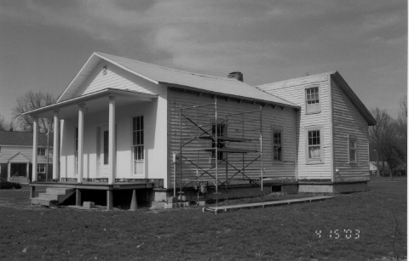
John W. Jones House at 1250 Davis St., Elmira, NY

The John W. Jones House in Elmira, New York presents an interesting illustration of the historical value of a moved building. On behalf of the John W. Jones Museum, Elise Johnson-Schmidt successfully nominated the property to the National Register of Historic Places in 2003. The current owners acquired the property, which had been condemned, in 1998 and moved it, in 2000, onto a new concrete block foundation at 1250 Davis Street, thus sparing it from demolition. This location, facing Woodlawn Cemetery, is its third location since constructed by Jones after the Civil War. While it is still on a portion of its original six -acre parcel, the land had been subdivided into smaller lots, and the house had been moved previously mid-twentieth century.
The property was nominated under Criteria B for its significant association with John W. Jones. Once a slave, he settled in Elmira in 1844 after escaping to freedom, and there was employed as sexton of the First Baptist Church for forty-three years, beginning in 1847. He also worked as assistant sexton, then sexton for both the
Main Street and Second Street cemeteries, and later as sexton for the newly established Woodlawn Cemetery. Jones purchased a home on Church Street (no longer extant) in 1854–a home which, over the years, often provided safe haven for the estimated eight hundred fugitive slaves whom he assisted as they migrated northward along the underground railroad. In his obituary, Jones was described as the originator of the underground railroad. During the Civil War, Jones’s role as sexton and superintendent of Woodlawn Cemetery led to his responsibility for burying there nearly three thousand Confederate soldiers who died while imprisoned at Elmira’s prisoner of war camp. In that capacity, he supervised twelve men who dug the graves, and prepared meticulous records of the burials. He was noted to be a man of great reverence and compassion. Following his death on December 16, 1900, John W. Jones, too, was interred at Woodlawn Cemetery.
Elmira’s prison camp was dismantled following the Civil War, and an auction held in 1866. Jones purchased pieces of the camp fence and buildings, which he then incorporated into the small farmhouse that he erected on his acreage. So it is that the Jones House was also nominated to the National Register under Criterion D. Examination of the building has revealed numerous intriguing discoveries which strengthen its association with the prison camp: there is physical resemblance to an officer’s headquarters building; planking on an interior partition is believed to have been a section of the fence which surrounded the camp, and contained remnants of early posters; a fragment of period currency was also attached to the interior, whitewashed planks; the porch columns and other decorative architectural features may have been reused from or designed on the basis of Jones’ Church Street house; analysis of the wallpaper (as many as eleven layers, over a base of fabric) confirmed that it is within the period of significance. The building, as artifact, has the potential to reveal important information.

Application of the NR Criteria Considerations When Moving a Historic Building
Clarity of the decision-making process is sometimes difficult to discern. The following two situations involve removal of historic buildings, both sited at National Historic Landmarks. At St. Mary’s City, the State of Maryland elected to remove a 19th century plantation complex in order to expose 17th century archaeological artifacts. At Cape Hatteras, North Carolina, the National Park Service sought to protect the endangered lighthouse from natural elements. Both decisions proved to be controversial.
St. Mary’s City was founded in 1634 and served as the provincial capital of Maryland until 1695. As stated by the Maryland Historical Trust, it “is probably the only remaining major seventeenth century town site in the United States that has never been overbuilt or seriously intruded upon. Still largely rural, the great natural beauty and general historic setting of this town has survived virtually unaltered since the seventeenth century. Containing the undisturbed foundations of some sixty seventeenth-century structures, St. Mary’s City is a major archeological site for the further study of seventeenth century building techniques and architecture.” The community (twelve hundred acres), in 1969, was designated as a National Historic Landmark for the significance of its contact period Indian village and the seventeenth century remains.

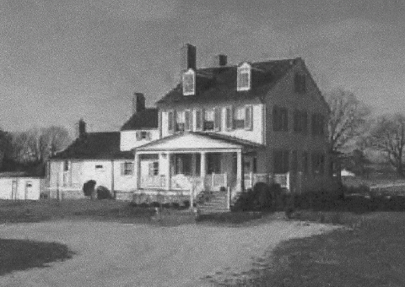
The Brome-Howard Inn (source: www.bromehowardinn.com, accessed June 30, 2003)
The State of Maryland began development of a museum at the site of Historic St. Mary’s City in 1967, and purchased the Brome-Howard House (contained therein) in 1980. This Greek Revival home, built for Dr. and Mrs. John Brome in 1840, had been the hub of a two-thousand acre plantation. But the State’s interest was in seventeenth century remains buried below–not in possible significance of the nineteenth-century history–and thus it was concluded that the complex should be relocated to a comparable site approximately one and one-half miles away. Great care was taken to protect and preserve the underground resources during the 1994 move.
Archaeological investigations are proceeding actively at the original site, and are likely to yield information about the seventeenth-century settlement. The Brome-Howard House had been constructed over a portion of the foundation for the large 1636 home of Governor Leonard Calvert, brother of Lord Baltimore (Cecil Calvert). Subsequently, the building was the residence for Governor William Stone, then the first official State House of Maryland and also the largest public inn and tavern in the colony. The community’s importance diminished when the capitol moved to Annapolis in 1695. By 1710, the building had been abandoned, the property converted to agricultural use.
In consultation with the Maryland Historic Trust, the Brome-Howard complex was positioned on its new thirty-acre site in the same arrangement as originally. Currently the Brome-Howard House and its associated buildings (dairy, smokehouse, slave quarters, carriage house) are privately operated as an inn. To Dr. Henry Miller, an archaeologist who argued unsuccessfully for retention of the Brome-Howard complex, the plantation was potentially eligible for the National Register. Though a nomination was not submitted, he reports that the Maryland Historical Trust deemed the buildings ineligible due to their relocation. As per the National Historical Landmark nomination (#69000310), the period of significance for St. Mary’s City is 1634-1694, and thus predates the establishment of the Brome Howard plantation. But the question remains, what of the nineteenth-century complex has interpretive value?
The lighthouse at Cape Hatteras, North Carolina, also a National Historic Landmark, provides a second example of a moved historic structure. In this case the landmark was threatened by shoreline erosion. And again, there was public controversy. Frequently, the decision to move is motivated by intense emotional connection to the building. Such has been the case, according to Richard Lohr, President of International Chimney Corporation (moving contractor for the Cape Hatteras complex), for numerous lighthouses and railroad stations – buildings often associated with a somewhat romanticized past.
In the video, “Moving America’s Lighthouse,” one witnesses the gamut of personal reactions to the relocation of the Cape Hatteras lighthouse complex. The conflict between local residents is apparent in the film, as they express fear of possible damage or even crumbling of the structure – a structure with close ties to the identity of “home,” in addition to a national symbol. Rather than relocate the lighthouse, many advocated the installation of various barriers to abate the shoreline’s erosion. Others proposed raising the lighthouse with placement on a new seawall, ultimately creating an island for the structure. There was acceptance of the inevitability of damage due to the ever-present wind and sand, and some felt that nature should simply run its course. Furthermore, there was an expressed sense that the local population had no role in the decision – that the government had taken control, would do whatever it wanted, and that the particular area would not be the same as a result. Criticisms of the proposed move ranged from a description as “cheap history,” to “a lot of money thrown out the window.”
On the other hand, one engineer described the project as a “no brainer.” Others from the contracted firms and the National Park Service spoke solemnly about their respect for the landmark and issued reassurances about monitoring systems. The thrill that comes from the challenge of the feat was obvious, as was their attention to a job well done. Although obviously after the fact, the choice of fatherly Walter Cronkite as host of the video has a steadying impact on the skeptical viewer.
After careful site preparation, relocation of other buildings in the complex, amazing mechanical and engineering displays, and even threats of hurricanes, the lighthouse stands approximately 1600 feet away from its original spot. Following the move, the original site was restored, marked by stones outlining the circle beneath which lay the old foundation. While some residents lament the loss of its historic context, others celebrate the increased tourism that resulted. One satisfied businessman even quips, “I wish they’d keep it on rollers and move it every year, back and forth, back and forth.” In general, the local population’s fears were relieved as the move progressed safely. While residents, contractors and the National Park Service staff all exhibit resolution of the public conflict, the twinge of loss still comes through. Ironically, the relative distance from the ocean (perceived as a significant change) was restored by the relocation.

Campus Tradition?
As presented in Chapter One, Westminster College imported a historic chapel from England to its campus, adding the Christopher Wren work for the sake of architectural preservation and commemorative celebration. It seems, however, that more often personal connections and pressures to expand programs or modernize facilities (while operating within financial constraints and property boundaries) spur administrative decisions to move university buildings. Rather than demolish buildings which prompt fond recollections among alumni, or which represent donations by generous benefactors, university officials have been known to move a building within the campus, essentially rearranging the existing buildings more compactly in order to make room for new construction. Circumstances vary, with some moves undertaken without application of the National Register criteria, but each of the following examples is illustrative.
In 1991, L.D. Dexheimer and Sons of Guilford moved Syracuse University’s Holden Observatory 190 feet southwest in order to make room for the expansion of the Maxwell School of Citizenship and Public Affairs. The observatory, which had been designed by prominent architect Archimedes Russell and constructed of Onondaga limestone, was the second building on campus when completed in 1887.

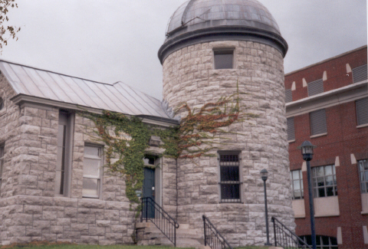Holden Observatory at Syracuse University, Syracuse, New York (August 2004)
The structure had been a gift of Erastus Holden, first Vice President of the University’s Board of Trustees, donated in memory of his son who died while attending Syracuse. As stated in the New York Times, "One problem the University had to overcome was Holden's designation as a national landmark. The status means the university had to insure that the move would not alter the building's physical structure." The observatory, with its refurbished interior and restored refractor telescope, was rededicated in 1998 and continues in use.
Dexheimer also contracted for the removal of the Cradit-Moore House from Cornell University’s campus. Constructed in 1817 as home for furniture maker Isaac Cradit, the two-story wood frame building had been enlarged and remodeled to Greek Revival style in mid-nineteenth century. Cornell acquired the 95 acres surrounding the house in 1914. Dr. Norman Moore, former director of the University’s student healthcare system, purchased the house and remaining five acres in 1937; he subsequently transferred it to Cornell on the condition that he would retain lifetime residency. Following Dr. Moore’s death in 1995, the University considered various options for the building, which by now stood in the path of ambitious development, the North Campus Residential Initiative. Conflict was manifest in the debate waged over rezoning, with differences of opinion published in the Ithaca Journal. After rejecting proposals to use the building for other purposes, Cornell administrators arranged with not-for-profit Historic Ithaca for the house to be moved on May 23, 2000. Cornell donated the new site, which is nearby and in fact was part of the Cradit family’s original acreage. Although Historic Ithaca had protested the relocation, they did participate in the crafting of a preservation easement for the NR-eligible residence, and facilitated the sale to new homeowners.
These are not isolated examples of campus rearranging. Siena College administrators advertised in 1988 that the Henry-Remsen House (an 1850-era Greek Revival structure, listed on the National Register of Historic Places) was available, providing the new homeowner would be willing to move it elsewhere in the town. At Princeton University, land use pressures were evident when the ten-year-old, reinforced concrete Woodrow Wilson Hall was moved on the campus of Princeton University in 1963, thus freeing a key corner site for expansion of the Woodrow Wilson School of Public and International Affairs. “Studies . . . indicated that the additional structure and sitework needed to squeeze a new building onto the site as it was would have cost more than the $250,000 move.” Unfortunately, in this case, the neighboring observatory was demolished. A dominant community force in Eugene, the University of Oregon, has been buying properties since the 1960s to allow expansion of its campus. Although the plans have not yet been finalized, it is anticipated that eventually the University will give away approximately eighty houses, on the condition that they be removed from the property. This wholesale undertaking, while it will save the housing stock, prompts the question whether moving has become, in fact, too easy a solution. It is noteworthy, both for this discussion and the one that follows, that the University of Oregon offers a graduate level Historic Preservation Program and city planning degrees within its School of Architecture and Allied Arts.

Community revitalization using threatened buildings
Thirty-five years after Ling wrote about the virtues of moving buildings, and influenced by the federal stance outlined in criteria for the National Register of Historic Places, the City of Eugene, Oregon published Housemoving: Old Houses Make Good Neighbors, endorsing the relocation of endangered historic buildings as a means of protecting neighborhoods. “By taking the past (as represented by old houses), and placing it in the present (as represented by functioning inner-city neighborhoods), we can provide for the future by ensuring the preservation of the house and the stabilization of the neighborhood.” The authors’ premise was that, if feasible within financial and physical constraints, the transfer of an otherwise threatened house to a vacant lot in an architecturally compatible neighborhood could deter the introduction of less desirable activities to that empty land, and consequently disrupt a likely cycle of deterioration brought about by changes in use and physical pattern of the neighborhood. Among the determinants of neighborhood compatibility were period, style, color and materials, setbacks, and organization of yards, although it must be noted that it was similarity (not monotony) that was sought. The anticipated outcome was to be greater neighborhood stability; by such maintenance of neighborhood character and appropriate density, gradual change was predicted to evolve at a more reasonable rate.
Hodgdon and Lipton suggested additional strategies to facilitate such preservation of neighborhoods and older homes, describing the collateral utility of historic zoning, code enforcement, high-risk loan pools, and neighborhood improvement programs. Numerous case studies were cited to illustrate the benefits of combining housemoving with such policies. Twenty-five years later, those case studies (cited by the authors and described below) demonstrate enduring success. And in Eugene, the practice continues. In recent communication, a city planner from Eugene reported, “We often recommend moving over demolition with good success in Eugene. The success is related to the fact that we are limited in our historic housing stock, since our population quadrupled after 1945, and we were still a very small town before that.”
In New Bedford, Massachusetts, five houses and landscape features were moved as part of the revitalization of the Waterfront Historic District.
There, a revolving fund of the not-for-profit preservation organization, Waterfront Historic Area League (WHALE) provided financial resources.
The County Department of Parks and Recreation owns San Diego’s Heritage County Park, and considers it to be the gateway to their park system. That site, nearly eight acres, contains seven examples of Victorian architecture that were moved as a result of downtown expansion during the 1970s. The project was a collaborative venture, with moving expenses for the first building borne by the Save Our Heritage Organization. Due to the high cost of interior renovations, the County chose to modify the buildings for adaptive reuse, and today uses some for park administration and leases others to a diverse group of tenants – law offices, a bed and breakfast inn, shops. Only the Temple Beth Israel, significant because of its association with notable Jewish members of the community and its history of being one of the oldest synagogues in the west, is on the National Register; the building is now used as a community center, hosting weddings, seminars and other special occasions. Three others of the seven properties have been classified as “3S,” indicating that upon review they appeared eligible for listing as separate properties.
In yet another West Coast example, designation of a fire zone in San Francisco threatened a collection of Victorian, frame buildings; twelve were chosen by the Landmarks Preservation Advisory Board to be moved. All were successfully nominated to the National Register of Historic Places in 1973, and consequently qualified for federal funding of the moves. A non-profit organization, the Foundation for San Francisco’s Architectural Heritage, purchased the houses for $500 apiece, then resold them with protective covenants in place in order to protect the buildings’ facades. Today, the properties remain in residential use and generally appear in good condition; they still appear individually on the National Register. San Francisco Architectural Heritage (SFAH) has not undertaken a similar project since. The organization is the only agent in San Francisco to receive, administer, and enforce preservation easements. Since the program’s inception in 1974, fifty-six permanent preservation easements have been donated, thus protecting the historic buildings and granting tax benefits to the property owner.

Federal Regulations: Section 106 of the National Historic Preservation Act
Eligibility for or listing in the National Register of Historic Places conveys not only honorific status, but also affords certain protections when there is potential for the building to be impacted by state- or federally-funded projects. Further, such designation may facilitate grants and public funding for mitigation and remediation at the historic site. Per the preamble of 16 U.S.C. 470f (NHPA), “Section 106 of the National Historic Preservation Act of 1966, as amended . . . requires Federal agencies to take into account the effect of their undertakings on properties included in or eligible for inclusion in the National Register of Historic Places and to afford the Council [Advisory Council on Historic Preservation] a reasonable opportunity to comment on such undertakings. . .” The following pertinent excerpts from 36 CFR Part 800 govern the protection of historic properties under the Section 106 review process:
- Sec. 800.5(a): Assessment of adverse effects (Apply criteria of adverse effect) (1) Criteria of adverse effect: “An adverse effect is found when an
undertaking may alter, directly or indirectly, any of the characteristics of a historic property that qualify the property for inclusion in the National Register in a manner that would diminish the integrity of the property’s location, design, setting, materials, workmanship, feeling, or association. . .
- Examples of adverse effects. Adverse effects on historic properties include, but are not limited to, …(iii) Removal of the property from its historic location.”
- Section 800.6: Resolution of adverse effects.
(a) “Continue consultation. The agency official shall consult with the
SHPO/THPO (Tribal Historic Preservation Officer) and other parties, including Indian tribes and Native Hawaiian organizations, to develop and evaluate alternatives or modifications to the undertaking that could avoid, minimize, or mitigate adverse effects on historic properties. . .
(b) Resolve adverse effects. . .
(c) Memorandum of agreement. A memorandum of agreement executed and
implemented pursuant to this section evidences the agency official’s
compliance with section 106 and this part and shall govern the undertaking
and all of its parts. The agency official shall ensure that the undertaking is
carried out in accordance with the memorandum of agreement.”

Mitigation: The Atlantic Avenue Control House
The Metropolitan Transportation Authority (MTA) prepared, in May 1996, a master plan for rehabilitation of Brooklyn’s Atlantic Terminal, also known as the Atlantic Avenue Station Complex. The Complex, composed of three subway stations for New York City Transit and a terminal for the Long Island Railroad, was operating above capacity, serving in excess of 65,000 passengers daily. The proposed redesign was intended to relieve severe congestion and poor circulation, to restore the Complex to a state of good repair, and to achieve compliance with the Americans with Disabilities Act requirements.
The MTA requested funding of the proposed rehabilitation from the Federal Transit Administration, thus bringing to bear the 1970 National Environmental Policy Act and the associated Department of Transportation Act. Those acts are aimed, among other things, at protecting historic resources that fall within the scope of federally funded transportation projects. In that context, in April 1998 consultants Louis Berger and Associates, Inc. conducted an environmental impact assessment (as mandated by the National Environmental Policy Act and Section 4(f) of the Department of Transportation Act) evaluation of the project, and identified a historic resource within the scope of Brooklyn’s Atlantic Terminal proposed rehabilitation.. That historic resource, the Atlantic Avenue Control House, is one of four remaining Interborough Rapid Transit Subway control houses that had been listed on the National Register of Historic Places in 1980. In the thematic nomination, the control houses were noted to be “of national significance for their importance in the history of urban transportation.” Designed by architects George Hein and Christopher LaFarge, the one-story building constructed in 1908 had provided an ornamental entrance to the nation’s first subway. The Berger report included the following descriptive statements: the derelict building was located on a traffic island at a high-traffic intersection; exterior was of brick, limestone and terra cotta; the windows and entrances were barricaded; no important interior features remained.
Having identified the National Register property, and consequently in accordance with the Section 106 of the National Historic Preservation Act, it was necessary to review the project’s potential impact on the historic Atlantic Avenue Control House. That impact was determined to be adverse, and therefore, several mechanisms were triggered to protect the building. It was necessary to consult with the State Historic Preservation Office to identify methods of mitigation, and to provide an opportunity for comment by the Advisory Council on Historic Preservation. By early 1999, in the resulting Memorandum of Agreement, the following conditions were stipulated:
- The Atlantic Avenue Control House will be rehabilitated in accordance with the Secretary of the Interior’s Standards. The new plaza will be sympathetically designed to reflect and enhance the historic character of the Control House.
- The Control House will be relocated temporarily to a site on the southeast corner of the intersection. (Guidelines were provided for selection of a building mover, photographic documentation prior to removal, detailed plans for the move itself, preparation of a foundation and protection at the temporary site.)
- Following temporary relocation, the relocated building will be placed on a new foundation at the original site, and will be appropriately repaired and restored. Plans for relocation and restoration will be submitted to NYSOPRHP for review prior to such action.
- Once returned to its original site, the Control House shall be occupied and used in conformity with its physical and historical integrity.
Those conditions were agreed upon by appropriate representatives of the Federal Transit Administration, the New York State Historic Preservation Officer, and the Advisory Council on Historic Preservation; the Metropolitan Transportation Authority/ New York City Transit concurred.
Finally, nearly three years after it was moved to a temporary site, the Atlantic Avenue Terminal was returned to its original location. Unfortunately, due to thermal and moisture conditions, the building’s physical state worsened during the lengthy delays. After consideration of various proposals for future use, the small, decorative structure essentially serves as a skylight to illuminate the concourse below. Plans called for there to be two maintenance closets, but otherwise interior access is restricted to viewing when looking up from the subway concourse below. The white and multi-colored terra cotta, which proved to be of higher quality than originally estimated, was restored (though some substitution was necessary due to scheduling constraints), and the new glass roof admits daylight to the concourse below. The highly ornamental building reopened in 2004.

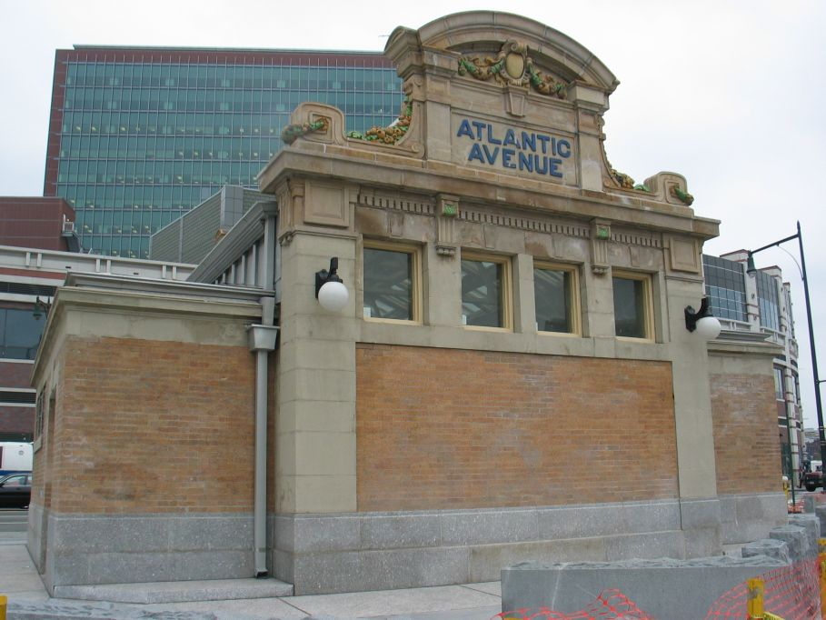
Atlantic Avenue Control House after rehabilitation (Photo taken 05-31-04; source: http://images.nycsubway.org)

King of Prussia Inn–Why did they wait so long?
This final example, though, begs the question, “What does it mean for a building to be threatened?” Pennsylvania’s King of Prussia Inn, a two and one-half story fieldstone building, constructed in 1719 and enlarged in 1769, “is an excellent example early inns that dotted the major roads of the area.” At the time of its nomination in 1975, the following description was included: “The Inn is presently located in the medial strip of U.S. Route 202. It has been boarded up for a number of years and is in poor condition. The King of Prussia Historical Society is currently planning a stabilization and restoration program.” While the abandoned inn still stood along a major roadway, the nature of that route had certainly changed: rather than afford one-day’s travel by horse to Philadelphia, the major highway now carried six lanes of traffic, and the inn’s neighbor was the sprawling King of Prussia Mall. By virtue of the growth around it, had not the inn’s sense of place within the larger community been long since lost?
The preservation of this remarkable historic building was finally culminated in a project to widen and reconstruct approximately five miles of U.S. Route 202. Archaeological investigations, performed for the Pennsylvania Department of Transportation (PennDOT) beginning in 1995, produced thousands of artifacts from the 18th, 19th and 20th centuries. After finding that there was no feasible and prudent alternative that could avoid the adverse impact on the King of Prussia Inn, a memorandum of agreement was executed by the Department of Transportation, the Federal Highway Administration, Pennsylvania’s Historical and Museum Commission, and the Advisory Council on Historic Preservation. PennDOT developed a marketing plan to relocate the inn, then selected (from the five proposals it received) the Chamber of Commerce bid for reuse. On August 20, 2000, with great care, the historic stone building was moved from U.S. Route 202 to its new site on Bill Smith Boulevard. International Chimney Corporation was the general contractor for the $1.6 million project. My question, or perhaps more aptly, my expression of frustration, is this: “What took so long?” One speculates that many other treasures have been lost due to neglect and encroachment over a lengthy span such as this.
Recommendations from the NTHP
In its advisory capacity, the National Trust for Historic Preservation issues the following statement, “The historical value of a historic house is more than simply the sum of its structural parts. Of almost equal importance is the building’s relation to the surrounding landscape, its ‘sense of place’ within the larger community. Even in the most carefully planned and executed relocations, some of the building’s historic integrity is inevitably compromised.” After noting the possible disincentives− delisting from the National Register, disqualification from historic tax credits that might facilitate rehabilitation–the NTHP, too, concedes that moving a historic building may be the only means of saving it from destruction. Under those conditions, they offer the following recommendations:
- Before planning to move a building that is listed on the National Register of Historic Places, contact the State Historic Preservation Office. It may be necessary to substantiate the reason for the proposed move, to describe the impact on the building’s historical value, and to provide information about the proposed site. Consequently, the property may be removed from the National Register; if desired, it may be possible to renominate.
- When selecting a new site, consider stylistic compatibility, proximity and similarity to the original site, neighborhood interests, and ease of transport.
- Select a reputable moving company that has previous experience with historic buildings. The International Association of Structural Movers may be a good resource. Ascertain adequate insurance coverage for public liability, property damage, and workers’ compensation. Obtain necessary building and moving permits; make arrangements with utility companies and law enforcement as appropriate.
- Document the building photographically while it is still intact; prepare measured drawings if it is historically significant. Record any disassembly that occurs as part of the move.

Conclusion
Economic benefits which derive from the continued use of the original materials, savings in labor, and capitalizing upon the value of land, were often sufficient justification to move a building in the past. Particularly since the passage of the 1966 National Historic Preservation Act, there has been increased awareness of the need to protect significant historic resources. Preservationists, intent upon maintaining the integrity of the historic structure within its original context, are quick to cite the obvious deterrents to moving a building: risk of fabric loss; opposition by the general public (including both old and new neighbors); the threat of ineligibility for or delisting from the National Register; the associated costs (direct expenses, plus resultant disqualification from rehabilitation tax credits). Numerous cases have been documented to illustrate relocations that have spared significant historic resources for use and appreciation by future generations. Even the Secretary of the Interior recognizes that, when other options have failed, moving a threatened building may be necessary in order to save it, as demonstrated by several of the cited examples.

CHAPTER THREE

PLANNING AND BUILDING PREPARATIONS

In considering whether or not to move a historic building, one must explore the physical as well as economic aspects of such an undertaking. In order to make a determination, key questions must have answers. What is the building’s present condition, can it withstand a move, and what are the plans for future use? What would be a suitable destination, and are such locations available? What preparations would be necessary, and who can assist? How will the move be financed? Architects and engineers, contractors, professional building movers, financial officers, state and local government officials can all contribute expertise. The bibliography prepared for this thesis includes relevant published resources. Once a decision has been made to move, careful planning will be essential for successful execution of the project. Factors to consider when planning include schedule, budget, building preparation and clean-up of the original site, travel route, and reestablishment at the new site.

Is the building historically significant?
If the building proposed for relocation is already listed in the National Register of Historic Places, or is believed to be eligible for listing, recognize that such designation conveys not only honorific status, but also affords certain protections and may impact funding for the undertaking. Before beginning, and then throughout the process if the move is undertaken, contact the State Historic Preservation Office for guidance. Among the issues which SHPO personnel can address are the following: status of listing in the National Register of Historic Places; technical assistance regarding the Secretary of Interior’s rehabilitation standards; archaeological potential at the historic and proposed sites; applicability of federal or (where available) state historic preservation tax credits; grant applications and other sources of public funding; mitigation of adverse effects determined by Section 106 reviews. If archaeological research is to be performed at either the existing or proposed sites, the preferred time for such endeavors will be prior to the move, thus working in advance of ground disturbance.

Assessment of the building in its current location
To begin, evaluate the building’s present condition. Inspect the structure for soundness of the building materials, research the style, and study the construction methods employed originally. Although the specific items to assess are variable according to construction type, the following sample questions illustrate structural items to be considered. What is the condition of the roof? Are the rafters rotted, slates broken or shingles missing, does the ridge sag? How was the framing assembled, is it square, and have there been additions through the years? Examine the exterior and foundation, searching for damaged wood, deteriorating mortar, cracked masonry. What are the interior finishes, and are the materials in good condition? Have there been leaks, does the floor buckle, are ornamental elements or lath and plaster intact? Document the building’s history, and prepare a thorough photographic record (particularly noting existing defects in the building). Measured drawings can be a valuable tool, especially for buildings of architectural significance.
Examine the building’s relationship to the original setting. Compare the scale of the building to the plot size. What is the topography, and how is the building positioned on the lot, e.g. setbacks, orientation to the street and sun? Are there mature trees, and how is the parcel landscaped? In addition to considering how the building relates to its individual setting, consider it within the context of its broader streetscape. Is street configuration a grid or curvilinear, narrow and intimate or broad and heavily traveled? What are the ages, architectural styles, and functions of associated properties, and how do those contrast to the relocation candidate? Each of these details will be relevant in the event of a move to a new location.

Search for a site
Having carefully studied the original site, next seek a new plot of land that replicates (as nearly as possible) that setting. Refer, once again, to Chapter Two for recommendations by municipal planning authorities in Eugene, Oregon. Topography, natural lighting, traffic flow, spatial proportions are all important factors. Proper selection and positioning on the new site will enhance the integration of the transplanted building into its new surroundings. Improper choices, however, can lead to problems such as uneven settling and structural defects. Recall that a second relocation of the Pope-Leighey House was necessary in order to correct deficiencies that developed as the result of the first move. Appropriate zoning is a critical factor. Failure to investigate local ordinances and subsequent noncompliance with those regulations can lead to conflict with the local zoning board.
In the following two figures, Virginia and Lee McAlester illustrate so-called “street rhythms” that reflect uniform and gradual development, respectively. Reference to these illustrations generally suggests how a building might be inserted into an existing neighborhood.
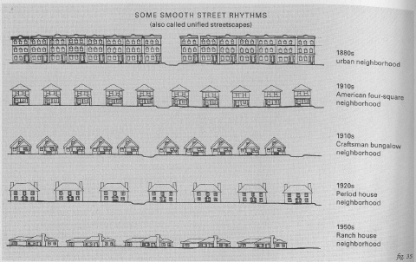 Unified streetscapes (source: McAlester)

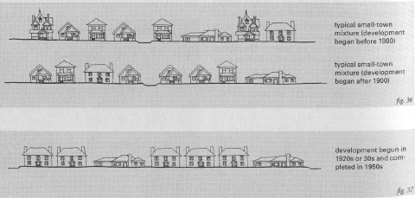
Streetscapes with gradual development (source: McAlester)
McAlesters’ third figure, below, shows problematic streetscapes, with inappropriate introduction of building types and sizes, and deterioration (perhaps due to fire or lacking preservation efforts).

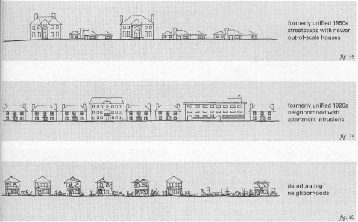
Problematic streetscapes (source: McAlester)
Having defined the criteria for a compatible site, begin the search. In addition to looking for available land by conventional methods (e.g. realtor listings, properties for sale by owners, tax sales or foreclosures), investigate other local resources. Some municipalities have established landbanks, whereby threatened property has been set aside and thus protected from inappropriate development. Non-profit organizations that focus on neighborhood improvement or historic preservation may also be aware of potentially suitable sites. Easements and protective covenants may apply to the land and/or building, and a thorough understanding will be essential to avoid unintentional violation of those restrictions. Agreements differ, but may cover such diverse issues as regrading, signage on the premises, building alterations, use of the property, and minimum maintenance standards. Likewise, the consequences of non-compliance vary.

Economics

If a full tally of the estimated expenses is calculated, the total may be less than the cost of a comparable new building. (Litchfield suggested that the total cost of a moved house would approximate one-half to two-thirds the cost of its replacement, but did not explain his calculations.) Budget expense categories include advanced planning for the move, the price of the building, clean-up at the vacated site, relocation costs (including the installation of utilities to compensate for disruption of services along the travel route), procurement of a new site, and rehabilitation. To complicate matters further, there is no standard means of financing the relocation of a building. Sources of capital vary significantly, depending on the circumstances surrounding the move. Often a combination of resources will be required in order to fund the relocation project.

Many of the previously cited examples were funded, at least in part, by the federal, state or local government agencies. Government subsidy in some form was available for projects intended to alleviate or reduce the threat of destruction by natural forces. The National Park Service commissioned the move of its endangered Cape Hatteras Lighthouse complex. Federal funding became available in San Francisco, where twelve historic buildings were removed from a newly established fire district. Grants and subsidized loans also enabled the relocation of non-historic homes from a floodplain in Rhineland, Missouri. Government subsidy was also employed to mitigate the adverse effects of federally- or state-funded transportation projects. The Pennsylvania Department of Transportation marketed then moved King of Prussia Inn, which stood in the path of a proposed highway. Mitigation plans that included the temporary relocation and rehabilitation of the Atlantic Avenue Control House were governed by a memorandum of agreement between the Federal Transit Administration, the Metropolitan Transportation Authority/New York City Transit, New York State’s Historic Preservation Officer and the Advisory Council on Historic Preservation.

Where there has been corporate involvement, there was also corporate sponsorship. Examples of such financial incentives include Cornell University’s donation of a new site for the relocated Cradit-Moore House, and Siena College’s donation of the Henry-Remsen House itself to a prospective owner who would arrange for the building’s removal from that college campus. The National Lead Corporation transferred ownership of company-owned houses to their tenants, then financed the relocations in order to expose valuable mineral deposits in the ground below.

Philanthropy, whether in the form of private investment, discounted materials, or volunteer efforts, may provide additional economic resources. Certainly the relocation of buildings and structures to or within outdoor museums (such as Greenfield Village and the Farmers’ Museum) have been underwritten in this manner. In some communities, where the practice of moving buildings is encouraged in order to conserve historic resources, alternative solutions have been utilized. Either the building or the lot may be offered at a reduced price, or even donated. High-risk loans may be underwritten by local agencies. In some instances, not-for-profit organizations (such as the Waterfront Historic Area League in New Bedford, Massachusetts) have started revolving loan funds, or facilitated the securing of low-interest loans by homeowners.

If the move is entirely a personal project, assembling the needed financial resources may be more difficult than for a customary real estate purchase. Unless the property owner has accumulated sufficient savings, credit will be a necessary ingredient. Due to the non-traditional procedures, and the inherent risks associated with moving the secured assets, bankers may be reluctant. Those wishing to move a structure should be prepared for rejections, and be forewarned that, rather than conventional financing, the lending institution may insist upon a short-term construction loan, offered at a higher rate of interest.

Consult a mover
When recruiting a building mover to undertake a project, prior experience and sensitivity to historical buildings will be key qualifications for the job. There is no dedicated educational program by which one acquires the skills employed in building moving operations. Movers’ backgrounds may include training in engineering, hauling, and construction trades, but often lessons are learned on the job and have been passed from one family generation to the next. The following paragraphs offer information about two referral sources that are available to owners who are in need of a building mover’s services, and brief comparisons of types of moving companies.
The International Association of Structural Movers (IASM), “representing the world’s oldest and largest recycling industry,” is a relatively young trade organization, founded in 1982. “Membership is limited to those persons regularly and actively engaged in the business of moving houses, bridges, ships, and other structures, or in the manufacturing of products used in this work. Retired persons from these categories may join as retired members.” The international membership rolls include approximately 300 businesses. Carl Tuxill, a founding member of the IASM, remarked that the volume of moves is, in part, a function of an area’s economy. The IASM holds annual conferences, sponsors awards in recognition of the magnitude of individual moves, and publishes a magazine, The Structural Mover, four times annually.
Another directory of structural movers is maintained, posted on the internet at www.BuildingMovers.com. The objective of this website, established in 1997, is to provide a resource site with its focus on the building moving business. Creators of the directory estimate that there are between two and three thousand professional building movers worldwide, but acknowledge the broad scope of services encompassed and include a caveat that there are varying degrees of professionalism represented among their listings.

In 2002, the Landmark Society of Western New York awarded a Special Citation to Matthews Building Movers, Inc. of Rochester, New York in recognition of the company’s outstanding commitment to the rehabilitation and relocation of the historic structures in western New York. Founded in 1867 (making it the oldest moving company in the country) by carpenter William Matthews, the small business has passed through successive generations of the family. As technology advanced, so too did the Matthews’ company equipment, progressing from the use of wood rollers and jacks that slowly raised a building one-quarter turn at a time (twenty such quarter-turns would lift the building approximately three inches, and each man was responsible for several jacks), to dollies with wood then iron wheels, to hydraulic jacking and steerable assemblies with pneumatic tires. Using the modern, labor-saving devices, a crew of only six men can now move a building down the road. Over the years they have moved buildings of assorted dimensions, materials (wood frame, masonry, steel), and functions (residential, agricultural, industrial, commercial), generally confining their territory to the western region of the state. But the company’s services are not limited to moving buildings. They also level and shore structures, raise roofs, and one family member has branched out to a related business, supplying portable offices to construction sites. They generally recommend that the property owner employ a separate contractor to prepare a new masonry foundation, initially pouring the footing and then constructing the walls to meet the awaiting building.
International Chimney Corporation, involved in the dramatic moves at Cape Hatteras and King of Prussia, has a different profile. The business, established by Roy Siegel in the 1920s, originally concentrated on the construction of smokestacks for steel and paper mills, then broadened their client base to include hospitals, schools and other businesses. Today, they continue to focus on tall structures and “dead weight” masonry – providing engineering expertise, rehabilitating church steeples, retrofitting chimneys, custom manufacturing bricks at a plant in Kittanning, Pennsylvania, contracting for concrete cutting and sawing on highway projects. Availability of their specialized equipment and staff eased the transition to safe and cost-effective lighthouse work. Headquarters for ICC are located near Buffalo, New York, with five branch offices elsewhere in the country. They operate internationally, often collaborating with others (such as hydraulics pioneer Peter Friesen and Expert House Movers, owned by the Matyiko brothers) on the preservation projects. In an interesting New York example, ICC temporarily raised the circa 1874 brick gasholder house at the former Saratoga Gas, Electric Light and Power Company complex, thus permitting others to perform archaeological investigation and soil decontamination. Among their numerous remarkable relocations of historic buildings are included the original passenger terminal and control tower at Newark International Airport, Shubert Theater in Minneapolis, the masonry and terra cotta Union Station Arch in Columbus, Detroit’s Gem Theater, and lighthouses in Massachusetts, Rhode Island and New Jersey.
Yet a third variation on theme is the business that speculatively purchases
threatened buildings, with the intent of resale. Rhode Island’s Stephen P. Mack, described in Historic Preservation as “The Resurrectionist,” focuses his efforts on the rescue and painstaking reconstruction of eighteenth-century houses. Mack may be alerted to candidates by state and local preservation groups, friends or acquaintances, and will consider acquiring and disassembling only if the house dates from prior to the nineteenth-century, retains its original exterior and interior fabric, and there is no other means of salvation. The article cites Mack’s practices of thorough documentation, and describes in detail the sequence and careful handling of the building materials during disassembly. Additions to the original building are routinely removed, along with plaster and lath. (The article notes that the plaster and lath may have been added later in the house’s history. While that may be true in some cases and removal is certainly necessary for disassembly, such loss might be avoided if the building were instead moved intact.) He is praised for his insistence upon historical accuracy of detail during reconstruction. “To practically every house he rebuilds, Mack attaches an ell containing a kitchen and downstairs bathroom, using like materials and style so that one cannot discern that the addition is not original to the house.” (While this is no doubt very attractive and adds modern functionality, the addition should be distinguishable per the Secretary of Interior’s Standards.) By 1993, Stephen Mack had disassembled fifty colonial buildings, and had twenty houses in storage, awaiting clients who would request reconstruction on an appropriate site. Mack also performs award-winning restoration work on site, and continues in business today.
Selection of a reputable building mover is critical. To protect your historic structure, only a mover who is qualified by virtue of his previous successful experiences with historic buildings should be employed. An experienced building mover will possess the technical skills and specialized equipment that will be utilized in the move. The mover can also offer guidance on issues such as requirements for traffic permits and temporary utility connections along the travel route; depending on contract stipulations, the mover may even be responsible for making the necessary arrangements with local authorities and utility companies. The building mover must provide proof of insurance: workers’ compensation to cover employee injuries; bonding to ensure timely and satisfactory completion of work; and liability to compensate for personal or property damages.

Planning the move
In conjunction with the mover, plan the route over which the building will travel. Basic determinants include route width, overhead clearance, and ground conditions. After identification of possible obstacles, make arrangements for remedies. Is the roadway wide enough to allow passage of the transport vehicle, or to negotiate a turn? Must the building pass under overhead ramps or bridge surfaces? How high above grade are electric, telephone, and cable lines suspended? Can the convoy pass safely underneath the wires? If not and utility services will be interrupted while the building moves along the route, the owner must bear the responsibility for costly temporary utility reconnections (and then removal of those temporary connections after the building passes). Similarly, if trees obstruct the path and trimming is necessary, it will be necessary to determine from whom permission must be obtained and who will bear the expense of the remedy. At ground level, consider railroad tracks and uneven surfaces, inclines, soil compaction. Extraordinary circumstances when moving the King of Prussia Inn mandated bridge reinforcement and the use of ground penetrating radar to detect sinkholes. Assignment of responsibility for the various facets of the project is variable, and should be spelled out in a contract. For example, will the property owner or mover coordinate with utility companies and obtain necessary permits? The issuance of permits by the government agencies with jurisdiction over the roads (be it local, county, state, or federal) is designed to ensure adequate preparations, as well as coordination with traffic control. Specifics such as redirection of normal vehicular traffic, spectator safety, and scheduling will need to be coordinated with authorities and utility companies. Press releases may be issued if the project is of general interest, and (especially in metropolitan areas) public announcements of anticipated traffic disruption may be advisable. Again referring to the King of Prussia experience, there were unusual stipulations: bonding of the mover was required by PennDOT, with financial penalties (“liquidated damages”) to be imposed if the move could not be completed (and thus traffic flow returned to normal) by a designated time.
While coordinating the move with the various utility companies, also schedule the discontinuation of services to the building. In addition to the electric, cable, and telephone companies previously mentioned, the lines that supply gas, water and sewer connection must be addressed. Concomitantly, arrange for the provision of utility services at the new site. If a separate contractor will be employed to construct a new foundation, he should at least be involved in the development stages, or he (according to his contract), may be given that responsibility.
Determine with the mover whether the building will be moved intact, partially disassembled, or disassembled prior to relocation. That determination will be influenced by the building’s present condition, by the anticipated modifications to the building as the result of rehabilitation, and by the restrictions (such as weight load limitations on bridges that must be crossed, and width of routes that must be travelled) imposed by the moving process. An intact move is preferred and is the method most frequently utilized. An intact move minimizes the potential loss of exterior and interior fabric. The mover will recommend the appropriate methods for stabilization of the building that is either to be moved intact or to be partially disassembled. With partial disassembly, as in the case of the Hapgood Carding Mill, the building is separated into large sections. In some instances, the roof is removed or the building is divided into its stories at the horizontal planes. Alternatively, sections may be separated along vertical lines, removing a porch or addition, or even cutting the building in half. The obvious destruction resulting from such procedures must be weighed carefully before deciding how best to proceed. Complete disassembly or dismantling of a building before a move, then reconstruction at the destination, is more likely if traveling long distances.

Wooden buildings
The loss of fabric when one disassembles a building constructed of wood is one deterrent to selecting that moving option. Assuming the structure is built of logs, the chinking between them will need to be replaced. If a heavy frame is moved, some of the pegs that fasten together the timber may be damaged. Vertical plank buildings can be partially disassembled, though intact moving is preferred. Light frame buildings are seldom disassembled. On the positive side, however, disassembly provides an opportunity for reconditioning of the lumber. In order to identify lumber that is in need of repair, carefully probe joists, rafters, studs, posts, sills. Systematically label and map the location of each item to facilitate reassembly; old markings, if present, will also be helpful. Good organization of the marked elements at the new site will be advantageous for efficient reassembly. In general, the building will be dismantled from the top down, with temporary bracing added for stability and safety as the supporting components are disarticulated. If pest-infested, fumigate the wood before transporting it to the new site. If rotted, damaged timber should be consolidated or spliced, and otherwise repaired.

Masonry buildings
Typically, masonry structures are moved intact. Stone or brick chimneys on wooden buildings can be left standing, unless there are serious concerns about structural weakness or deterioration of mortar. Several examples have been cited previously, including massive churches, multi-story commercial buildings and towering lighthouses. If masonry is disassembled, sacrifice of the original mortar will of course lessen the building’s integrity; care should be taken to match the color, strength, and tooling of mortar when rebuilding. Prior to dismantling stone walls or foundations, use unique symbols to mark each exposed interface temporarily, then add inconspicuous permanently markings in order to direct the reconstruction.

Cast iron, plus the importance of site security
Cast iron construction is well-suited to dismantling, moving and reassembly. This method has been employed with several lighthouses, enabling the relocation of the 1852 Matagorda Island Lighthouse in Texas (moved in 1873) and the 1893 Chicago Harbor Light on Lake Michigan (moved in 1919) so that they might function in a different location. Beginning in the mid-nineteenth century, the use of cast iron in commercial construction was popularized, cited for its strength, its suitability to industrialized production, and its supposed fireproof qualities. James Bogardus (1800-1874, born in Catskill, New York) developed and patented a process for mass production of cast iron building framework. This systematic method offered distinct advantages, enabling fabrication of uniform parts, and consequently easy and inexpensive assembly (and disassembly) of buildings.
The following case study illustrates the methods employed in documenting and disassembling a historic cast iron building. It also, unfortunately, teaches an important lesson about site security. The Edgar Laing Stores (also known as the Bogardus

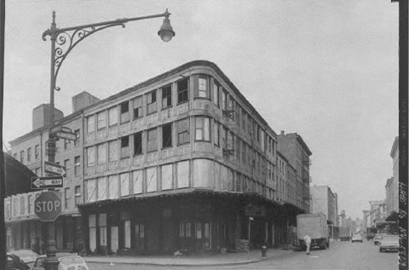
Edgar Laing Stores (source: HABS, NY, 31-NEYO, 76-3)
Buildings), erected in 1849 at the corner of Washington and Murray Streets, were described in 1971 as what “may have been the first cast iron-fronted buildings completed in New York City, or possibly anywhere else, as far as is known.” Located within the Washington Street Urban Renewal Area (future site of the World Trade Center), the buildings were threatened with demolition. Negotiation between the New York City Landmarks Preservation Commission and the Housing and Development Administration resulted in an alternative solution: the buildings were slated for relocation to the campus of City University of New York.

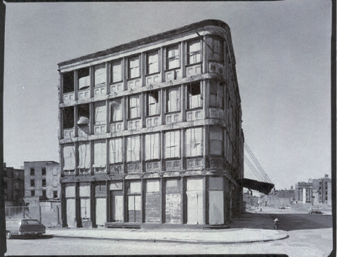
Edward Laing Stores stand alone (source: HABS, NY, 31-NEYO, 76-2)
A set of measured drawings and photographic documentation were subcontracted to a team of graduate students from Columbia University’s program in the Restoration and Preservation of Historic Architecture, and were submitted to the Historic American Buildings Survey. In February and March 1971, careful disassembly was performed, supervised by an architectural historian. The procedure consisted of burning off the heads of the bolts, loosening the member, and lowering it with a hoist. Molds were created of the few brittle components that cracked in the cold weather, but in general the task was executed smoothly. The elements were then wire brushed, red-leaded with markings to facilitate identification and reassembly, and stored.

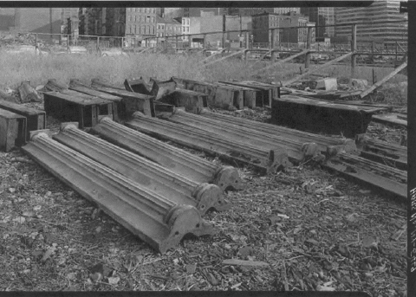
Edgar Laing Stores dismantled (source: HABS, NY, 31-NEYO, 76-33)

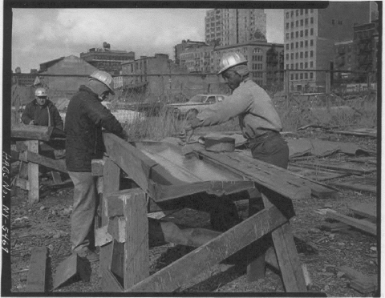
Edgar Laing Stores – preparation for storage (source: HABS, NY, 31-NEYO, 76-42)
The methods utilized in preparing this cast iron building for its anticipated relocation demonstrate the creation of a detailed historic record, the ease of disassembly, and the collaboration between government agencies. Furthermore, the subsequent unfortunate turn of events teaches a valuable lesson that is applicable to all moving projects, regardless of building construction type. That lesson highlights the importance of adequate site security. The calamity was the discovery in 1974 that a scrap metal dealer had stolen and sold portions of the stored building elements, thereby ruling out the realization of the anticipated relocation. Instead, the architectural firm of Beyer Blinder Belle, inspired by the Bogardus Buildings, designed a new building as part of the historic South Street Seaport.
If the intended reassembly could have occurred, subsequent steps in the process should have included the application of primer, proper alignment of all components, and the replacement of missing fasteners with like, stainless steel hardware. Where joints had previously been caulked, the application of either architectural-grade polyurethane sealant or white lead paste would have been recommended.

Temporary protection
One must not overlook reasonable measures designed to protect the building and sites. Anticipate the risks – vandalism, building instability, fire hazard, inclement weather, unsatisfactory thermal conditions. Secure the sites, and stabilize the building accordingly in order to minimize potential loss. Vigilant monitoring will both deter possible intruders and enable early detection of abnormal conditions. If damage should occur, the baseline documentation that was prepared at the inception of the project will provide a valuable comparison. In one example, theft of the cast iron elements from the Laing Stores demonstrates the need for site security. Second, the recent experience with the Atlantic Avenue Control House underscores the importance of temporary protection from inclement conditions. Detailed excerpts from the Memorandum of Agreement that governed the Atlantic Avenue project and relevant plans prepared by Cowley and Pradon Architects, L.L.C. are available in Appendix C. When those plans for that structure’s protection were outlined, no one imagined that three years would lapse before the Control House would be return to its original location from the “temporary” site two and one-half blocks away. During that lengthy span of time, despite those precautions, conditions (notably of the terra cotta) continued to deteriorate due to prolonged exposure to adverse temperatures and moisture.

Conclusion
It has been established buildings can be relocated. Thousands of structures of various sizes, functions, construction materials, and ages have been moved across varying terrains for many reasons. Concerns about damage to building fabric and loss of context have prompted preservationists to oppose the removal of a historic building from its original site. Yet while that practice is discouraged generally, relocation can be an effective means of preserving a historic building that is threatened. The decision whether or not to moving a building requires that extensive investigation be carried out, including an assessment of the building’s significance and physical condition. Preparation of a project schedule and budget, the search for a new site, and knowledge of the moving process itself will help to determine the feasibility of moving an endangered building. Information gleaned from employees at the State Historic Preservation Office, from building movers, and from other professionals involved in such an undertaking will help guide the decision-making. Funding the project may be challenging. If it is concluded that moving a building is advisable, the following will facilitate accomplishment of the relocation: select a qualified building mover; select a compatible location; outline the processes and responsibilities for site preparations (old and new), the building’s removal, transportation (including requirements such as utility connections and traffic control along the route), and reestablishment. After planning carefully and taking precautions to minimize risks to the building, a property owner can successfully introduce a historic building into a new setting, thus preserving a valuable asset for continued use and appreciation.

CHAPTER FOUR

MUSEUMS AS HISTORIC DISTRICTS

Outdoor museums abound, providing visitors with opportunities for educational and recreational exploration. Some are privately owned, others publicly, and some are private non-profit organizations, all portraying historic experiences with varying degrees of authenticity. Costumed interpreters and demonstrations of period activities are often in place to enhance the visitor’s understanding. The built fabric of the museum may include an accumulation of dwellings and structures gathered from other locations, new construction which represents the characteristics of particular building types, reconstructions of buildings which previously existed at the site, or a combination thereof. “It is not usual to list artificial groupings of buildings that have been created for purposes of interpretation, protection, or maintenance. Moving buildings to such a grouping destroys the integrity of location and setting, and can create a false sense of historic development.” But when there are serious attempts to preserve and to educate the public, shouldn’t these sites be candidates for the National Register of Historic Places? National Register listings for at least some such artificial groupings of buildings were easily identified, so in an effort to answer this question, three sites were examined. Initially, application of the criteria for eligibility seemed inconsistent. A “common thread” for the selection of the three museums was that each illustrates facets of rural, mid-nineteenth century life. Greenfield Village, the premier American outdoor history museum, is a disparate collection of moved and newly constructed buildings. Not only is it listed on the National Register of Historic Places, but in 1981 it was awarded the status of National Historic Landmark. In contrast, The Farmers’ Museum, similarly an amalgam of relocated and in situ buildings that have been restored and configured to simulate a village, is not listed on the National Register of Historic Places and therefore cannot benefit from the recognition and protections afforded by such designation. The obvious care for the buildings at the Farmer’s Museum is indicative of the value placed upon them as material culture, and the general trend of excluding such museums from the National Register seemed an injustice. The third example, Hopewell Furnace National Historic Site, a restored and reconstructed community, was nominated to the National Register in 1985. The goal was to understand the distinctions that qualified two museums, but not the third, for the National Register. Was provenance of the buildings the determining factor? Hopewell Furnace showcased a community at its original location. At the Farmers Museum, only the original agricultural structures were listed on the National Register. But, no, Greenfield Village, with its buildings collected from many locations in the United States and even England, disproved the notion that only buildings at their original sites could be nominated. Was retention of the original fabric the determining factor? Again, the answer was no. Buildings at both the Greenfield and Hopewell villages had been reconstructed or even newly constructed. Investigation of the three museums was necessary in order to understand the reasoning by which such districts could qualify as significant historic resources.

Greenfield Village
Automobile magnate Henry Ford founded Greenfield Village on ninety acres at Dearborn, Michigan and, on October 21, 1929, hosted a grand celebration of both the outdoor museum’s dedication and the fifty-year anniversary of Edison’s invention of the incandescent light bulb. Conceived as tribute to prolific inventor and personal friend Thomas Edison, the Edison Institute complex mushroomed into a broader expanse of Americana, honoring other famous Americans and depicting lifestyles that spanned early settlement, the Industrial Revolution and modern times. Ford felt strongly that written history’s deficiency was that it concentrated on political controversies and territorial expansions, and thus reflected little of peoples’ daily existence. The intent of the museum then was to educate visitors about American heritage, particularly highlighting goals and achievements under the free enterprise system.
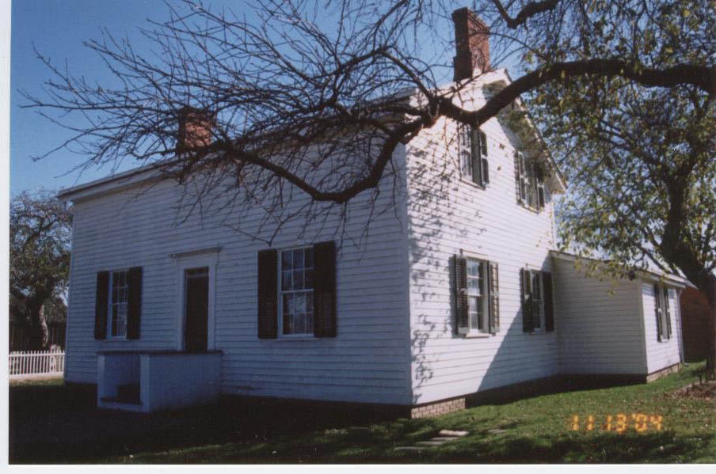
Greenfield Village: Henry Ford’s childhood home (November 2004)

Under Ford’s direct supervision, Edward J. Cutler was in charge of building design and reconstruction at Greenfield Village. Plans called for synthesis of a New England village, and the concept was further developed when Ford acquired the Edison materials from Menlo Park, New Jersey. Cutler and Ford carved out a village commons from the field that would become the outdoor museum’s grounds, and Cutler recalled, “The commons was a very valuable piece of ground. We always had something better to put around it….We always wanted the best buildings there.”
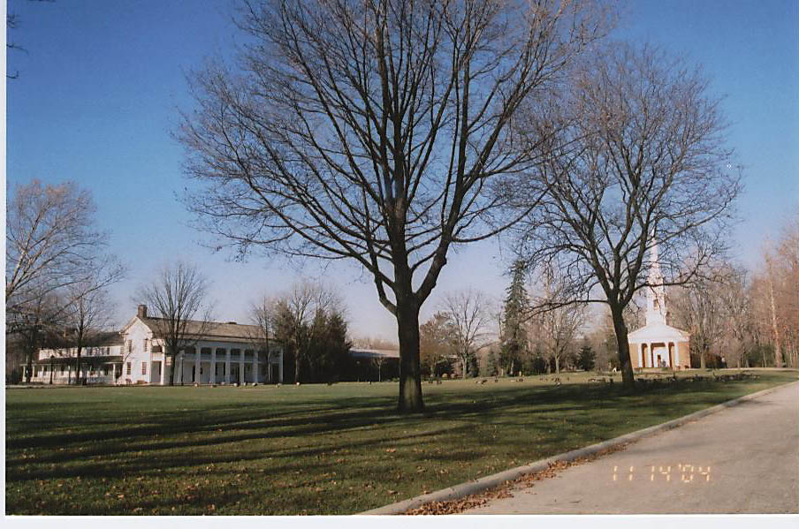
Greenfield Village: Eagle Tavern and Chapel of Martha-Mary on the commons (November 2004)

When design of the commons began in 1927, Ford owned four historic buildings that stood on their original sites, each awaiting transfer to the new outdoor museum: Thomas Edison’s laboratory in Fort Myers, Florida; the Clinton (Michigan) Inn now known as Eagle Tavern; the Waterford (Michigan) Country Store, and the Scotch Settlement School in Dearborn. For one end of the green, Cutler designed the prominent Chapel of Martha-Mary (named in honor of Henry Ford’s mother and mother-in-law) and had it constructed using bricks and doors from other buildings with which Henry and Clara Ford had been personally associated. Cutler also designed the Greek Revival style town hall which still stands opposite the chapel. Since Greenfield Village’s inception, over one hundred structures have been moved to the museum in an effort to “preserve the physical surroundings of a typical American
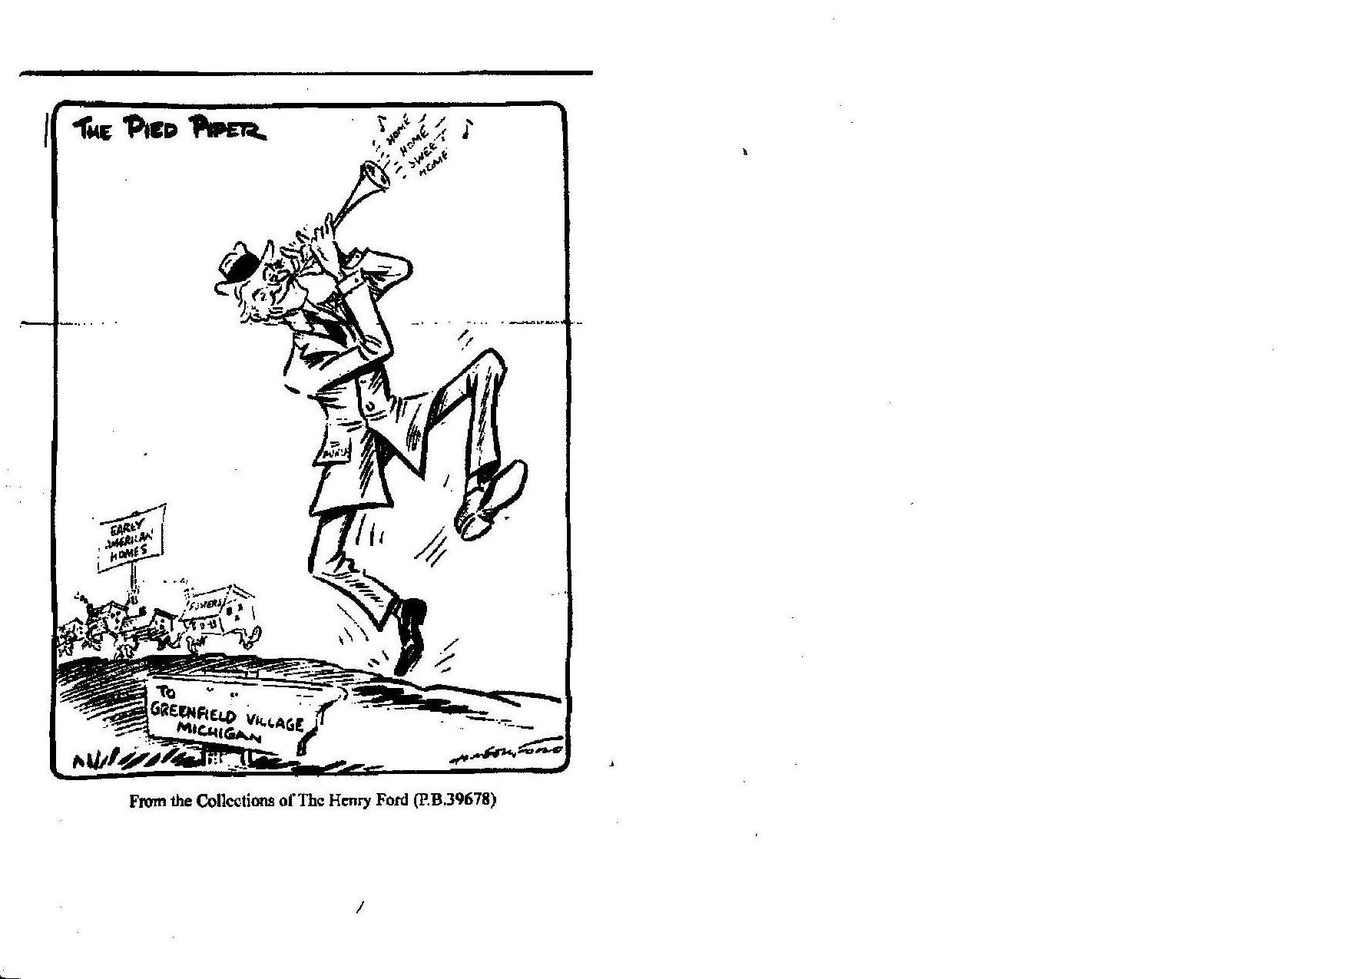
community whose roots date to the seventeenth century and illustrate the marriage of home life, manufacturing, and transportation in the development of this nation.”
Many times Ford, through his purchases, rescued the relocated buildings from a looming threat. In some instances, such as the H.J. Heinz House, the buildings were donated rather than purchased. In other cases, for example the Logan County Courthouse, the acquisition was prompted expressly by Ford’s desire to represent certain facets of history and provoked controversy.

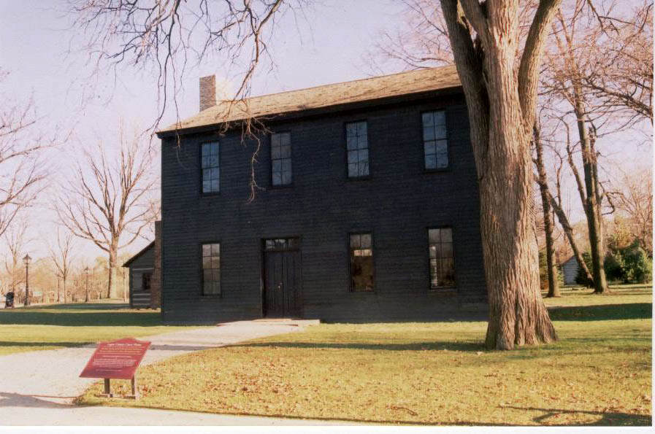
Greenfield Village: Logan County Courthouse, with the George Washington Carver log cabin visible to the left and rear (November 2004)

Henry Ford wanted his village to include a building associated with Abraham Lincoln, and therefore purchased the Logan County Courthouse. Before objecting townspeople could obtain a court injunction, the building was taken down very quickly and moved to Dearborn. (A replica was later built by the State in Lincoln, Illinois.) The accomplishments of noteworthy Americans such as Edison, Wilbur and Orville Wright, Abraham Lincoln, H.J. Heinz, Noah Webster and Henry Ford himself were celebrated by relocating homes, laboratories, shops, agricultural structures, even the aforementioned courthouse.
In preparation for moving, Cutler and his crew recorded the chosen buildings using sketches, photographs and measured drawings, then labeled and (often with manpower supplemented by local Ford dealerships) dismantled the buildings for shipment. Once at the allocated site in Greenfield Village, those buildings were reassembled using original and replacement materials, then outfitted to the degree possible with original furnishings and equipment. Accompanying documents were added to an extensive reference collection, now housed in the Benson Ford Research Center (constructed 2002). Where it was not feasible to move an original structure to Greenfield Village, representatives of desired building types were constructed, as in the case of the tintype studio and pottery shop. In other instances, reduced versions such as the quarter-scale Ford Motor Company were recreated. The two-story Sir John Bennett Jewelry Shop, now functioning as a sweet shop, retains its decorative clock figures of mythical characters but has been shortened to only two stories; inside, a historic photograph reveals that the building was five stories tall when it stood in London, England.
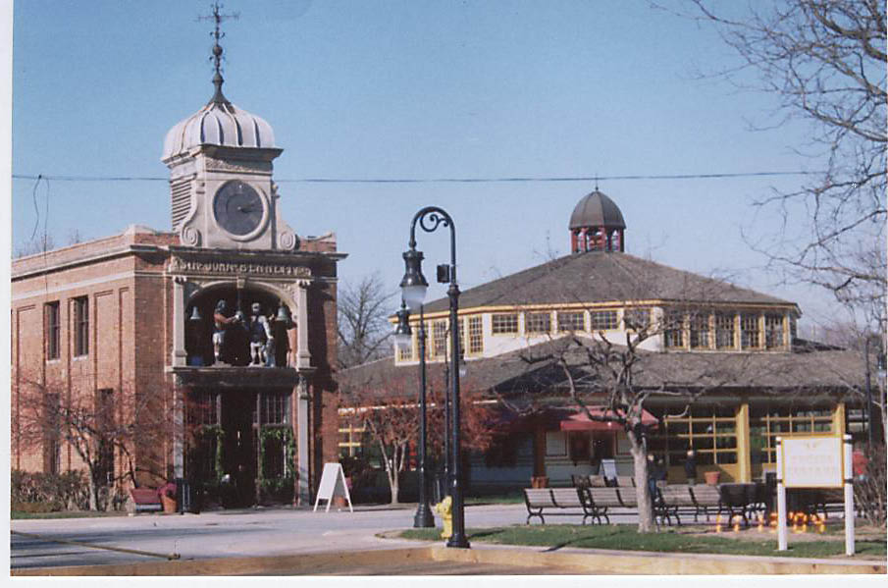
Greenfield Village: Sir John Bennett Jewelry Shop and carousel (November 2004)

Some exhibitions, such as wood planing and brickmaking, grew from the need to supply the village with materials.
Through the years, some buildings have been repositioned multiple times in order to permit the insertion of newly acquired buildings. The collection of buildings grew from thirty (30) in 1929, to sixty-eight (68) in 1940, to eighty-eight (88) by 1947. Additionally, relocations have been prompted by revisions of exhibit priorities. Greenfield Village recently reopened to the public after a nine-month hiatus during which $60,000,000 worth of infrastructure repairs and upgrades were made, and these modifications too prompted the reshuffling of several buildings.
Promotional signs encourage the potential audience, “Visit Greenfield Village, America’s Hometown. See, hear, and be a part of history.” Throughout the Village, buildings are clustered on the basis of general themes, thus facilitating interpretation for the present-day visitor. Placards at each site provide a brief description of the building’s historic origins and function, thus trying to avoid misrepresentation. Visitors of all ages stroll casually around the network of streets, and some opt to travel in vintage automobiles or horse-drawn carriages. At Main Street, the hub of the outdoor museum, the chapel and town hall still hold honorific places, anchoring the village green. The Scotch Settlement School, Eagle Tavern (with its modern addition of the Taste of History Restaurant), Lincoln courthouse, and other prized buildings also line the commons. Shops (e.g. the Wright Brothers’ bicycle shop, a millinery, and general store), a post office from Connecticut, a physician’s office, and several homes are present on adjoining streets. Piped music, a carousel, special events (e.g. private weddings, public “Holiday Nights” festivities during the month of December), and custard stands all lend to a festive atmosphere. An array of industries is on display, with Edison’s and Ford’s inventive works featured. Exhibits in the area designated as Liberty Craftworks are enlivened with demonstrations such as sawmilling, glass making, pottery manufacturing, and weaving. While agrarian influences are evident at several sites, the most comprehensive illustration of agriculture at Greenfield Village is at the Firestone Farm, ancestral home of Henry Ford’s friend and pioneer tire-maker Harvey Firestone. This homestead, moved from Ohio in 1984, includes a brick dwelling, several operational outbuildings, and fenced plots for crops and livestock (although the pen of merino sheep seems incongruous at its location behind the elaborate Henry Ford Museum). At the Railroad Junction, attractions include a roundhouse and depot, with train tracks encircling the village. Through the years, the complex has offered formal educational programs at its facilities, ranging from elementary school in the tradition of a one-room schoolhouse to post-secondary programs. Today the Walnut Grove section of the Village encompasses the campus of Henry Ford Academy, a charter high school. The Porches and Parlors neighborhood is a disparate assemblage of relocated and replicated residences, with some chosen for their regional style and others selected for their association with their well-known occupants. Amidst this “sampler,” an English Cotswold cottage and its outbuildings stand next door to an early house from colonial New England, a southern plantation is across the street, and a Swiss chalet is nearby. Robert Frost “resides” next to Noah Webster, the log cabin in which educator William McGuffey lived as a child is located adjacent to a reproduction of George Washington Carver’s cabin.

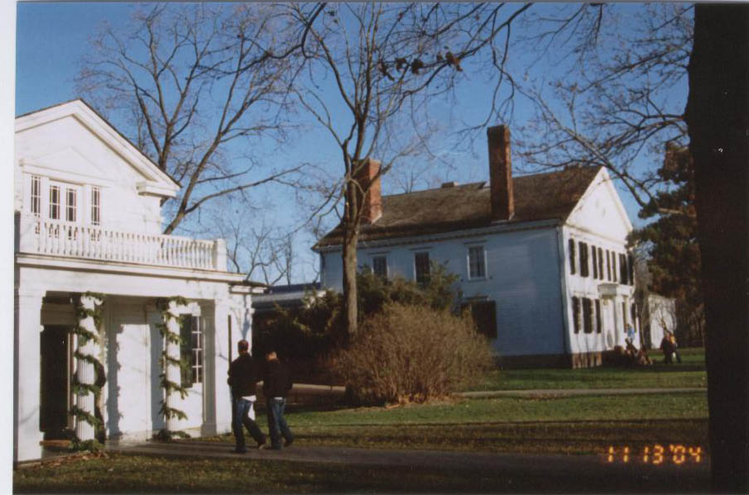
Greenfield Village: Homes of Robert Frost (left) and Noah Webster (November 2004)

The houses in this collection reflect a span of approximately three hundred years. In addition to the few international examples mentioned above, they represent a diverse cultural and geographic sampling from north, south, east, and midwest America.

An application for the National Register of Historic Places was initiated in 1969. But did this aggregate “village” made up of moved buildings, scale models and reproductions possess the prerequisites of significance, integrity, and age necessary for listing on the National Register of Historic Places? Remarkably enough, Greenfield Village (and the Henry Ford Museum) were nominated by National Parks Service staff and designated as National Historic Landmarks by the Secretary of Interior in 1981, and thus were automatically listed on the NRHP. Review of the nomination documentation substantiates that Edison Institute was deemed to have national historic significance in four respects:
“First, it illustrates Henry Ford’s conception that the history of American material progress is a story of the development and growth of agriculture, manufacturing, and transportation. As a reflection of Ford’s ideas, the Institute [Edison Institute, including the Henry Ford Museum and Greenfield Village] contributes to the understanding of an important figure in American industrial history. Second, the Henry Ford Museum contains one of the most important collections of Americana in the United States. As such, it is deemed an important educational resource. Third, Greenfield Village is a precedent setting open-air outdoor village museum that served as a model in the development of other such villages across the United States. Lastly, Greenfield Village influenced the historic preservation movement, first, by developing a type of historic preservation centered on preserving and interpreting historic buildings by moving them to a re-created village setting and, second, by stimulating a reaction to the museum village that led to the extension of the historic preservation concept to include the preservation of the man built environment in situ as documents of time, place, and historical continuity.”

The Farmers’ Museum
When the “Farm and Craft Collection” opened in Cooperstown, New York on July 4, 1942, it offered a preview of the Farmers’ Museum. At its early location in Otsego County, on the second floor of the downtown Village Club, the new tourist-attraction was a one-room exhibit of approximately 5,000 agricultural artifacts, household implements and hand tools. Stephen C. Clark, of the Singer Sewing Machine Company, had invited the New York State Historical Association (NYSHA) to relocate from Ticonderoga, New York and, through his generous offer of assistance, encouraged the rural history museum’s formation in order to bolster the economy of the agricultural community. The Farmers’ Museum, administered by NYSHA, was granted its Absolute Charter by the New York State Board of Regents on April 16, 1943.
Contemporary outdoor museum projects, such as Michigan’s Greenfield Village and Virginia’s Colonial Williamsburg, were perceived in the 1940s to be prime mechanisms for historic preservation. By using moved, restored and recreated buildings as staging for the depiction of life during earlier times, affluent patrons such as Henry Ford and John D. Rockefeller, Jr. were saving significant architectural resources and educating the public about broad themes in history. Furthermore, the projects were an effective way “. . . to counteract the pervasive and unsightly intrusions of modernization.” Such models inspired Stephen Clark, but building restrictions imposed during World War II curtailed plans to construct a simulation of a nineteenth century barn as a new home for the recently organized Farmers’ Museum. Instead, in 1943 Stephen Clark financed the museum’s move to the stone dairy barn on the Fenimore Farm, inherited by Clark from his brother, Edward. Initial plans called for the use of relatively inexpensive dioramas to depict activities and sites that were commonly associated with rural New York, including the Erie Canal, the maple sugar industry, and logging, gristmilling, and cider making.
By 1946, the early concept of a semi-circular village green just north of the dairy barn and exhibition hall evolved to a plan calling for the design of a village crossroads that would have typified the period 1780–1860. While sections of the original farm road were incorporated into the new crossroads, the landscape was otherwise significantly revised by regrading, eliminating fences, and removing trees. Over the next decade, most of the farm’s extant structures were demolished or altered as the museum staff sought to reconstruct a characteristic village shaped by research findings, financial constraints and technical problems. Beginning in 1948 and guided by curator Janet MacFarland, historic landscape architect Albert Kaupe carried out both on-site and documentary investigations of typical small towns in central New York. The regional surveys examined popular street configurations, proximity to utilities, patterns of community development, and common building functions. In spite of that research (perhaps out of frugality), acquired buildings generally would be positioned symmetrically along the existing thoroughfare, rather than in a somewhat haphazard arrangement that often arises from spontaneous community growth. The massive stone barn, valued for its open space and fire resistant construction, was but the beginning of the collection.
A country store, constructed in Toddsville around 1820 and purchased for the museum in 1943, was the first transplant, and offered a good setting for displays. To facilitate its move the following year, the stone building was dismantled; when reconstructed, the cellar was not replaced. Although in hindsight there was an apparent lack of appreciation for many of the extant Fenimore agricultural buildings, and inaccurate reconstruction of the store (perhaps due to inadequate financial support), one should acknowledge the growing sensitivity of staff for preservation. Given the standards of the time, they made an excellent attempt to reassemble the store’s random stone placement as accurately as possible. As the Museum expanded−acquiring, for example, a one-room schoolhouse from Filers’ Corners in 1946, the blacksmith shop from New Berlin in 1947, and a white clapboard church from Cornwallville in 1964–the selections were guided by instruction to use buildings for their original purposes whenever possible. A caveat not to remove early attractive buildings from Cooperstown protected local architectural resources. Unlike Greenfield Village, where there was considerable emphasis placed upon the well-known owners and occupants of the buildings, at the Farmers’ Museum the value of a building was derived from its symbolic representation of ideals and ordinary life. The buildings themselves were the priority for interpretation; little documentation was focused on the arrangement of structures or landscape design. Although a harmonious grouping, the arrangement was not suggested by an actual village. A visitor in 1957 described what he observed as “. . . a group of buildings set one next to the other with no real sense of constituting the main street of a village . . . nine authentically recreated main buildings of a somewhat arbitrary nature, lined up on a narrow half-dozen acres, flanked on two sides by a distinctly twentieth-century golf course, and paralleling the heavily traveled lakeside road into town.”

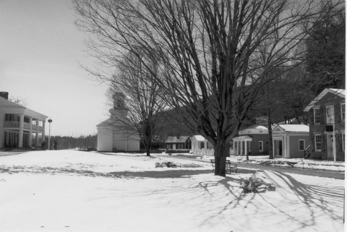 The Farmers’ Museum (left to right): Bump Tavern, church, Lippitt farmhouse, law office, druggist’s shop, doctor’s office, printer (April 2003)

Beginning in 1998, a series of changes was instituted to correct some of those perceived shortcomings, for historic preservation approaches and museum practices had changed since the museum’s inception. An additional nine buildings (including several houses, curiously absent until this point) were to be incorporated into the collection, and restorations of six historic gardens were to be initiated. After research of numerous atlases, and examination of grid plans and variations so popular in city planning, the rearrangement commenced.
Reactions to the prospects of reconfiguration were varied. The Board of The Farmers’ Museum endorsed the concept, approving sizable expenditures from endowment funds to enable the project. The Ohrstrom Foundation awarded a generous grant for reconstruction of a house. Other funders provided substantial financial support and in-kind donations. Some community members, often those with sentimental connections to the site, initially were reluctant to see the vista change, but have subsequently voiced approval. The museum remained open to the public as the building moves and concomitant infrastructure upgrades progressed, thus providing an educational opportunity of a different type, with visitors taking great interest in the restoration process itself. Wrangling over the applicability of life safety codes to the historic setting came to a head with the planned move of the carriage house near Bump

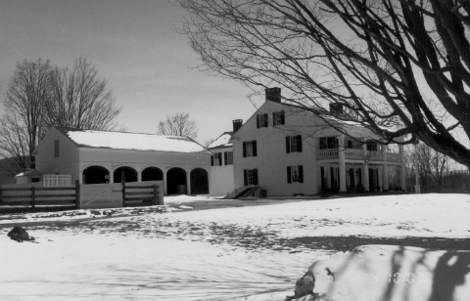
The Farmers’ Museum (left to right): carriage house, Bump Tavern (April 2003)
Tavern: its anticipated proximity to the tavern posed a fire hazard, according to code, and yet the proposed solution offer by code enforcement, i.e. introduction of electricity, seemed contradictory since it would introduce another hazard to and detract from the authenticity of the building. Only after nine months’ delay, thousands of dollars in expense, and protracted administrative appeals, would the carriage house finally be positioned.
Rearrangement of buildings (in some cases, relocated by professional movers, and in others, undertaken by museum staff) and revisions to the landscape were planned to enhance the outdoor museum’s authenticity. In order to eliminate visitors’ confusion that previously arose on occasion due to interpretations of multiple eras, the staff chose to represent the time period circa 1845. A large, central pond, originally planned as a water supply for a gristmill that no longer remained, was infilled, and the surrounding Victorian era landscaping (not in keeping with the museum’s period of significance) was removed. The historic church, once separated from the other community buildings by that pond and located, essentially, in the farmyard, was relocated to an appropriately prominent position on the village green. After plotting the original cemetery affiliated with the church, and utilizing a collection of donated headstones, a “graveyard” was designed and enclosed adjoining the church. In all, greater focus was directed on simulations of a viable village and functioning farmstead, using building placement and suggestions of barriers to more clearly identify the distinct but interdependent economic units.

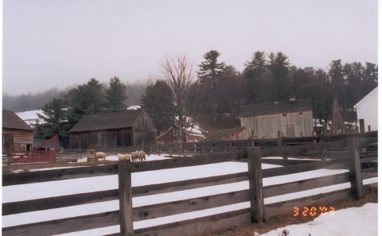
The Farmers’ Museum: Lippitt farmstead (corner of church visible at right)
(March 2003)

Dr. Gilbert Vincent, Director of Museums since 1995, emphasized the need to accurately portray the Lippitt farm as a progressive economic unit, an enterprising endeavor that changed with improvements in technology and often relied simultaneously on eight to ten products to yield income. Besides the Lippitt residence, the farmstead’s buildings include a smokehouse (the only farmstead structure of brick), drive shed, an 1840s hop barn, hen house (new construction), granary, and two English barns−one log, and the other timber-framed. The courtyard layout of the farmstead was a typical configuration; its angled position and tall hops plantings set it apart from the village, which is oriented along polar directions. In addition to its collection of barns and outbuildings, the Farmers’ Museum demonstrates early nineteenth century entrepreneurship with an active agricultural program, raising heritage livestock breeds and heirloom plant materials. Such programs, along with seasonal enactments of typical crafts in the village (blacksmithing and the manufacture of wallpaper, for example) by costumed interpreters, serve to educate visitors to the museum regarding life during the dynamic Jacksonian era. An extensive library of genealogical resources and New York history, shared with the New York State Historical Association, is available for research.
Where evidence exists of historic construction details, that precedent is utilized to the degree possible during restoration. Since the original foundation for the church is non-extant (having been moved twice prior to its inclusion in the museum), the replacement foundation was carefully designed on the basis of, and reusing materials from, the foundation of a similar church in the initial vicinity of the building. When historic evidence is not available, the museum makes an effort to represent the range of building methods of the era, and thus the museum has created somewhat of a sampler effect. For example, it displays numerous fence constructs and hardware when authentic details are missing for the specific application. By doing so, a visitor with a keen interest, say, in latches is provided the opportunity to examine many styles, though they may not have been used at the building in question. Likewise, the building materials for a house’s foundation may not be original to the building, or perhaps not even replicate its original design, but instead, may be of a different style altogether. Thus the foundation may serve the building functionally while simultaneously representing another common building methodology of the same vintage. Interestingly, several of the small buildings along Main Street actually rest on the original site of the Fenimore Farm’s shop. That sizable building, after being removed from its foundation, was transported to a site at the far end of the museum, extended, rebuilt and placed on a new foundation, where it continues to serve as a modern workshop for staff. This resulting patchwork, while instructive, is one factor in what is characterized as “lacking integrity” by the State Historic Preservation Office. This is an obstacle to listing of the museum on the National Register of Historic Places.
The relocation of the buildings–and some have been moved multiple times, even before acquisition by The Farmers’ Museum−is clearly perceived to be an impediment to eligibility according to the Secretary of Interior’s Standards. On the other hand, these buildings likely would have been lost had they not been moved to Cooperstown. Instead they remain, evidently appreciated and continuing in service to educate the public about historic lifestyle and technologic improvements. The organization demonstrates dedication to its mission, is committed to sensitive interpretation, and is forthright in its depictions. The Farmers’ Museum is to be commended for its recent accomplishments.
It is noteworthy that the substantial stone dairy barn, creamery, and herder’s cottage, plus the stone boundary wall that extends along Lake Road, were added to the National Register of Historic Places in 1997. At that time, the physical boundaries of the Cooperstown Historic District, originally listed in 1980, were expanded to encompass these contributing resources, noting that the features “preserve a strong visual and thematic connection to Fenimore House.” The distinctive Colonial Revival buildings, designed by New York City architect, Frank Whiting, were constructed in 1918, beyond the interpretive period of the museum. The district boundary was drawn precisely to exclude other portions of the Farmers’ Museum

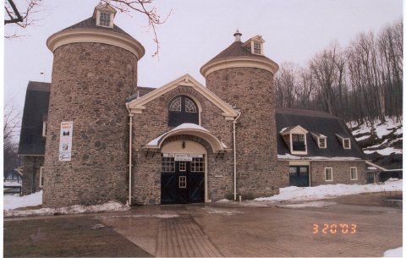
The Farmers’ Museum: dairy barn / exhibition hall (March 2003)

property, while noting that the museum might, in and of itself, be considered for the National Register as a site significant in education and social history. In that way, the valuable collection of nineteenth century buildings possibly could be afforded the benefits and protections of placement on the National Register of Historic Places.

Hopewell Furnace
In comparison, consider Hopewell Furnace, an outdoor museum located in Elverson, Pennsylvania. The origins of the Berks County site center around iron production, with operations predating the Revolutionary War and continuing until 1883. In his history, author Joseph Walker notes, “Hopewell had no particular eminence among the many similar smelting works.” Yet it survives, the built environment relatively intact, supplying a glimpse of an early industrial society, and thus contributing a great benefit today. Further, it has available extensive collections of documentary resources, including journals, business ledgers, and correspondence. The federal government purchased the Hopewell property (approximately 6,000 acres) in 1935, stating, “. . . the lands are being acquired for use as a public park and recreational area, for the restoration of structures of historic interest, the conservation of natural resources, the preservation of scenic beauty, forestation and reforestation ...” and to construct the improvements necessary to provide public facilities. Sadly, the buildings had been permitted to deteriorate in the years since the furnace’s closing. The Franklin Institute of Philadelphia, to whom the blastworks had been promised, withdrew their claim and thus permitted retention of the machinery for exhibition at the furnace. Initial restoration was performed by about four hundred men in the Civilian Conservation Corps, under the aegis of the Works Progress Administration. Three years later, citing the relationship of the land and structures to the nation’s colonial history, E.K. Burlew, Acting Secretary of the Interior, designated the property as a National Historic Site. Such designation of a National Park Service unit automatically places the property on the National Register of Historic Places. Ownership of approximately 5000 acres was transferred to the Commonwealth of Pennsylvania in 1947, but today the remaining 848 acres (including the village) continue under federal ownership and the management of the National Park Service.
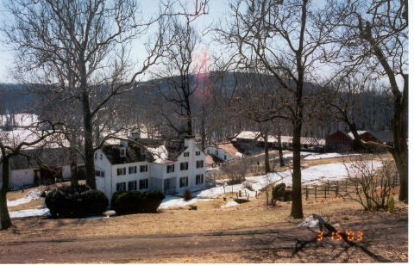
Hopewell Furnace (left to right): barn, ironmaster’s mansion, furnace, charcoal house (March 2003)

When Mark Bird established the Hopewell Furnace in 1771, he chose the site for its available resources: deposits of iron ore near the surface, ample timber to convert to charcoal fuel for the furnace, a supply of limestone for flux, and a source of water to turn the wheel that powered the blast bellows. Additionally, the waterway provided a major transportation route. He had inherited over 8000 acres from his father in 1763, and continued to amass more. The earliest extant cast iron stove, the item most frequently manufactured in Hopewell, is dated 1772. Through the years, they also produced cookware, farm implements, nails, and weights. Because the assembly of ironmaster, clerk, founder, woodcutters, collier, miners, gutterman, molders and laborers produced cannons needed by the Continental Army during the Revolutionary War, they were exempt from military service. The community struggled during post-war depression, endured losses due to flooding, and underwent several changes in ownership before reaching the pinnacle of their success in the 1840s. Thereafter, the furnace produced primarily pig iron, which it marketed to other forges. Remnants of a second massive chimney still stand, testament to the unsuccessful attempt in the 1850s to convert to anthracite fuel, signifying a change in technology employed by competitors that ultimately led to the obsolescence of Hopewell’s charcoal-fired iron furnace.
The restored coal house and cooling shed, huge water wheel, and original hearth, along with explanations about the preparation of charcoal, proper loading of raw materials and flow of molten iron into molds or pig beds, provide the visitor with an understanding and appreciation for the production.

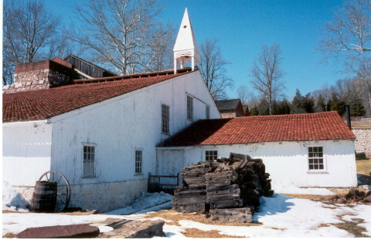
Hopewell Furnace: cast house and furnace (March 2003)

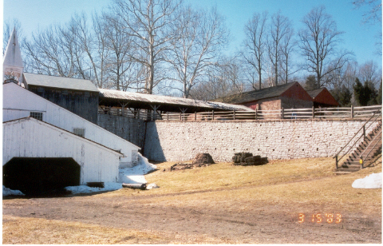
Hopewell Furnace (left to right): cast house/furnace, wheel house, bridge, charcoal house (March 2003)

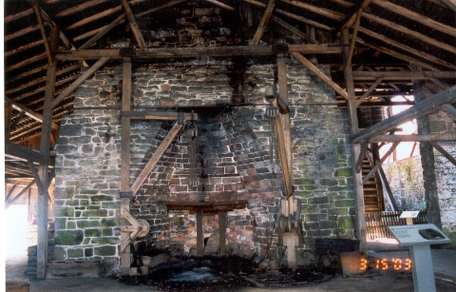
Hopewell Furnace: central hearth (water wheel visible on right) (March 2003)
But there is more to Hopewell Furnace. A tour of the ironmaster’s large home, gardens and dependencies (e.g. ovens, spring house for cold storage and laundry) reveals information about status, business practices, household fashion, and food preparation. The substantial barn conveys the importance of horse teams and livestock. In the small combination store and office, a visitor can observe the economic functioning of the community, one in which workers were fairly compensated by store credit, and in which records of exchanges reveal other attitudes. For example, ledgers document the contracts of indentured workers, illustrate donations of merchandise by one resident to another who was indigent, or forfeiture of a day’s work (and thus wages) to assist someone in need. The simple, but well-built tenant houses were furnished with necessities, and perhaps a few luxuries. Some were home to several generations of a family, with trade skills passed from parent to child

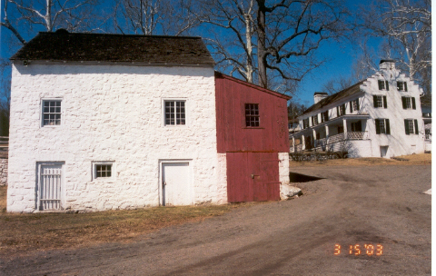
Hopewell Furnace (left to right): clerk’s office/company store, ironmaster’s mansion (March 2003)

or through apprenticeship. Single men were accommodated in dormitory-type boarding facilities, often dining communally or purchasing meals from a family, and contracting for such services as laundry. The presence of a school reflects the considered value of early education for the children of workers and ironmaster alike. The ironmaster’s children, and sometimes others, continued their education at boarding schools elsewhere. Although the village does not contain a church, there are records of services and attendance in neighboring locations, with notation that residents of various enclaves participated at different churches. Thus, the small community evolved, populated by residents who either participated in the production of a thousand tons of cast iron annually, or provided necessary ancillary services for those workers. Social and economic interdependence, the depiction of which is sought at The Farmers’ Museum, was part of the everyday life at Hopewell Furnace.

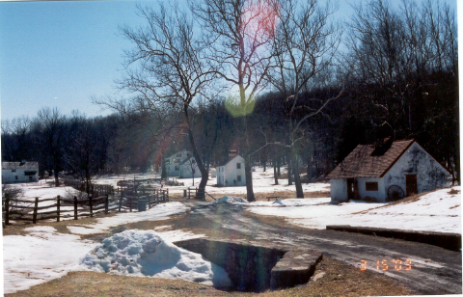
Hopewell Furnace (left to right): boarding house, tenant houses (3), blacksmith’s shop (March 2003)

For a visitor who is accustomed to the massive steel mills that used to line the rivers around Pittsburgh, it is the observation of Hopewell’s scale that makes the most immediate impact. True to its history, it remains a fairly remote, rural setting, although now accessed by paved roads. The waterway that provided incentive for selection of this furnace site remains, but today the visitor meanders through a narrow stretch of woods past the rustic collier’s hut (reconstructed 1980), and encounters a modern dam and spillway. Unlike The Farmers’ Museum, this is not a community of moved buildings. There are several buildings that are not of the period of significance, set aside from the historic village and in this case easily recognized as twentieth-century construction. Nor are all of the original buildings intact, and several of the wooden ones are reconstructions. Some that are missing, such as the schoolhouse and the brick kilns, have been revealed by archaeological excavation, a process that is generally not employed either at Cooperstown facility or at the original locations from which the buildings have been moved to The Farmers’ Museum. Those buildings that remain at Hopewell, however, are positioned as they were originally, thus providing an accurate perspective for the visitor. Realization of the distances between the ironmaster’s house and the company store/office, between worker housing and the blacksmith’s shop (a frequent gathering place), or the length of the bridge over which raw materials were shuttled between the cooling shed and the furnace hearth, all facilitate understanding of the dynamics of the community. As at The Farmers’ Museum, the experience is enhanced by the presence of livestock and, during the summer months, by costumed interpreters. However, as pointed out by Richard Francaviglia in his writings on heritage tourism, the visitor today views a bucolic Hopewell village, rather than the pervasive soot and commotion that historically would have been present on this industrial landscape. Still, it is indeed an impressive site, one that retains a high level of integrity, offers insight into history, and clearly merits its 1985 placement on the National Register of Historic Places.

Conclusion
Beginning approximately eighty years ago, interest in historic preservation and the desire to educate the public about their heritage led to the establishment of outdoor museums. Historic buildings are the essential structural components of such museums; other artifacts, costumed interpreters and themed programming all contribute authenticity to the educational environment. During development of a museum, where original buildings could be retained on the museum grounds, the curator’s task was to preserve, rehabilitate or restore. If an important building was no longer extant, the curator might undertake its careful reconstruction. In many instances, however, the museums were designed to suggest a community that had never actually existed. Under those conditions, the buildings were procured in different ways. Sometimes new buildings were constructed to represent old ones. Often, a vital element in the museum’s development was the acquisition of historic buildings from other locations. The use of moved buildings in such museums led to the inclusion of this chapter in the thesis. The relevance (and frequent irrelevance) of the National Historic Preservation Act to such museums was also investigated.
The author examined three outdoor museums: The Farmers’ Museum in New York, Hopewell Furnace in Pennsylvania, and Greenfield Village in Michigan. During visits to each museum, she became more astute in her observations, recognizing the impact of the museum’s layout. Clearly, the retained landscape and positioning of original structures at Hopewell Furnace had a significant bearing on the visitor’s comprehension of the area’s history. At both Greenfield Village and The Farmers’ Museum, historic buildings were relocated from elsewhere to create small “communities.” It is not known to what degree visitors recognize those fabricated villages as synthetic. The potential for visitors’ misperception of the buildings’ context deserves the concern that is engendered among preservation professionals. All three organizations fulfill their objectives, protecting historic assets while promoting public appreciation of particular themes in history. All three facilities maintain extensive documentary archives to support their educational missions. Each is commendable.
According to the published guidelines, artificial groupings of buildings that have been created for interpretive or protective purposes are not generally eligible for listing in the National Register of Historic Places. The tremendous advantage of seeing buildings in their original context was apparent at Hopewell Furnace, a National Historic Landmark. Although Greenfield Village lacked that significant context, it too was a National Historic Landmark. The apparent contradiction between the designations of those two museums was resolved when the author obtained the nomination packets. Greenfield Village was deemed significant for its pioneering role in the development of the outdoor museum movement, as well as for its association with Henry Ford. The Farmers’ Museum, likewise an artificial grouping of buildings patterned in part on Greenfield Village, does not appear on the National Register of Historic Places. Only select buildings, original to the property, are included as contributing structures in a local historic district. While the buildings which came from elsewhere do not qualify for individual NR listings, it is possible that nomination of The Farmers’ Museum in toto on the basis of its significance as an educational facility would succeed. Such a nomination has not been submitted. It is recommended that The Farmers’ Museum collaborate with the State Historic Preservation Office toward that end. Likewise, there are other notable museums that are fifty or more years old (e.g. Old Sturbridge Village) that are not currently recognized on the National Register, but should be encouraged to apply for such status and thus reap the honor, protections (such as Section 106 reviews) and benefits (such as increased funding possibilities) accorded by the National Historic Protection Act.
The application prepared for nomination of Greenfield Village also provides an introspective commentary about the historic preservation movement. The following remarks are extracted from that document: “Beginning in the 1960s a reaction developed against museum villages in general and Williamsburg and Greenfield Village in particular. Some critics charged that they presented an artificial, dream-like view of an unreal past that was periodized and sanitized to fit the conception of their wealthy patrons. . . .Greenfield Village and the other outdoor museums thus influenced historic preservation, first, by pioneering the preservation of historic structures by moving them to village like settings, and second, by providing a model and ideology of history against which the new historic preservation rebelled…”
CONCLUSION

The quest to move a nineteenth-century schoolhouse sparked a series of inquiries about how to accomplish such an undertaking. The property owners sought to move the small, sound building to a more accessible location, and planned then to rehabilitate the school for conversion to a local history museum. The underlying assumption was that moving the historic building was a worthwhile endeavor, one that would preserve a neglected building and simultaneously put it to better use. This thesis documents the answers to early questions about whether this school (and other historic buildings, more generally) could be moved, and if so, how that would be accomplished. The property owners intended to nominate the schoolhouse to the National Register of Historic Places, both to recognize the significance of the building and, hopefully, to enlist financial support for the costly project. They were discouraged, however, to learn that the building would be ineligible for the National Register if it were moved. To deny eligibility for National Register listing if a building were moved seemed to contradict the notion of protecting historic buildings. Where the goals were to preserve the fabric of the building, and to render it serviceable for further valuable use, why should the building not be recognized as historic? In the absence of such recognition, the financial viability (and thus the likelihood of execution) of a well-intentioned project was clearly jeopardized. Consequently, the scope of this thesis then was expanded as the author pursued a clearer understanding of the National Register criteria, intent upon convincing others that moving such a building was a viable means of historic preservation and that as such, the project should qualify for National Register status.
The first question, “Is it possible to move this building?” was answered readily. A literature search produced considerable documentation of the practice, describing in detail the techniques and reasons for moving, and substantiating the effectiveness with which valuable resources were thus spared. Primarily periodicals, but also some books, documented scores of examples. There is a long precedent for moving buildings. Historically, thousands of buildings, seemingly of all combinations of type and construction, have been relocated to new sites. There was a vast array of examples – small, frame houses; larger buildings such as apartments and hotels; an authentic colonial inn built of stone; massive lighthouses; even entire communities. Authors recounted the functional, economic, cultural and aesthetic advantages of saving those buildings, leading the reader to marvel at both the innovation of the procedures and the wisdom of protecting the “endangered species” of early buildings. The reasons for those moves varied. Often, practicality and efficacy provided the impetus for the move. Such examples included agricultural buildings that were repositioned to improve the efficiency of farming operations, and structures that were elevated or set back in order to permit the introduction of public utilities. Many buildings were moved, driven by the need to clear the site (such as to make way for urban renewal and real estate development), and then situated on new piece of land where they could continue to be utilized and appreciated. There were several instances of either removing or moving closer together historic buildings in college settings, where the valued associations of a structure with tradition and donors seem to compete with pressures for expansion and modernization within the fixed boundaries of the campus. In other cases, the motivation for moving was to protect the building from destruction by nature. Numerous lighthouses have been relocated accordingly, and there were instances of even entire communities being moved in order to escape repeated flooding. Approximately eighty years ago, the desire to educate the public about their heritage, and the growing interest in preservation of historic resources, spurred the establishment of outdoor museums. These museums included collections of buildings selected for their interpretive value, and often gathered from other locations. So, briefly, the answer to the first question was, “Yes, it is possible to move a historic building.”
Likewise, the methods used for accomplishing the moves varied, powered by equipment ranging from horse-drawn to hydraulics. After reviewing the published materials and interviewing professional structural movers, the author compiled a brief directory of equipment that might be utilized in moving a building. While the technology has changed, the basic process has not. First, stabilize the building in order to minimize the risk of structural damage, then remove it from its foundation. The preferred technique is to move the building intact; where that is not workable, division of the building into large sections or even disassembly may be necessary. Second, move the building to the desired location, utilizing the appropriate equipment and avoiding impediments along the travel route. Finally, reinstall the building at its new, prepared site.
The process seemed simple enough, but the project grew more challenging when the property owners addressed the next two issues. First, they aspired to bring honorific recognition to the historic school through nomination to the National Register of Historic Places. But their goal was quickly thwarted. They were informed by the State Historic Preservation Office that moving the school would render it ineligible for the National Register. Second, the property owners anticipated applying for grants to supplement their financial resources; the proposed relocation and rehabilitation would be an expensive undertaking. But again the group encountered a barrier. Many grant applications stipulated that funding was restricted; parties seeking financial assistance need not apply unless the expenditures would be dedicated to the preservation of a property listed on the National Register. While the mechanics of a building relocation are straightforward, the implications of a move are not, and thus led to an investigation of the second question, “Should a historic building be moved?”
It was not difficult to discover that many moved buildings were in fact listed on the National Register of Historic Places. Shortly after Cornell and Historic Ithaca (a local not-for profit organization that advocates preservation) collaborated on the relocation of the Cradit-Moore House from the university campus, the author and her classmates had the opportunity to tour the building. That so little damage had occurred during the move, and that the lovely old house would once again be a private residence, both left strong, favorable impressions on the students. In the prominent case of the Pope-Leighey House, a property owned by the National Trust for Historic Preservation had not only been moved (twice, no less), and also had been listed when it was far less than the benchmark age of fifty years. How could that be? And while Cooperstown’s acclaimed Farmers’ Museum was denied designation as historic, Henry Ford’s Greenfield Village with its collection of uprooted, out-of-context buildings and even reduced-scale replicas was recognized as a National Historic Landmark! Such apparent inconsistency seemed wrong in principle, and was sure to be a detriment to preservation efforts. Thereupon the author set out to fight for the cause of moved buildings that unjustifiably were denied the protections and benefits associated with listing on the National Register of Historic Places.
Anecdotally, research for a different assignment uncovered articles which “added fuel to the fire.” The author was incensed when she read about large-scale demolition programs, underwritten at least in part by the federal government’s Housing and Urban Development. Hundreds of tear-downs in Buffalo were thus subsidized. HUD’s deputy assistant secretary stated, “Particularly in the second-tier cities that don’t get much attention, the Syracuses of the world, this money is tremendously important. It’s for buildings that can’t be rehabbed and are not designated and not up for historic designation.” The author’s personal experience in helping to salvage usable building materials from one house in Syracuse (admittedly an inadequate sample, but worthy of consideration nonetheless) contradicted that official’s statement. The Syracuse house was far from being irreparable, and could have offered a decent home for two families. In another example, the use of state funds for a project in Hartford, Connecticut mandated the review of proposed demolitions by the State Historic Preservation Office. After SHPO identified approximately twenty per cent of the eighty buildings as contributing to National Register districts, the city circumvented the process by using its own funds (rather than the state’s) to tear down the unwanted buildings. In another example of wanton destruction, Detroit officials planned to demolish thousands of houses that instead could have been rehabilitated; this was an effort to clear lands in anticipation of new development, despite the absence of formal plans for such. Gary, Indiana offered a more encouraging, alternative strategy: reclaim entire blocks with a combination of rehabilitated houses and new ones, encouraging owner occupation to improve maintenance and safety in the neighborhood. Certainly the philosophy espoused by the authors from Eugene, Oregon (in Housemoving: Old Houses Make Good Neighbors) would enhance Gary’s ability to renew deteriorating neighborhoods. The relocation of buildings with potential for rehabilitation, rather than wholesale demolitions, would be preferable solutions in the “rust belt” cities such as Detroit, Buffalo and Hartford. Would it not be more desirable to infill neighborhood gaps with compatible buildings and to thereby retain older housing stock and preserve neighborhoods, than to wipe out entire blocks and fill the city’s dump with construction materials?
The key to understanding the question of eligibility for National Register status arose from the definition of “preservation.” Contrary to popular response, the fact that a building has been moved does not always preclude historic designation. As the author gained more thorough understanding of the National Historic Preservation Act, the distinctions became clear. The importance of context, and the qualifying conditions for a “threatened” building became clearer as the author contrasted the various examples. There are, in fact, limited provisions for the listing of buildings on the National Register despite the building having been moved. Furthermore, there are conditions under which a building that is already listed on the National Register can be moved and still retain its historic designation. There are even examples in which the relocation of a significant historic building was mandated under the NHPA in order to protect it. There are instances where threats to a building lead logically to its relocation in order to save it. There are examples where the fabric losses sustained during a building’s move are outweighed by the benefits gained by its preservation at a new site. Too, the drawbacks from the sacrifice of its historic site may pale in comparison to the benefits derived from the continued existence of that historic building. Admittedly, while it may resemble the historic setting, any new site will be a new context and thus it is valuable (for interpretive purposes) to identify the building as having been moved. Practically, however, recognize that context even at the original site may have evolved, such as due to encroaching development. In some cases, that change weakens the argument against moving that is cast by many preservationists. Briefly then, the answer to the second thesis question is, “Yes, under qualified conditions, the building should be moved.”
For the property owner who is determined to relocate a building (with or without the “blessing” of listing on the National Register of Historic Places), the question then becomes, “What steps are necessary to produce a successful move?” To begin, assess the physical condition of the building in its present location, and prepare a detailed record of the findings. Carefully analyze the setting, using those observations as the basis for selecting a new, compatible site. Prepare time schedules and cost estimates, and secure the required funding. Select a qualified structural mover, i.e. one who has demonstrated the ability to protect a historic building throughout the project. Prepare the building for the move, disturbing the integrity of its fabric as little as possible. Prepare the new site to receive the building, constructing a foundation and installing utility connections. Seek the assistance of professionals throughout the planning and execution of the move. They can help navigate the myriad regulations pertaining to local zoning ordinances, life safety codes, traffic control and continuation of utility services along the travel route on moving day. Clean up the vacated site, and proceed with the rehabilitation at the new site. With careful planning and execution, a historic building can indeed be successfully introduced into a new setting, its fabric preserved and its function restored or adapted for future generations. Briefly, the answer to the third thesis question is, “Enlist professional assistance, plan thoroughly, and execute the move carefully in order to successfully relocate a historic building.”
The development of outdoor museums arose, beginning in the first half of the twentieth century, from an increased awareness of the educational value of historic buildings. As one who has been enjoyed and advocated the educational and recreational experiences available at such institutions, the author investigated three museums, noting particularly the impact of relocated buildings and the applicability of the National Historic Preservation Act. At Hopewell Furnace, the federal government took the initiative to preserve intact historic sites. Public moneys enabled the setting aside of lands for public benefit, essentially reserving the property for educational and recreational uses. Public moneys also enabled the preservation, rehabilitation, restoration or reconstruction of built and natural elements for interpretative use, and the accumulation of documentary archives to support the educational mission. Buildings were not “imported” to Hopewell Furnace. Greenfield Village, on the other hand, is representative of an outdoor museum with different origins. Wealthy patron Henry Ford (and his successors) assembled a fictional community in order to educate the public about the history which he perceived as having been neglected. Exhibits were planned to portray everyday activities that were typical of the simpler, pre-industrial era, e.g. the operation of family farms, education in one-room schools, and the conduct of civic proceedings in the town hall. Simultaneously, he showcased invention and emphasized its impact on American society, and in so doing paid tribute to industrial giants such as friend Thomas Edison. Ford and his associates gathered dwindling historic resources into his safe enclave, then supplemented his collection by constructing scaled replicas and designing archetypical representations of other buildings that he deemed necessary, in order to complete his depiction of a particular historic theme. The third example, The Farmers’ Museum, was patterned, in part, after Greenfield Village. Buildings and artifacts were collected from nearby communities and assembled to illustrate agricultural history and to bolster the regional economy. Today, the Cooperstown organization clearly fulfills its mission, promoting historic agricultural practices and educating the public about rural life. The Farmer’s Museum staff members are to be commended for the quality of their programs. Further, their stewardship of the historic buildings is testament to the value they place on those buildings as material culture.
In fact, all three museums have in common the high value they place on their historic artifacts and their commitment to their educational missions. But there are differences. Obviously, the museums vary significantly in scope and scale. For the purposes of this thesis, however, the author focused on a less obvious difference, i.e. their National Register status. Section 60.4 of the NHPA states the general policy of excluding such museums from the National Register. The practice of denying National Register status to museums seemed an injustice. Yet two of the three museums (Hopewell Furnace and Greenfield Village) are National Historic Landmarks, while at the third (The Farmer’s Museum), select buildings are listed on the National Register of Historic Places, identified as contributing elements in a historic district. It appeared that criteria for nomination of a historic resource had been applied inconsistently to the three museums. Resolution to the apparent disparity was reached after touring the three museums, and reviewing the nomination documents. The importance of an intact landscape became readily apparent when personally observed; the immediate impact of the terrain and configuration was striking when the author contrasted her visit to Hopewell Furnace with her tours of The Farmers’ Museum. The designation of Greenfield Village however, remained perplexing. Like The Farmer’s Museum, Greenfield is a simulated community, rather than a historic complex presented in its original context as at Hopewell Furnace. Yet both Greenfield Village and Hopewell Furnace are National Historic Landmarks, so context was not the determining factor in the historic designations. After reading the nomination documents, the applicability of the NHPA to Greenfield Village became clear. Contained therein were the statements regarding criteria for the museum’s significance. Yes, there was significant association with industrialist Henry Ford. But the remaining criteria were more important in clarifying the author’s understanding. Greenfield Village was designated as significant for its educational role, and exemplifies early outdoor museum development; as such, it set precedent for other open-air history museums such as Sturbridge Village and The Farmers’ Museum. By virtue of their role in education and as early examples of outdoor museum development, other museums that are fifty or more years old may be eligible for inclusion in the National Register of Historic Places. Organizations such as The Farmers’ Museum and Sturbridge Village, not currently listed, might gain the advantages of the NHPA according to this criterion. The final statement of Greenfield’s importance was particularly revealing to the author (and student of historic preservation), finally resolving the perception of discord. That is, Greenfield Village was a reflection of an evolution in the definition of preservation. While the museum was originally a model of the preservation concept, that philosophy was altered through the years to the extent that Greenfield became nearly the antithesis of preservation due to its removal of buildings from their contextual setting.
This thesis has been an introduction to the concept of moving historic buildings. It is limited in its explanations, and should not be viewed as a comprehensive resource on engineering principles, project management, financing methodology, the National Historic Preservation Act, or disaster management. The author remains a proponent of moving threatened buildings, while recognizing that the building may be reasonably disqualified from historic designation. While preparing this work, she gained a clearer understanding of the arguments for and against moving historic buildings, and therefore has tempered her enthusiasm for the practice. The relocation of a historic building may or may not be described appropriately as historic preservation. Regardless, the move may produce worthwhile outcomes, e.g. revitalization of a deteriorating neighborhood, continued use of diminished resources, or fulfillment of an educational mission and satisfaction that comes from the fostering of local heritage. Whether relocation is the only way to preserve a threatened historic building, or whether it is simply an economical and resource-conserving endeavor to reuse a serviceable building, it is critical for the property owner to fully understand the ramifications of the project.
For those who wish to further explore this subject, the following topics might form the basis for more in-depth study: cost versus benefit analysis of moving a historic building; subsurface conditions, and how they can influence foundation settling and disaster management; engineering principles utilized to minimize structural damage; building codes and their application to historic structures; statistical analysis of data available via the National Resource Information System to identify distribution and patterns among moved buildings in the National Register of Historic Places; relevant case studies in property rights and mitigation; international preservation practices; correlation between historic building supply and advocacy for building relocation. For students interested particularly in museums, there are other suggestions for further investigation. A survey of museum professionals might examine attitudes about the importance of National Register listing. A survey of museum visitors could reveal the impact of context upon the visitors’ perception of history. Investigation of the communities from which museums’ historic buildings were removed might strengthen the arguments for and against moving. (Did the community support the move in order to rescue a resource that would have been destroyed? Or did the community oppose the move and have a sense of having lost a valuable asset? The latter question is a sensitive one, given the repatriation issues faced by museum professionals.) Further study of each suggested topic would correct limitations found within this thesis. In each case, too, the information gained might strengthen the author’s advocacy for the selective practice of moving historic buildings. Building relocation is one means by which to save a historic resource, and thereby to provide continued aesthetic, economic, historic and functional value.

APPENDIX A
SURVEY OF STATE HISTORIC PRESERVATION OFFICERS

As a Cornell University student of historic preservation planning, I am writing my thesis on moving buildings. My intent is to address aspects including rationale, technology, financial considerations, and impact on eligibility for National Register status. Please respond to the following:

- Approximately ____% of the listings in ____ state have been moved.

- When considering nominations for buildings that were moved previously, are the following influential? If yes, please elaborate.

____ How long ago was the building moved?

____ How does the new setting compare to the original?

____ What was the reason for the move?
- The building was threatened with demolition.
- The surroundings had changed such that the original context was lost (as in the development of housing tracts on formerly rural property, or transition from residential to commercial land use).
- The building could serve an educational purpose.
- The building could be utilized more effectively in a different location.

- If a move is proposed for a listed property, what actions are necessary?

- Of the buildings that have been moved after listing, approximately ____%
have not been reinstated.

- Please identify a noteworthy example of a moved building, and briefly
comment on its success or failure.

Thank you very much for your assistance with my research!

APPENDIX B
TEMPORARY PROTECTION: ATLANTIC AVENUE CONTROL HOUSE

The Memorandum of Agreement for that project spelled out the responsibilities:
- The mover was required to prepare a plan for the temporary relocation which detailed “the methods to be used for protecting all exposed surfaces from the elements during relocation and its subsequent temporary installation.”
- “The MTA-New York City Transit will prepare a foundation to receive the Control House during the temporary location.”
- “The MTA-New York City Transit will undertake all necessary protection to the buildings during the move and on the temporary site until such time as the Control House is moved back to its original location.”
The following instructions appear on the set of plans prepared in March 1998 by Crowley and Pradon Architects, LLC.
“General Demolition and Selective Removal Notes
- All existing materials not specifically identified for removal are historic and must be protected at all times.
- All existing materials marked for removal and salvage shall be recorded and numbered to allow for future reinstallation, and shall be removed carefully and stored.
- All existing piping, drains, exposed electrical conduits, equipment, cables, inserts, and supports shall be demolished and removed.
- All piping and conduits penetrating walls and slabs shall be cut and plugged two (2) inches below the surface.
Temporary protection notes
- The Control House shall be kept water and weather tight, safe, secure, well-ventilated and in good repair at all times.
- All temporary protection shall be coordinated with the shoring, bracing, and other protection measures necessary for moving and temporary relocation. All such protective measures shall be kept in good repair so as to avoid staining and damage to the remaining historic fabric.
- Temporary partition infills and enclosures are to be minimally ¾” marine grade plywood and to have 3-5/8” 18GA metal studs for partitions and 2”x4” wood studs for enclosures.
Temporary relocation notes
- The Control House is to be moved offsite to allow for the construction of
the below-grade concourse and is to be placed on a temporary offsite and newly constructed foundation.
- The relocation contractor shall provide, install, maintain, and remove all
temporary shoring, bracing, grillage or other measures necessary for temporarily relocating the Control House and shall be coordinated with other temporary protection measures.
- Where lift points or other measures have been indicated on the drawings,
those notes and locations are provided to establish intent. The contractor remains responsible for all measures necessary for relocation and protection.”
The drawings which follow illustrate the placement for protective enclosures and bracing of the parapets, and temporary infill partitions. They are, of course, only a fragment of the plans, but are included as examples.
BIBLIOGRAPHY

“1887 Observatory, All 375 Tons of It, Moves to New Site,” New York Times, June 30, 1991.

Alanen, Arnold R. and Melnick, Robert Z., editors. Preserving Cultural Landscapes in America. Baltimore: Johns Hopkins University Press, 2000.

Albert, Leanne et al. “Spirit of the Past: The Story of The Farmers’ Museum,” in Heritage: The Magazine of the New York State Historical Association, Volume 9, Number 3 (Spring 1993), pages 10-21.

“Atlantic Terminal Complex Rehabilitation: Environmental Assessment and Section 4 (f) Evaluation,” prepared by Louis Berger & Associates, Inc. for New York City Transit Authority, April 1998 (draft).

Booher, Mike and Ezell, Lin. Out of Harm’s Way: Moving America’s Lighthouse. Annapolis, MD: Eastwind Publishing, 2001.

The Book of Greenfield Village, Being an Account of the Historic Village Founded by the Late Mr. Henry Ford at Dearborn, in the State of Michigan and Containing Descriptions of the Nearly One Hundred Original and Reconstructed Buildings, which Reflect the Life and Work of Colonial and Nineteen-Century America. Dearborn: Greenfield Village Print Shop, 1953.

Brooks, H. Allen. “Frank Lloyd Wright – His Concepts and Career,” in Historic Preservation: Special Issue on the Pope-Leighey House,” the magazine of the National Trust for Historic Preservation, Vol. 21, No. 2-3 (April – September 1969).

Bureau of Municipal Research and Service. Municipal Control of the Moving of Buildings (Information Bulletin No. 152). University of Oregon, 1967.

“Business as Usual While Moving,” Scientific American, Vol. 125 (November 1921), page 27.

Clifford, Candace. “Preserving Lighthouses – Moving Lighthouses,” in CRM Bulletin, Vol. 22, No. 9 (1999), pages 36-40.

Close, Charles S. “Moving Brick Houses,” Journal of the Franklin Institute, Vol. 70, No. 3 (September 1875), pages 178-180.

Cooperstown Historic District (Boundary Expansion) Registration Form, National Register of Historic Places, 1997.

“A Courthouse Going to Court,” Scientific American, No. 81 (October 7, 1899), page 232.

Crowe, Michael J. “A Short History of the Crowe Moving Business,” in The Structural Mover, Volume 14, Number 2 (September 1996), pages 8-11.

“Curious Feat of House Moving,” Scientific American, No. 128 (June 1923), page 378.

Curtis, John Obed. Moving Historic Buildings. Washington: Heritage Conservation and Recreation Service (U.S. Department of the Interior), 1979.

“Death of a Prominent Colored Citizen - Born a Slave - Died Rich - Originator of Underground Railroad,” Elmira Daily Gazette and Free Press, December 17, 1900.

Department of Transportation, Finding [26 Pa.B. 2056], “The Pennsylvania Bulletin.” [Pa.B. Doc. No. 96-694. Filed for public inspection April 26, 1996.]

Donofrio, Gregory A. Building the Farmers’ Museum, 1943 – 1965. Master’s thesis, Cornell University: 2001.

“Down the Drain: Raising Chicago,” Chicago Public Library Digital Collections (www.chipublib.org/digital/sewers/history2.html, referenced 03-06-2005)

“Edison Institute Museum and Village,” (brochure) 1934.

Edward J. Cutler, Interviews 1955-56. Oral histories, memoirs, and reminiscences, E.I. #251, Box 3, Benson Ford Research Center, The Henry Ford.

“An Eight-Mile House Moving,” Scientific American, No. 84 (January 26, 1901), page 56.

The Farmers’ Museum. 2001 Annual Report: Growth – Potential. Cooperstown, NY.

Fischetti, David C. “Relocating the Cape Hatteras Lighthouse in Buxton, North Carolina,” in APT Bulletin, Vol. 31, No. 2-3 (2000), pages 9-15.

Fisher, George M. “Moving Hibbing by Tractor and Truck: Minnesota Town in Iron Belt Forced to Move Houses Because of Undermining,” in The American City, Vol. XXV, No. 2 (August 1921), page 105.

Fowlkes, Maryem. “Moving Houses in New York City, 1843,” in Antiques, Vol. 100 (December 1971), page 864.

Freeman, Allen. “New Wave Demolition,” in Preservation, Volume 51, Number 3 (May/June 1999), pages 14-15.

Freeman, Allen. “The Resurrectionist,” in Historic Preservation, Volume 42, Number 4 (July-August 1990), pages 30-37.

Gayle, Margot and Gayle, Carol. Cast-Iron Architecture in America: The Significance of James Bogardus. New York: W.W. Norton & Company, 1998.

Gold, Michael W. “Bogardus Cast Iron: Designed to be Dismantled and Rebuilt,” Historic Preservation, the magazine of the National Trust for Historic Preservation, Vol. 23, No. 3 (July-September 1971), pages 12-19.

Greenfield Village and the Henry Ford Museum Inventory- Nomination Form, National Register of Historic Places, 1981.

Haas, Irvin. America’s Historic Villages and Restorations. New York: Arco Publishing Company, 1974.

Hodgdon, Rosaria F. and Lipton, S. Gregory. Housemoving: Old Houses Make Good Neighbors. Eugene, OR, 1979.

Hopewell Village National Historic Site (Hopewell Furnace) Nomination Form, National Register of Historic Places, 1985.

“House is Focus of Cornell Meeting,” The Ithaca Journal, December 13, 1999.

“House Moving in Boston,” Journal of the Franklin Institute, Vol. LIX, third series, No. 2 (February 1870), pages 89-92

http://archives.syr.edu/arch/buildings/holdendesc.htm

Hudnut, William H. III. “New Strategies for Old Buildings and Abandoned Land,” in Urban Land, Volume 55, No. 6 (June 1997), pages 39-42.

“If a New Highway is Headed Your Way Should You Get Into House Moving?,” House and Home, Vol. 6, No. 4 (October 1954), pages 164 – 167.

Institution of Civil Engineers. Repair and Renewal of Buildings – Proceedings of a Conference Organized by the Institution of Civil Engineers and held in London on 17 November 1982. London: Thomas Telford, Ltd, 1983.

International Chimney Corporation. “Move-System Component Definitions.” 2001
.
International Code Council, Inc. 2003 International Existing Building Code – Final Draft. Chapter 10, August 2001.

IRT Subway Control Houses: Thematic Resources Nomination Form, National Register of Historic Places, 1980.

John W. Jones House: National Register of Historic Places Registration Form, 2003.

Jopp, F.G. “Moving a House of Glass,” Scientific American, Vol. 126 (June 1922), page 387.

Katz, Alyssa. “Dismantling the Motor City,” in Metropolis, Volume 17, No. 9 (June 1998), pages 33-37.

King of Prussia Inn Nomination Form, National Register of Historic Places, 1975

Leighey, Marjorie. “A Testimony to Beauty,” in Historic Preservation: Special Issue on the Pope-Leighey House,” the magazine of the National Trust for Historic Preservation, Vol. 21, No. 2-3 (April – September 1969).

Library of Congress, Prints and Photographs Division, Historic American Buildings Survey NY-5469 (Edgar Laing Stores).

Ling, Arthur. “Moving Buildings in the USSR,” in The Architect’s Journal, No. 2561, Vol. 99 (February 29, 1944), pages 151 – 163.

Litchfield, Michael. Salvaged Treasures. New York: Van Nostrand Reinhold Company, 1983.

Lord, M.G. “A Moving Tale from Movieland: The Restoration of a Beverly Hills House Opens a Forgotten Chapter of Los Angeles History,” in Preservation, the magazine of the National Trust for Historic Preservation, Vol. 52, No. 4 (July – August 2000), pages 60 - 64.

Lutzker, Susan J. and Moriarity, Lyn Howell, editors. “Revolving Funds: Saving Buildings and Bringing New Life to Communities,” in Historic Preservation Forum, The Journal of the National Trust for Historic Preservation, Volume 12, No. 1 (Fall 1997).

McAlester, Virginia and Lee. A Field Guide to America’s Historic Neighborhoods and Museum Houses: The Western States. New York: Alfred A. Knopf, 1998.

McDonald, Molly. “The Archaeology and History of Moving Houses on the South Fork of Long Island,” in Vernacular Architecture, Volume 32 (2001), pages 34 – 47.

Morley, Christopher, Editor. Familiar Quotations: A Collection of Passages, Phrases and Proverbs, Traced to Their Sources in Ancient and Modern Literature by John Bartlett, 12th Edition Revised and Enlarged. Boston: Little, Brown and Company, 1951.

Morton, Terry B. “The Threat, Rescue and Move,” in Historic Preservation: Special Issue on the Pope-Leighey House,” the magazine of the National Trust for Historic Preservation, Vol. 21, No. 2-3 (April – September 1969), pages 101-118.

“A Most Unusual House Moving Operation,” Building Age Magazine, Volume 35 (1913), page 553.

“Moving America’s Lighthouse.” Produced by Naka Productions in association with WETV, Charlotte, NC. 2000.

Moving a 1,100-Ton Brick Railway Station,” Scientific American, No. 115 (September 2, 1916), page 209.

“Moving a Church of 3200 Tons,” Scientific American, No. 128 (March 1923), page 186.

“Moving Houses to Clear the Mines,” in Scientific American, No. 125 (August 6, 1921), page 95.

“Moving 3,500 Tons of Building,” Architectural Forum. Volume 119 (July 1963), pages 108-109.

National Park Service, U.S. Department of the Interior. National Register Bulletin: How to Apply the National Register Criteria for Evaluation. 1997.

National Trust for Historic Preservation (Zagars, Julie, editor). Preservation Yellow Pages: The Complete Information Source for Homeowners, Communities, and Professionals (revised edition). New York: John Wiley & Sons, Inc., 1997.

National Trust Resource Center. “Information Sheet #6: Moving Historic Buildings.” National Trust for Historic Preservation, updated August 2002.

Oppenheimer-Dean, Andrea. “Looking for Mr. Wright,” in Historic Preservation, the magazine of the National Trust for Historic Preservation, Vol. 48, No. 2, page 17.

The Reminiscences of Edward J. Cutler, Volumes 1 and 2. Ford Motor Company Archives, Oral History Section, March 1952.

Rickert, Howard C. “The Challenge of Constructing a Wright House,” in Historic Preservation: Special Issue on the Pope-Leighey House,” the magazine of the National Trust for Historic Preservation, Vol. 21, No. 2-3 (April – September 1969), page 81.

St. Mary’s City Inventory – Nomination Form, National Register of Historic Places, 1969.

“Siena College Offers House But You Must Take It With You,” Albany Preservation Reporter, Volume 7, Number 2 (Spring 1988).

Stipe, Robert E. and Antoinette J. Lee, editors. The American Mosaic: Preserving a Nation’s Heritage. Detroit, MI: Wayne State University Press for US/ICOMOS, 1997

Sullivan, Ann C. “Re-creating Wright,” in Architecture, Vol. 8, No. 8 (August 1997), pages 126-132.

“Tale of a Church in Two Cities,” AIA Journal, Vol. 56, No. 1 (July 1971), pages 27 – 30.

“To CU: Look at Options for This Old House,” The Ithaca Journal, May 21, 1999.

“Two Villages That Disappeared Via the Recycle Route: Tahawus, New York and Osborn, Ohio,” in The Structural Mover, Volume 12, Number 2 (September 1994), pages 20-28.

Upward, Geoffrey C., editor. A Home for Our Heritage: The Building and Growth of Greenfield Village and Henry Ford Museum, 1929-1979. Dearborn, MI: The Henry Ford Museum Press, 1979.

“A Vertical House Moving,” Scientific American, No. 89 (December 12, 1903), page 446.

“A Voyaging Lighthouse,” Scientific American, No. 115 (July 1, 1916), page 17.

Waite, John G., AIA. “Technical Preservation Service Brief 27: The Maintenance and Repair of Architectural Cast Iron.” Washington, D.C.: Department of the Interior (National Park Service), 1991.

Walker, Joseph E. Hopewell Village: The Dynamics of a Nineteenth-Century Iron-Making Community. Eastern National / University of Pennsylvania Press, 2000.

Watterson, Joseph, FAIA. “Siting and Landscaping,” in Historic Preservation: Special Issue on the Pope-Leighey House,” the magazine of the National Trust for Historic Preservation, Vol. 21, No. 2-3 (April – September 1969).

“Why We Opposed Cradit-Moore Rezoning,” The Ithaca Journal, January 7, 2000.

“Woman Looks to Buy Historic House,” The Ithaca Journal, September 14, 1999.

www.beyerblinderbelle.com

www.bromehowardinn.com

www.buildingMovers.com

www.cr.nps.gov/nr/about.htm

www.delmars.com/flwtrip/popela.html

www.gazetteonline.com/special/homefront/story11.html

www.iasm.org

www.iccsafe.org/about/index.htm

www.marylandhistoricaltrust.net

www.nam.org

www.nationalregisterofhistoricalplaces.com

www.nationaltrust.org/help/moving_historic_buildings.html

www.quinnevans.com/craft.html

www.sfheritage.org

www.stephenpmack.com

www.urscorp.com/newsroom/press/pr_091200.html

www.us202.com/Pages/news_and_updates.asp?section=400

U.S. Department of the Interior, National Park Service. National Register Bulletin: How to Complete the National Register Registration Form, 1997.
Zagars, Julie, editor, for the National Trust for Historic Preservation. Preservation Yellow Pages: The Complete Information Source for Homeowners, Communities, and Professionals (revised edition). New York: John Wiley & Sons, Inc., 1997, page 53.
Secretary of Interior’s Standards for the Treatment of Historic Properties (1995), ww2.cr.nps.gov/tps.
Crowe, Michael J. “A Short History of the Crowe Moving Business,” in The Structural Mover, Volume 14, Number 2 (September 1996), pages 8-11. No attempt was made to contact Mr. Crowe.
“Two Villages That Disappeared Via the Recycle Route: Tahawus, NY and Osborn, Ohio,” in The Structural Mover, Volume 12, Number 2 (September 1994), pages 20-28. Bob and Dottie Gheen addresses is identified per footnote 15 as 1374 Eastview Drive, Fairborn, Ohio 45234. There was no attempt to contact them during this research.
Ling, Arthur. “Moving Buildings in the USSR,” in The Architect’s Journal, No. 2561, Vol. 99 (February 29, 1944), page 151.
Fowlkes, Maryem. “Moving Houses in New York City, 1843,” in Antiques, Vol. 100 (December 1971), page 864, quoting Mrs. Felton, American Life: A Narrative of Two Years’ City and Country Residence in the United States, Bolton Percy, 1843, pages 51-52.
“Down the Drain: Raising Chicago,” Chicago Public Library Digital Collections (www.chipublib.org/digital/sewers/history2.html, referenced 03-06-2005)
“House Moving in Boston,” Journal of the Franklin Institute, Vol. LIX, third series, No. 2 (February 1870), pages 89-92.
Close, Charles S. “Moving Brick Houses,” Journal of the Franklin Institute, Vol. 70, No. 3 (September 1875), pages 178-180.
“A Courthouse Going to Court,” Scientific American, No. 81 (October 7, 1899), page 232.
“An Eight-Mile House Moving,” Scientific American, No. 84 (January 26, 1901), page 56.
“A Vertical House Moving,” Scientific American, No. 89 (December 12, 1903), page 446.
“A Most Unusual House Moving Operation,” Building Age Magazine, Vol. 35 (1913), page 553.
“Curious Feat of House Moving,” Scientific American, No. 128 (June 1923), page 378.
“A Voyaging Lighthouse,” Scientific American, No. 115 (July 1, 1916), page 17.
“Moving a 1,100-Ton Brick Railway Station,” Scientific American, No. 115 (September 2, 1916), page 209.
“Moving Houses to Clear the Mines,” in Scientific American, Vol. 125 (August 6, 1921), page 95.
Fisher, George M. “Moving Hibbing by Tractor and Truck: Minnesota Town in Iron Belt Forced to Move Houses Because of Undermining,” in The American City, Vol. XXV, No. 2 (August 1921), page 105.
Lord, M.G. “A Moving Tale from Movieland: The Restoration of a Beverly Hills House Opens a Forgotten Chapter of Los Angeles History,” in Preservation, the magazine of the National Trust for Historic Preservation, Vol. 52, No. 4 (July – August 2000), page 63.
“Business as Usual While Moving,” Scientific American, Vol. 125 (November 1921), page 27.
Jopp, F.G. “Moving a House of Glass,” Scientific American, Vol. 126 (June 1922), page 387.
“Moving a Church of 3200 Tons,” Scientific American, No. 128 (March 1923), page 186.
“A Walking Tour of the Cottage Farm Heritage District of Fair Haven, New York,” published by the Sterling Historical Society, 2002.
“If a New Highway is Headed Your Way Should You Get Into House Moving?,” House and Home, Vol. 6, No. 4 (October 1954), pages 164 – 167.
“Tale of a Church in Two Cities,” AIA Journal, Vol. 56, No. 1 (July 1971), pages 27 - 30.
Curtis, John O. “The Move and Restoration of the Hapgood Wool Carding Mill: A Case History from the 1960’s.” Bulletin of the Association for Preservation Technology, Vol. XII, No. 1 (1980), pages 30-51.
“Two Villages That Disappeared Via the Recycle Route: Tahawus, New York and Osborn, Ohio,” in The Structural Mover, Volume 12, Number 2 (September 1994), pages 20-28.
Note that, per Carl Tuxill, buildings on slab can be moved, either with or without the slab intact, depending upon ground conditions. Sometimes use steel banding as straps? Telephone interview, June 9, 2003.
“Operation Fresh Start: Rhineland, Missouri,” at www.sustainable.doe.gov. Also, www.experthousemovers.com. (Referenced June 7, 2003.) Personal correspondence with Steve Etcher, Executive Director of Boonslick Regional Planning Commission, dated June 9, 2003.
Fischetti, David C. “Relocating the Cape Hatteras Lighthouse in Buxton, North Carolina,” in APT Bulletin, Vol. 31, No. 2-3 (2000), pages 9-15.
Clifford, Candace. “Preserving Lighthouses – Moving Lighthouses,” in CRM Bulletin, Vol. 22, No. 9 (1999), pages 36-40.
Booher, Mike and Ezell, Lin. Out of Harm’s Way - Moving America’s Lighthouse. Eastwind Publishing: Annapolis, MD, 2001.
McDonald, Molly. “The Archaeology and History of Moving Houses on the South Fork of Long Island,” in Vernacular Architecture, Volume 32 (2001), pages 34 – 47.
International Chimney Corporation. “Move-System Component Definitions,” 2001.
“Two Villages That Disappeared Via the Recycle Route: Tahawus, NY and Osborn, Ohio,” in The Structural Mover, Volume 12, Number 2 (September 1994), pages 20-28. Also, www.nam.org (National Association of Manufacturers, referenced June 9, 2003).
Ibid.
www.gazetteonline.com/special/homefront/story11.html (referenced June 9, 2003).
International Chimney Corporation. “Move-System Component Definitions.” 2001.
Litchfield, Michael. Salvaged Treasures: Designing and Building with Architectural Salvage. New York: Van Nostrand and Reinhold Co., 1983, page 230. Current figures are not maintained by the International Association of Structural Movers, per correspondence from N. Eugene Brymer, Chief Executive Staff, dated 01-30-2003.
Telephone interview on June 9, 2003. Mr. Tuxill confirmed that IASM does not maintain such statistics, but estimated the volume of moves on the basis of 200 – 250 movers, with each moving approximately forty buildings annually.
Ling, Arthur. “Moving Buildings in the USSR,” in The Architect’s Journal, No. 2561, Vol. 99 (February 29, 1944), pages 151 – 163.
Ibid, page 152.
Ibid, page 161.
Brooks, H. Allen. “Frank Lloyd Wright – His Concepts and Career,” in Historic Preservation: Special Issue on the Pope-Leighey House,” the magazine of the National Trust for Historic Preservation, Vol. 21, No. 2-3 (April – September 1969), page 37.
www.delmars.com/flwtrip/popela.html
Watterson, Joseph, FAIA. “Siting and Landscaping,” in Historic Preservation: Special Issue on the Pope-Leighey House,” the magazine of the National Trust for Historic Preservation, Vol. 21, No. 2-3 (April – September 1969), page 87.
Leighey, Marjorie. “A Testimony to Beauty,” in Historic Preservation: Special Issue on the Pope-Leighey House,” the magazine of the National Trust for Historic Preservation, Vol. 21, No. 2-3 (April – September 1969), page 62.
Rickert, Howard C. “The Challenge of Constructing a Wright House,” in Historic Preservation: Special Issue on the Pope-Leighey House,” the magazine of the National Trust for Historic Preservation, Vol. 21, No. 2-3 (April – September 1969), page 81.
Morton, Terry B. “The Threat, Rescue and Move,” in Historic Preservation: Special Issue on the Pope-Leighey House,” the magazine of the National Trust for Historic Preservation, Vol. 21, No. 2-3 (April – September 1969), pages 101-118.
www.quinnevans.com/craft.html
Oppenheimer-Dean, Andrea. “Looking for Mr. Wright,” in Historic Preservation, the magazine of the National Trust for Historic Preservation, Vol. 48, No. 2, page 17.
Sullivan, Ann C. “Re-creating Wright,” in Architecture, Vol. 8, No. 8 (August 1997), pages 126-132.
Stipe, Robert E. and Antoinette J. Lee, editors. The American Mosaic: Preserving a Nation’s Heritage. Detroit, MI: Wayne State University Press for US/ICOMOS, 1997, pages 2-5.
www.cr.nps.gov/nr/about.htm (accessed June 26, 2003) Note that the number of listings is quoted at 78,310 per www.nationalregisterofhistoricalplaces.com (accessed June 30, 2003).
Correspondence with John P. Byrne, National Register Database Manager (December 23, 2005).
National Park Service, U.S. Department of the Interior. National Register Bulletin: How to Apply the National Register Criteria for Evaluation. 1997, pages 11-24.
National Park Service, U.S. Department of the Interior. National Register Bulletin: How to Apply the National Register Criteria for Evaluation. 1977, pages 29-31.
John W. Jones House: National Register of Historic Places Registration Form, 2003.
The farm was stated to contain sixteen acres in Mr. Jones’ obituary.
“Death of a Prominent Colored Citizen - Born a Slave - Died Rich - Originator of Underground Railroad,” Elmira Daily Gazette and Free Press, December 17, 1900 (www.angelfire.com/ny5/elmiraprison/johnjonesobit.html, accessed June 25, 2003).
www.marylandhistoricaltrust.net
Correspondence with Dr. Henry Miller, St. Mary’s College, June 8-10, 2003.
St. Mary’s City Inventory – Nomination Form, National Register of Historic Places (1969).
Interview, April 17, 2003.
“Moving America’s Lighthouse.” Produced by Naka Productions in association with WETV, Charlotte, NC. 2000.
http://archives.syr.edu/arch/buildings/holdendesc.htm (accessed February 26, 2003).
“1887 Observatory, All 375 Tons of It, Moves to New Site,” New York Times, June 30, 1991.
“To CU: Look at Options for This Old House,” May 21, 1999; “Woman Looks to Buy Historic House,” September 14, 1999; “House is Focus of Cornell Meeting,” December 13, 1999; “Why We Opposed Cradit-Moore Rezoning,” January 7, 2000.
Historic Ithaca, in their argument to retain the house on campus, cited several Ivy League examples where historic houses continued in use. While they did agree to serve as a facilitator for the move, they refused to offer evidence for the site plan because they felt that the move was less desirable than preservation of the house at its original location
“Siena College Offers House But You Must Take It With You,” Albany Preservation Reporter, Volume 7, Number 2 (Spring 1988).
“Moving 3,500 Tons of Building,” Architectural Forum. Volume 119 (July 1963), pages 108-109.
Correspondence with Ken Guzowski, City Planner, February 9 - June 2, 2003.
Hodgdon, Rosaria F. and Lipton, S. Gregory. Housemoving: Old Houses Make Good Neighbors. Eugene, OR: City of Eugene, 1979.
Ibid, page 5.
Personal communication from Kenneth Guzowski, Senior Planner, March 10, 2003.
Hodgdon, Rosaria F. and Lipton, S. Gregory. Housemoving: Old Houses Make Good Neighbors. Eugene, OR: City of Eugene, 1979. Also,www.sdscounty.ca.gov/cntydpts (referenced June 3, 2003), and correspondence with Lynne Christenson, Historian, County of San Diego, dated June 5 -12, 2003.
Correspondence with Don Andreini, San Francisco Architectural Heritage, June 12, 2003. Note that Mr. Andreini referred to “at least nine” moved houses, so the actual number may be less that the twelve identified in Hodgdon and Lipton’s book.
www.sfheritage.org (referenced June 3, 2003).
“Atlantic Terminal Complex Rehabilitation: Environmental Assessment and Section 4 (f) Evaluation,” prepared by Louis Berger & Associates, Inc. for New York City Transit Authority, April 1998 (draft, copy on file at the New York State Office of Parks, Recreation and Historic Preservation).
IRT Subway Control Houses: Thematic Resources Nomination Form, National Register of Historic Places, 1980.
National Trust for Historic Preservation (Julie Zagars, editor). Preservation Yellow Pages: The Complete Information Source for Homeowners, Communities, and Professionals (revised edition). New York: John Wiley & Sons, Inc., 1997. Also, www.environment.fhwa.dot.gov.
Telephone interview with Page Ayres Cowley, AIA.
King of Prussia Inn Nomination Form, National Register of Historic Places, 1975.
www.urscorp.com/newsroom/press/pr_091200.html (referenced June 4, 2003).
Department of Transportation, Finding [26 Pa.B. 2056], “The Pennsylvania Bulletin.” [Pa.B. Doc. No. 96-694. Filed for public inspection April 26, 1996.]
www.us202.com/Pages/news_and_updates.asp?section=400 (referenced June 4, 2003).
National Trust Resource Center. “Information Sheet #6: Moving Historic Buildings.” National Trust for Historic Preservation, updated August 2002.
McAlester, Virginia and Lee. A Field Guide to America’s Historic Neighborhoods and Museum Houses: The Western States. New York: Alfred A. Knopf, 1998. Page 702.
Ibid, page 702.
Ibid, page 703.
Litchfield, Michael. Salvaged Treasures. New York: Van Nostrand Reinhold Company, 1983.
Hodgdon, Rosaria F. and Lipton, S. Gregory. Housemoving: Old Houses Make Good Neighbors. Eugene, OR, 1979, Chapter 3.
www.iasm.org (accessed 06-07-2003, 01-11-2006)
Telephone interview with Carl Tuxill, June 9, 2003. On a personal note, I was interested to learn that Mr. Tuxill had moved Corning’s clock tower during the 1950s.
“2002 Preservation Award Winners,” in Cornerstone, Newsletter of the Landmark Society of Western New York, January 2002.
Interview with William Matthews, Matthews Building Moving, Inc. on June 2, 2003.
Elvin, Liz. “Setting the Pace,” in The Low Bidder, July – August 1998, pages 22-27.
Interview with Richard Lohr, President of International Chimney Corporation, on April 17, 2003.
Freeman, Allen. “The Resurrectionist,” in Historic Preservation, Volume 42, Number 4 (July-August 1990), pages 30-37. Also see www.stephenpmack.com.
Litchfield, Michael. Salvaged Treasures: Designing and Building with Architectural Salvage. New York: VanNostrand and Reinhold Co., 1983, Chapter 11.
Clifford, Candace. “Preserving Lighthouses – Moving Lighthouses,” in CRM Bulletin, Vol. 22, No. 9 (1999), pages 36 – 40.
Gold, Michael W. “Bogardus Cast Iron: Designed to be Dismantled and Rebuilt,” Historic Preservation, the magazine of the National Trust for Historic Preservation, Vol. 23, No. 3 (July-September 1971), pages 12-19.
Library of Congress, Prints and Photographs Division, Historic American Buildings Survey NY-5469.
www.beyerblinderbelle.com, referenced February 20, 2003.
Waite, John G., AIA. “Technical Preservation Service Brief 27: The Maintenance and Repair of Architectural Cast Iron.” Washington, D.C.: Department of the Interior (National Park Service), 1991.
National Park Service, U.S. Department of the Interior. National Register Bulletin: How to Apply the National Register Criteria for Evaluation. 1997, page 29.
Subsequent to listing on the National Register of Historic Places, Greenfield Village (as part of the Edison Institute) was determined to be an exceptional historic resource of national significance, and thus designated as a National Historic Landmark.
Although the Farmers Museum is not listed in the National Register of Historic Places, the three Fenimore Farm stone agricultural buildings and stone wall contained therein were successfully nominated as part of the expansion of the Cooperstown Historic District in 1997.
This was not Henry Ford’s first venture into preservation or moving buildings. Ford had previously undertaken the painstaking restoration of sites of personal significance, including his family homestead and the Scotch Settlement School which he had attended as a child. In 1923, he purchased the historic Wayside Inn (South Sudbury, Massachusetts) referenced in Henry Wadsworth Longfellow’s poetry and began to assemble a small village of farms and schools to enhance the inn, but managing the project from a distance was difficult. Returning closer to home, in 1924 he purchased the Botsford Inn near Detroit. Both for aesthetics and safeguarding, Ford arranged for the Botsford Inn to be set back from the highway before it was restored. In 1924, Ford declined an invitation from the city of Williamsburg, Virginia to restore dozens of buildings on their original site. (That ambitious project was subsequently undertaken by John D. Rockefeller, Jr.)
The 255-acre Edison Institute, now known as the Henry Ford, includes Greenfield Village and the adjacent Henry Ford Museum. The Henry Ford Museum is beyond the scope of this discussion.
Henry Ford Museum Staff. Greenfield Village and the Henry Ford Museum. New York: Crown Publishers, Inc., 1972, page 7.
Cutler previously had been employed in the Windshield Department then the Drafting Department at Ford Motor Company, and involved in the Wayside Inn restoration.
The Reminiscences of Edward J. Cutler. Ford Motor Company Archives, Oral History Section, March 1952., page 25.
Ibid, page 9.
Edward J. Cutler, Interviews 1955-56. Oral histories, memoirs, and reminiscences, E.I. #251, Box 3. Benson Ford Research Center, The Henry Ford.
Henry Ford espoused a philosophy of “learning by doing,” and aspired to create a network of schools at various locations in the United States and England. Students were chosen from a variety of backgrounds, although many were related to Ford Motor Company employees. Enrollments at Greenfield were 32 in 1929, 190 in 1937 (the year of the first high school graduating class), and peaked at approximately 300 in 1940. Tuition was not charged, and children were paid for some activities. (Upward, Geoffrey C., editor. A Home for Our Heritage: The Building and Growth of Greenfield Village and Henry Ford Museum, 1929-1979. Dearborn, MI: The Henry Ford Museum Press, 1979.)
Greenfield Village and the Henry Ford Museum Inventory- Nomination Form, National Register of Historic Places, 1981.
Albert, Leanne et al. “Spirit of the Past: The Story of The Farmers’ Museum,” in Heritage: The Magazine of the New York State Historical Association, Volume 9, Number 3 (Spring 1993), pages 10-21. With the same intent, Clark also was responsible for the establishment of the National Baseball Hall of Fame.
The Farmers’ Museum. 2001 Annual Report: Growth – Potential. Cooperstown, NY.
Donofrio, Gregory A. Building the Farmers’ Museum, 1943 – 1965. Master’s thesis, Cornell University: 2001, page 2.
The farm is so named because of its historic association with author James Fenimore Cooper.
Ibid, page 147.
Kaupe, whose profession was not indicated in Donofrio’s thesis, was identified as a historic landscape architect by Leanne Albert et al.
Ibid, pages 117 – 121. Also: Albert, Leanne et al. “Spirit of the Past: The Story of The Farmers’ Museum,” in Heritage: The Magazine of the New York State Historical Association, Volume 9, Number 3 (Spring 1993), pages 10-21
Ibid, pages 110 – 111. The possibility of shortening the building by ten to twelve feet in the course of the move was considered, but it is unclear whether or not this was executed.
Personal interview with Dr. Gilbert Vincent, April 10, 2003.
Haas, Irvin. America’s Historic Villages and Restorations. New York: Arco Publishing Co., Inc., 1974.
Donofrio, Gregory A. Building the Farmers’ Museum, 1943 – 1965. Master’s thesis, Cornell University: 2001, page 166.
Interview with Dr. Gilbert Vincent, March 20, 2003.
Cooperstown Historic District (Boundary Expansion) Registration Form, National Register of Historic Places, 1997.
Walker, Joseph E. Hopewell Village: The Dynamics of a Nineteenth-Century Iron-Making Community. Eastern National / University of Pennsylvania Press, 2000, page 11.
Walker, Joseph E. Hopewell Village: The Dynamics of a Nineteenth-Century Iron-Making Community. Eastern National / University of Pennsylvania Press, 2000, page 70.
Hopewell Village National Historic Site (Hopewell Furnace) Nomination Form, National Register of Historic Places, 1985. The cooling shed was reconstructed in 1958.
Alanen, Arnold R. and Melnick, Robert Z., editors. Preserving Cultural Landscapes in America. Baltimore: The Johns Hopkins University Press, 2000, page 58.
Ibid.
Freeman, Allen. “New Wave Demolition: House by House, Cities are Turning Neighborhoods into Dead Zones,” in Preservation, Volume 51, Number 3 (May-June 1999), pages 14-15.
Ibid.
Katz, Alyssa. “Dismantling the Motor City,” in Metropolis, Volume 17, Number 9 (June 1998), pages 33-37.
Freeman, Allen. “New Wave Demolition: House by House, Cities are Turning Neighborhoods into Dead Zones,” in Preservation, Volume 51, Number 3 (May-June 1999), pages 14-15.
“Memorandum of Agreement among the Federal Transit Administration, the Advisory Council on Historic Preservation, the New York State Historic Preservation Officer, and Metropolitan Transportation Authority – New York City Transit Regarding the Implementation of the Atlantic Terminal Complex Rehabilitation,” prepared 1999.
Temporary Protection, Control House Elevations.” Page TP-3005 of plans prepared by Cowley and Pradon Architects, LLC for Contract A-35695, Atlantic Avenue Complex Station Rehabilitation, Atlantic Avenue Station Eastern Parkway Line (IRT), Borough of Brooklyn. March 17, 1998.

